**DIGITAL ASSIGNMENT-2**

**DATE:14-04-2020**

**NAME: AVULA.ROHITHA**

**REG NO:17BLC1007**

**COURSE TITLE: DATA MINING**

**COURSE CODE: CSE3019**

**SLOT: D2**

**FACULTY: Dr. ANUSHA K**

**----------------------------------------------------------------------------------------------------------------**

**QUESTION 1:**

**Implement and analyse different classification algorithms on a dataset (HEART DISEASE, customer satisfaction or feedback etc.,) and predict the result for the same. Generate the confusion matrix for the same. (you can use any simulation tool like RapidMiner).**

**ANSWER:**

**SIMULATION TOOL USED:** RAPID MINER

**DATASET:** CREDIT DATASET

**STEPS TO PERFORM:**

In RapidMiner, to import the data, in the Repository window, click the Import Data button.

Choose the excel file present in your pc.

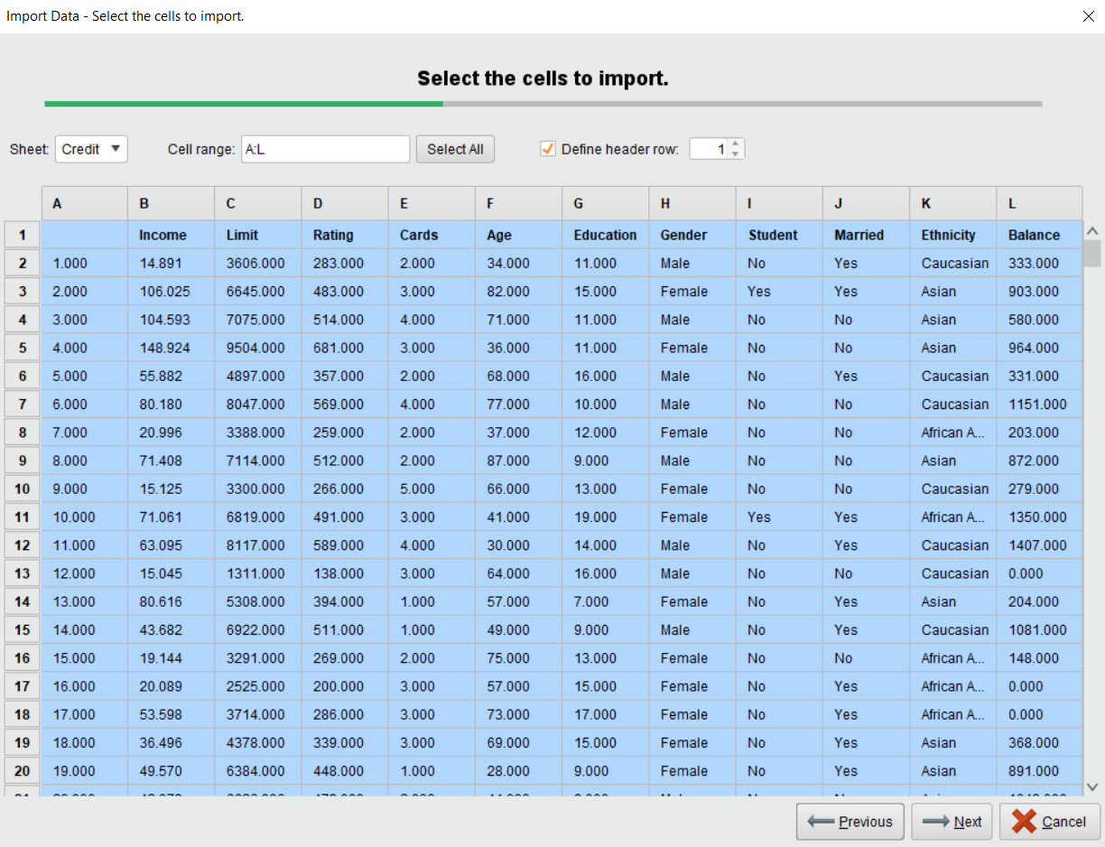

Data gets imported

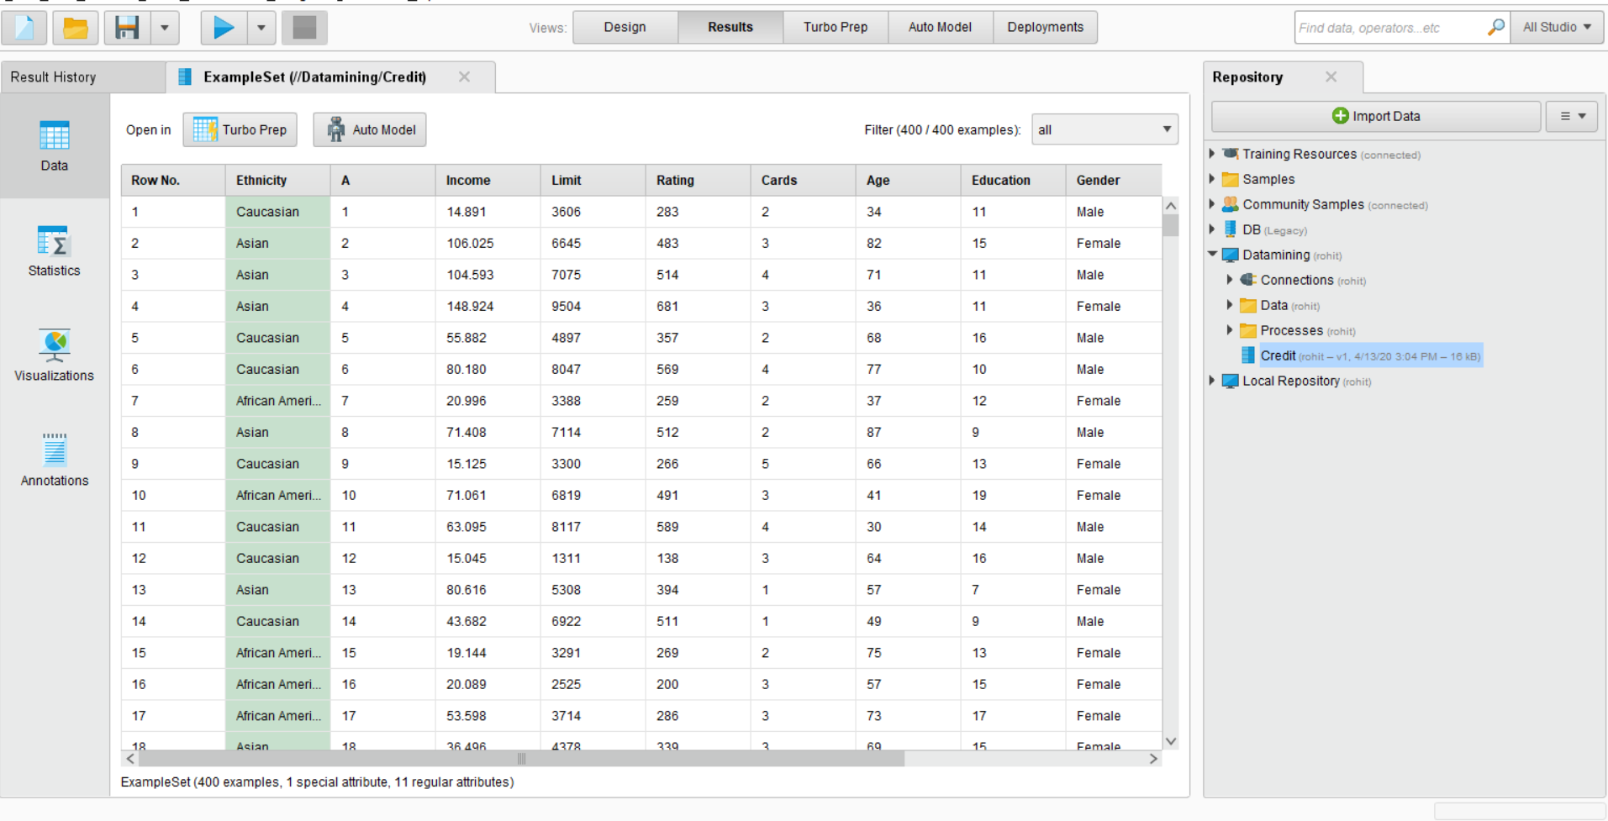

Drag the data onto the Process Window when the data has finished importing

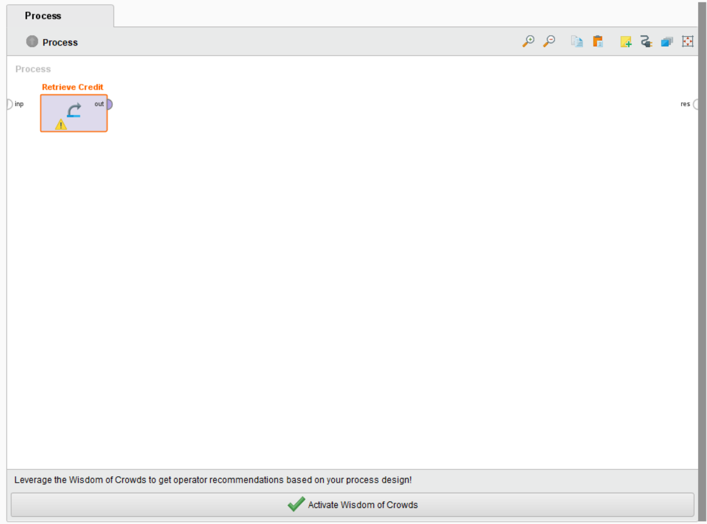

Next, we will split the data. I used 75/25 split.  
Search for Split Data in the Operators Window. Drag it to the Process Window. Select the Split Data Operator, and in the Parameters window (to the right of the screen), select Edit Numeration. This pop-up window is the way in which the data will be split. In the ratio box, type 0.75 (or whatever split you have chosen), next, select Add Entry and enter the remainder of the split (0.25). The total should equal 1.  
The sampling type should be shuffled sampling as we are looking for randomised samples in out two sets.

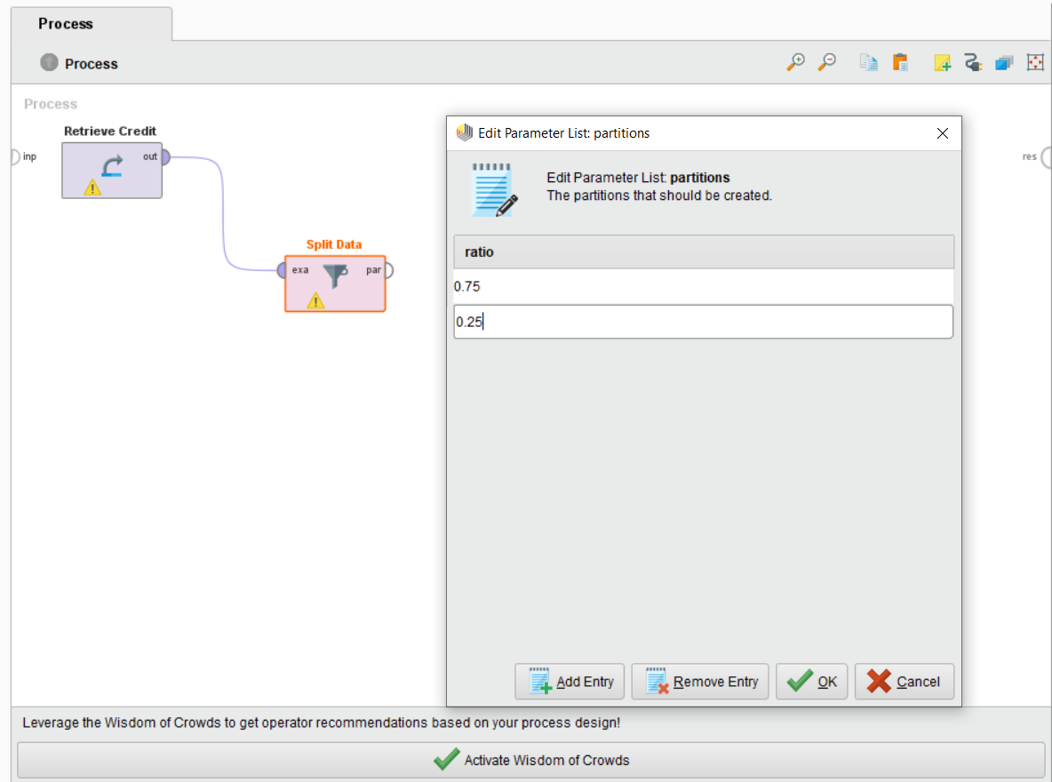

Now, search for Naive Bayes and place it on the process board. We will also need an Apply Model operator to make sure it runs correctly. This sets the split to be the dividing point and then partitions the dataset into a training set and test set…  
The top “par” output from Split Data should connect to the input for Naive Bayes.  
The top “mod” output from Naive Bayes should connect to the top “mod” input for Apply Model.  
The second (bottom) “par” output from Split Data should connect to the bottom “uni” input for Apply Model.

**1)NAÏVE BAYES CLASSIFICATION:**

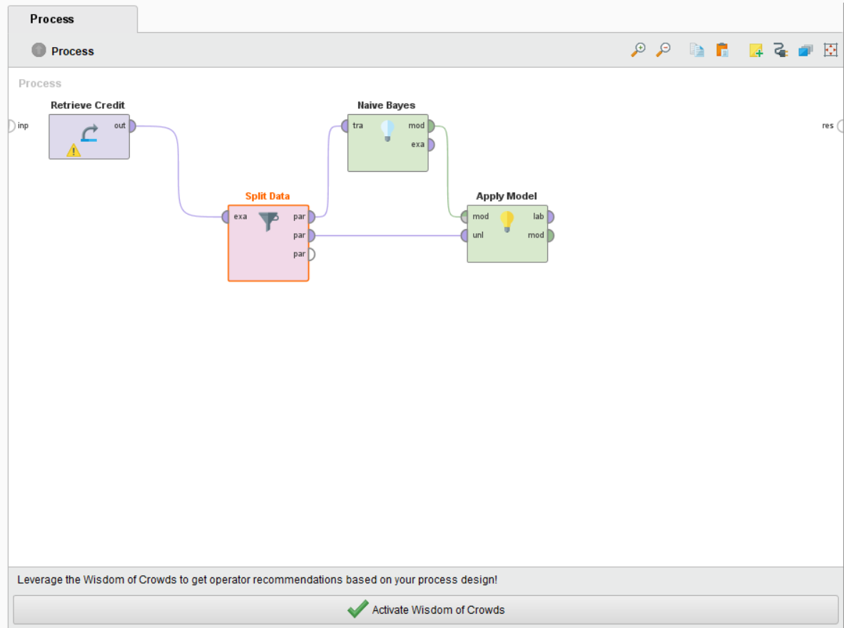

We can connect the outputs of the Apply Model to the final “res” connection. This will provide us with a result of the model. But to test accuracy RapidMiner needs a Performance operator.  
Search for Performance (there are many performance operators, we are looking for just “Performance”.  It may require scrolling to find when searching) and drag the model to the Processes.  
Connect the top “lab” output from Apply Model to the top “lab” input on Performance.  
Connect the “per” and “exa” outputs from Performance to the “res” connections.  
Connect the “mod” output from Apply Model to the “res” connection.

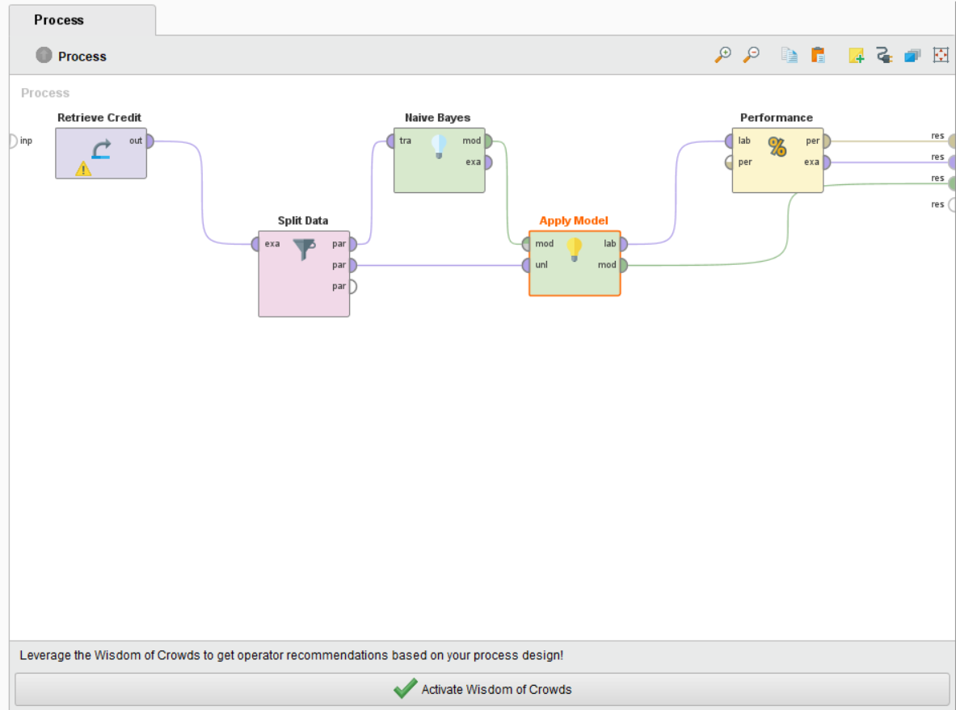

Now run,

**FOR ETHNICITY CLASSIFICATION:**

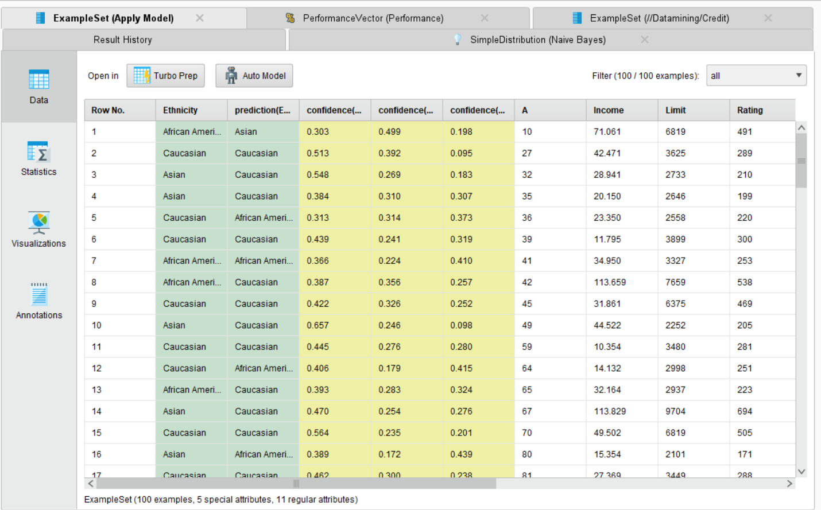

**STATISTICS:**

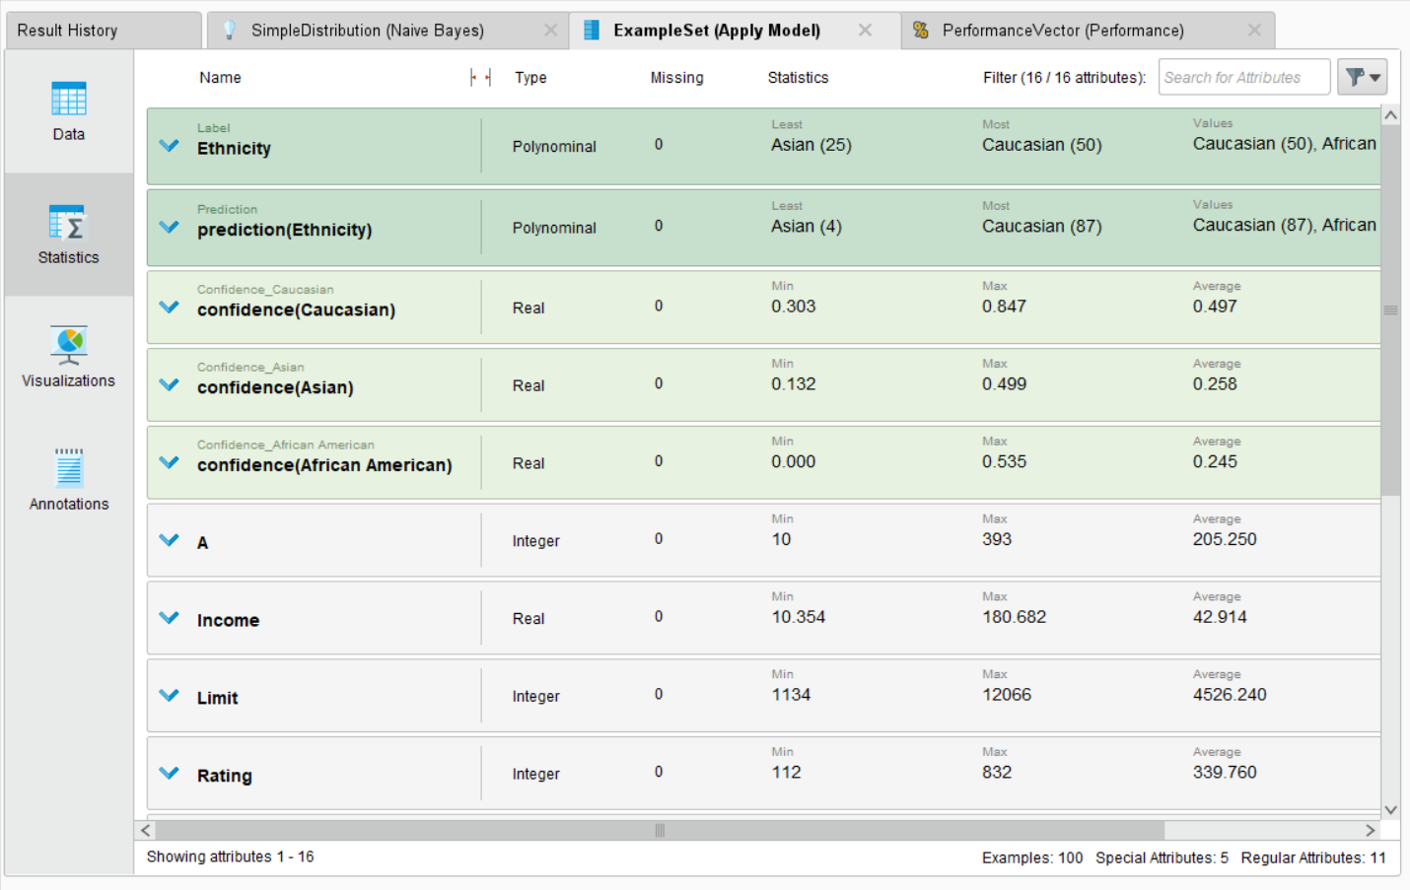

**VISUALIZATION:**

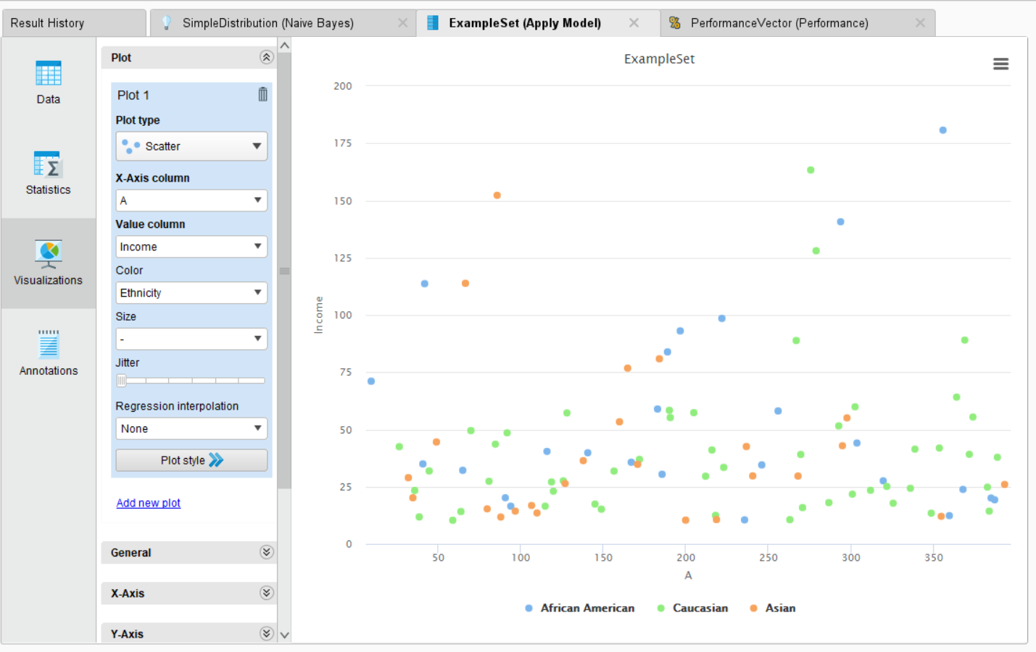

**CONFUSION MATRIX:**

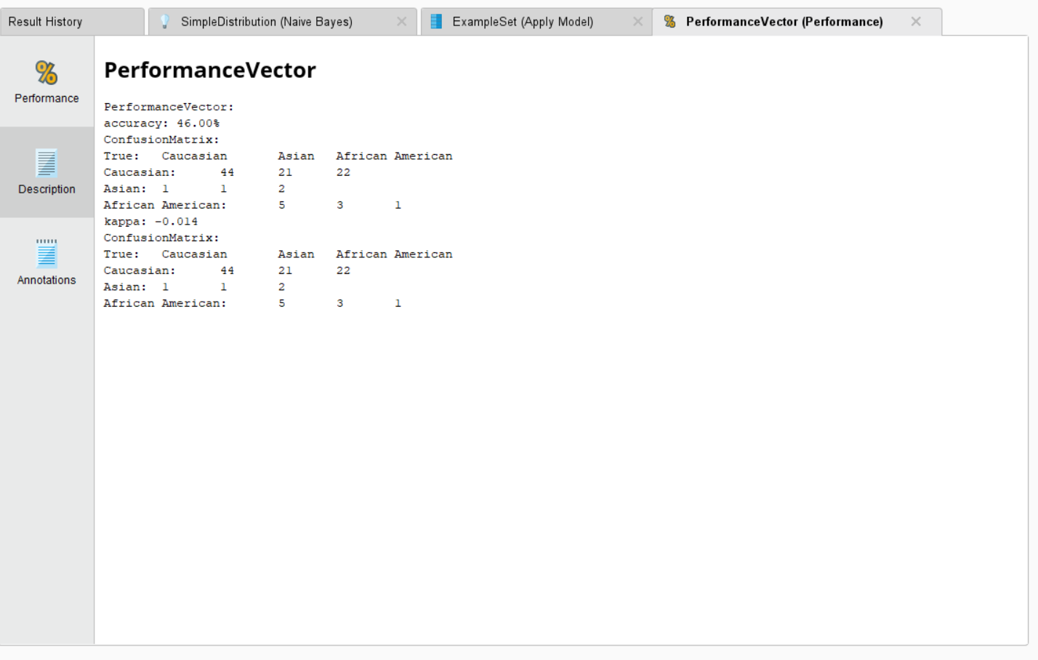

**ACCURACY:**

**TABLE VIEW:**

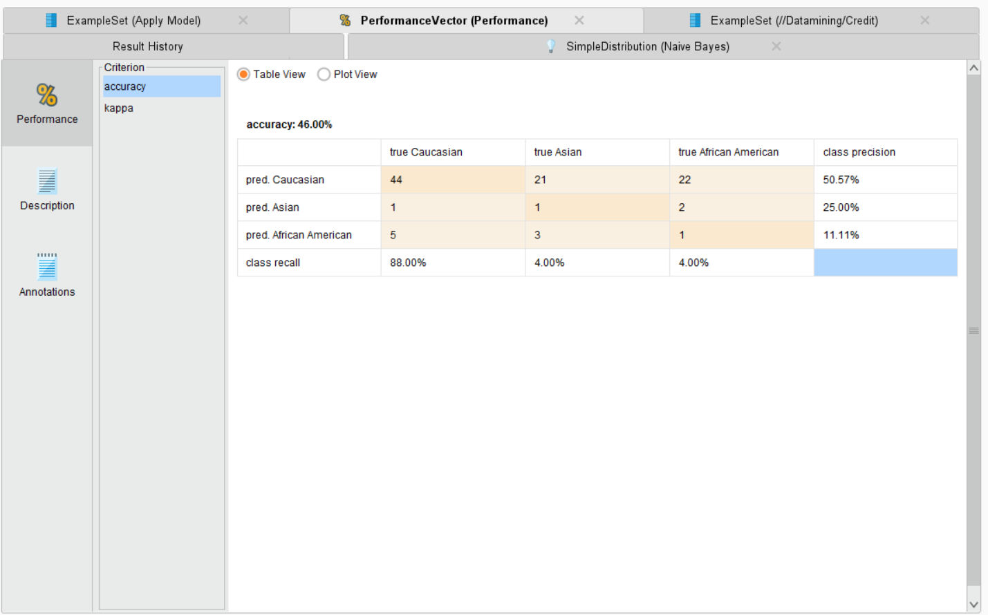

**PLOT VIEW:**

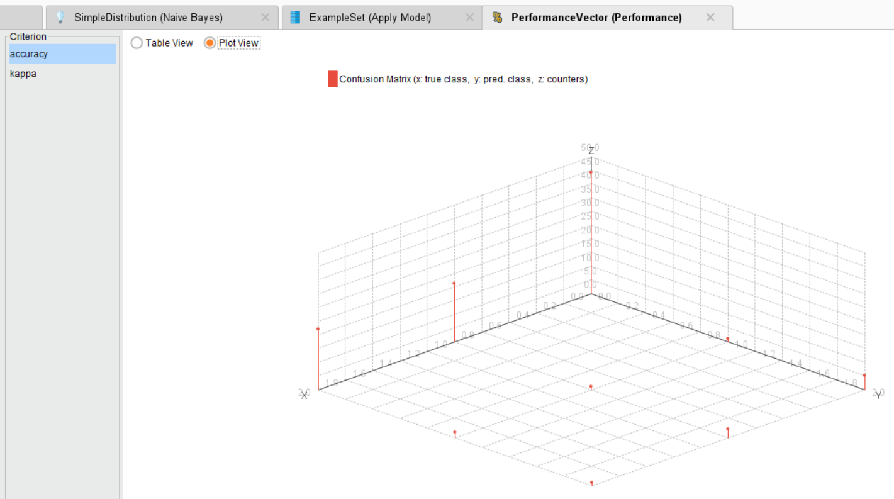

**KAPPA:**

**TABLE VIEW:**

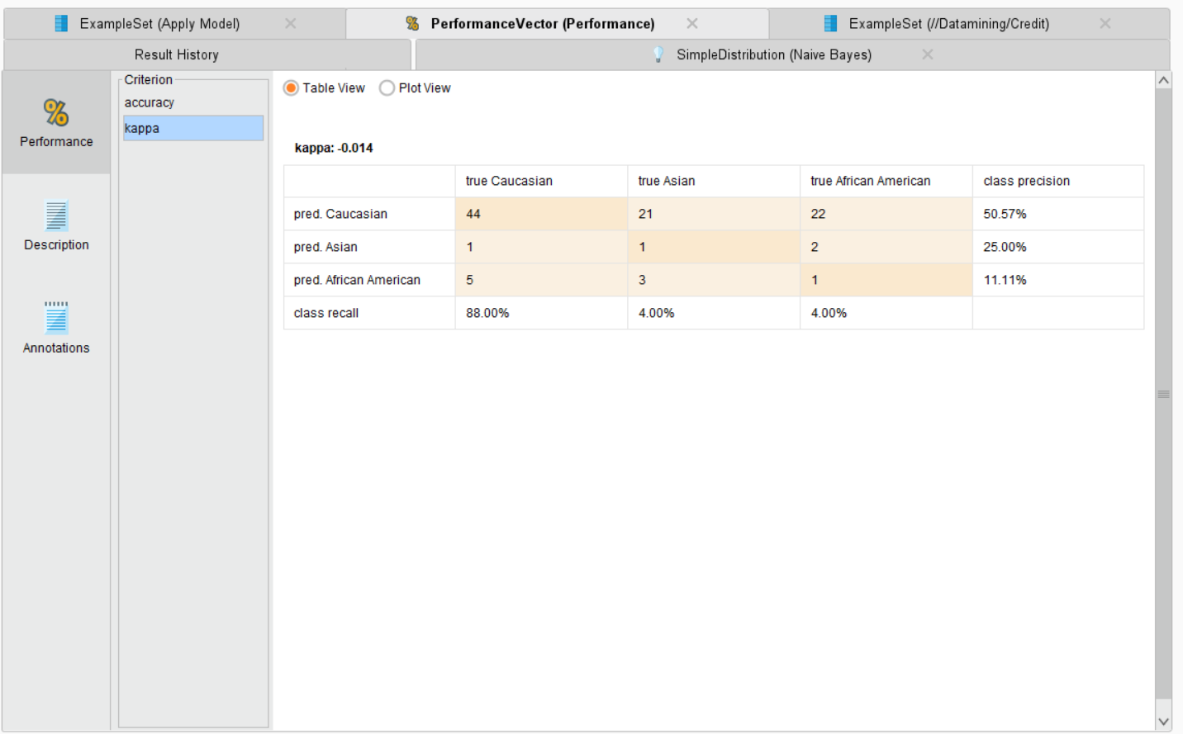

**PLOT VIEW:**

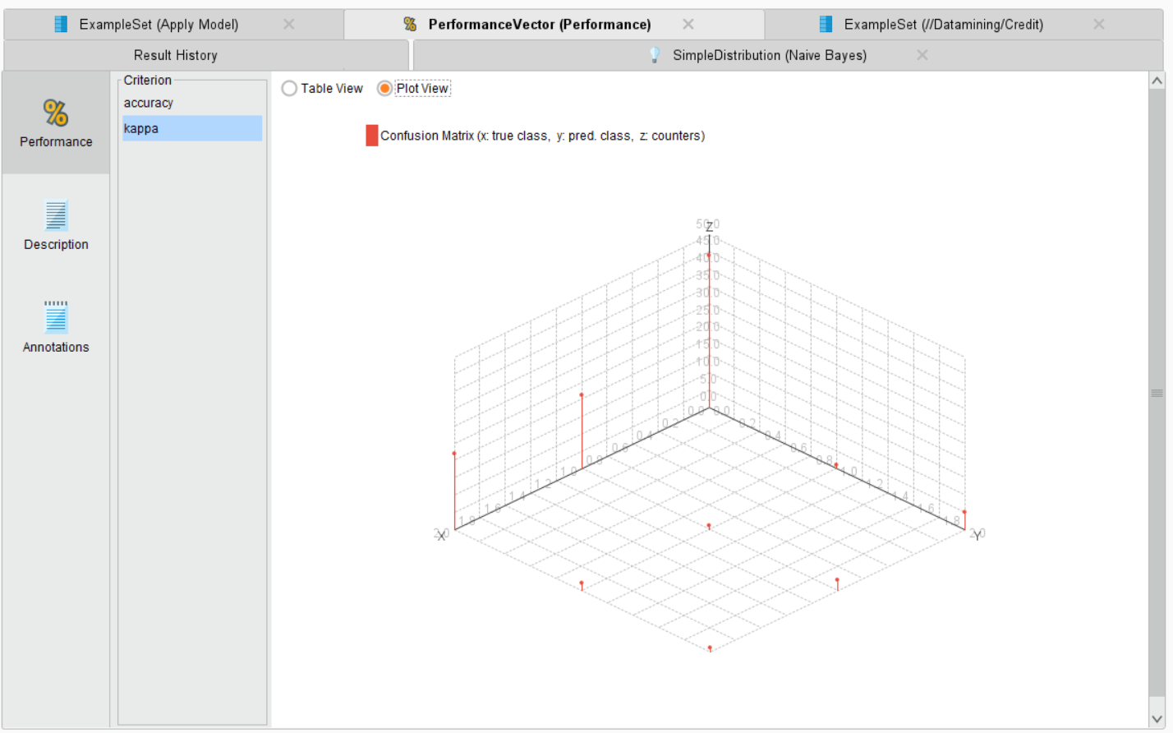

**SIMPLE DISTRIBUTION**

**DESCRIPTION:**

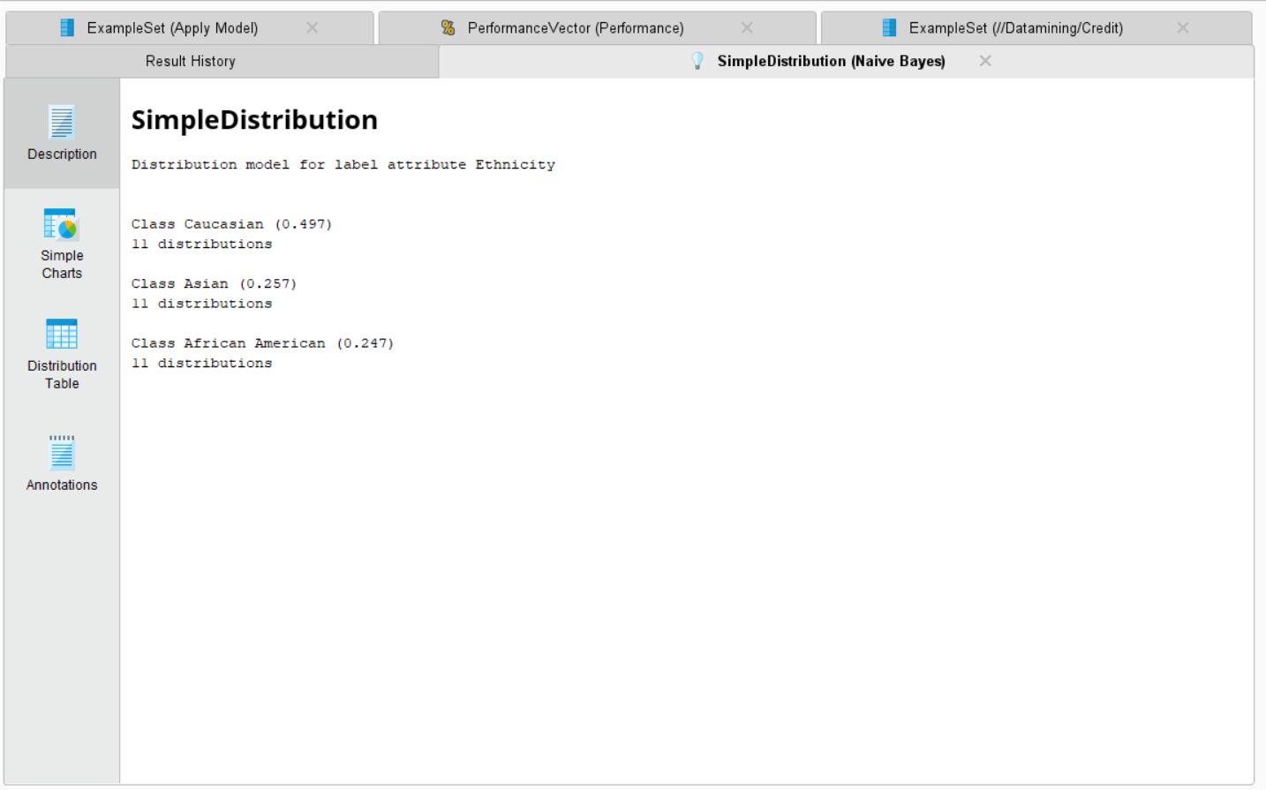

**SIMPLE CHARTS:**

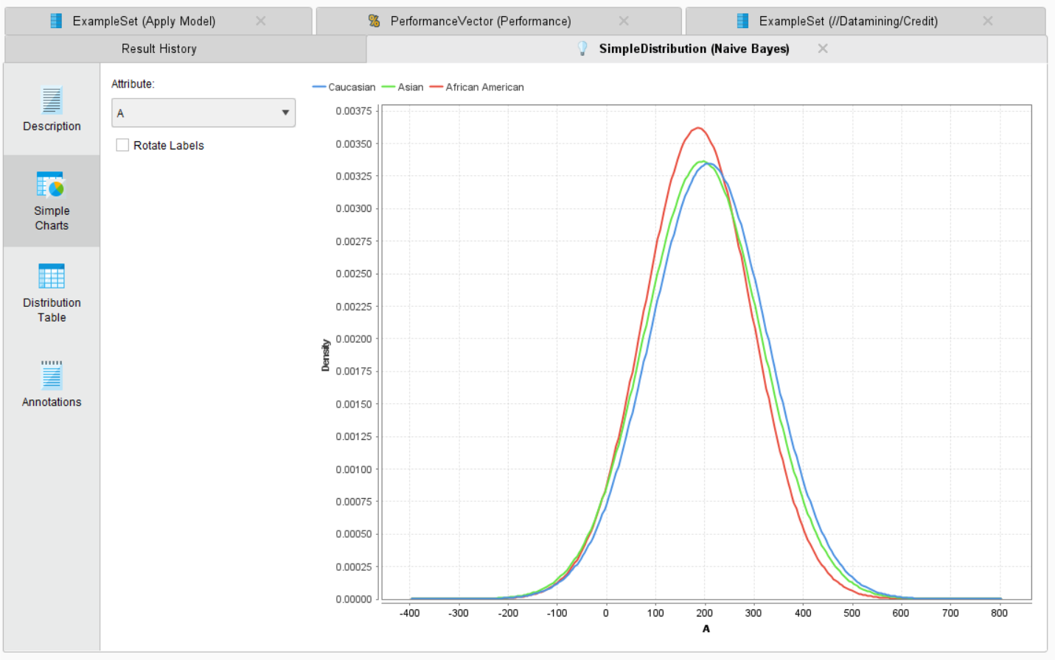

**DISTRIBUTION TABLE:**

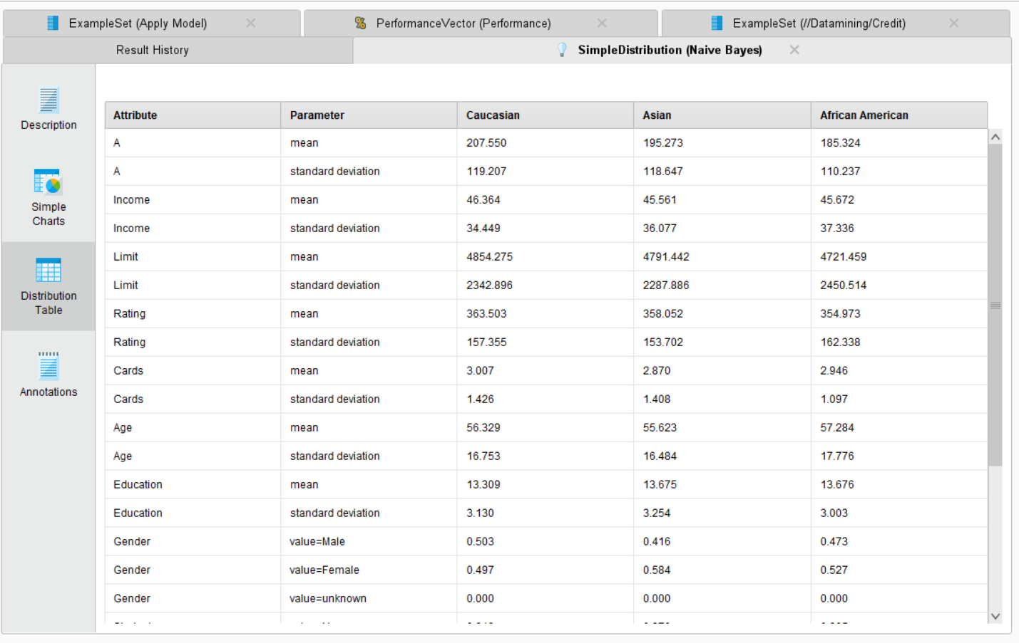

**FOR GENDER CLASSIFICATION:**

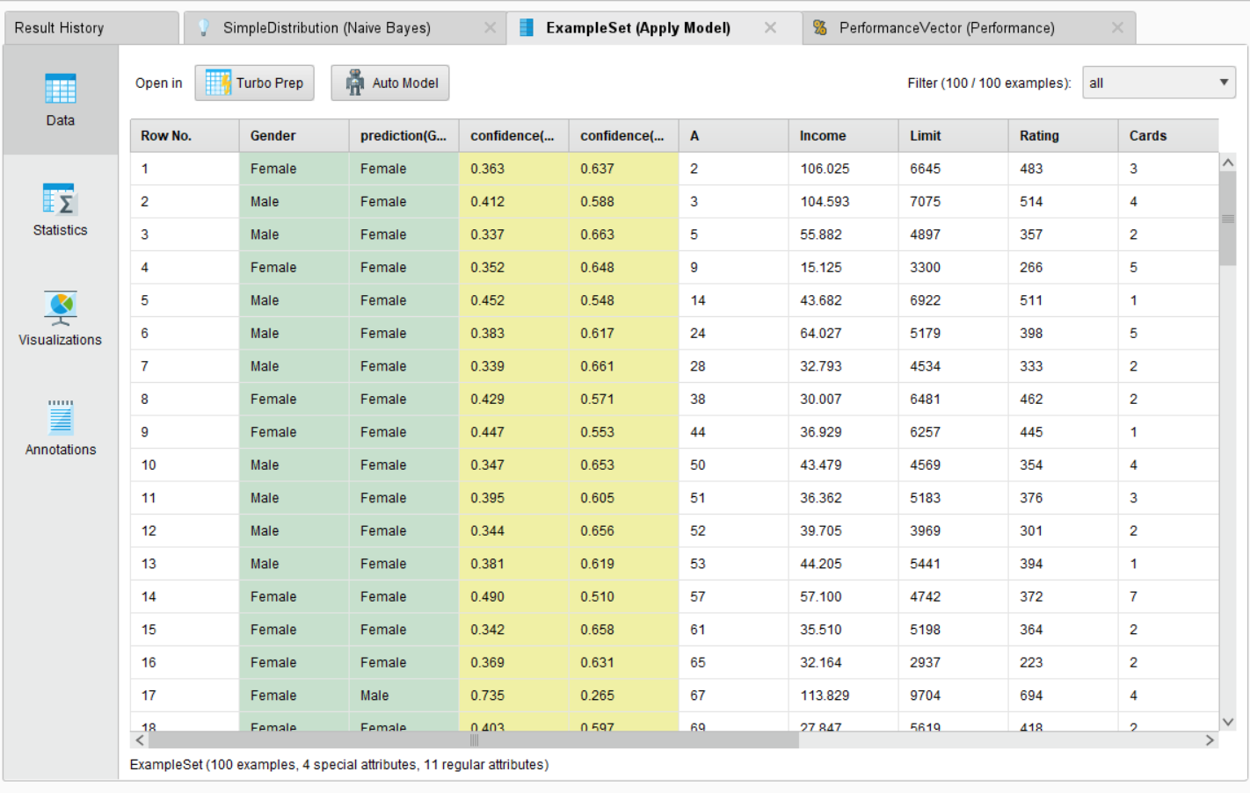

**STATISTICS:**

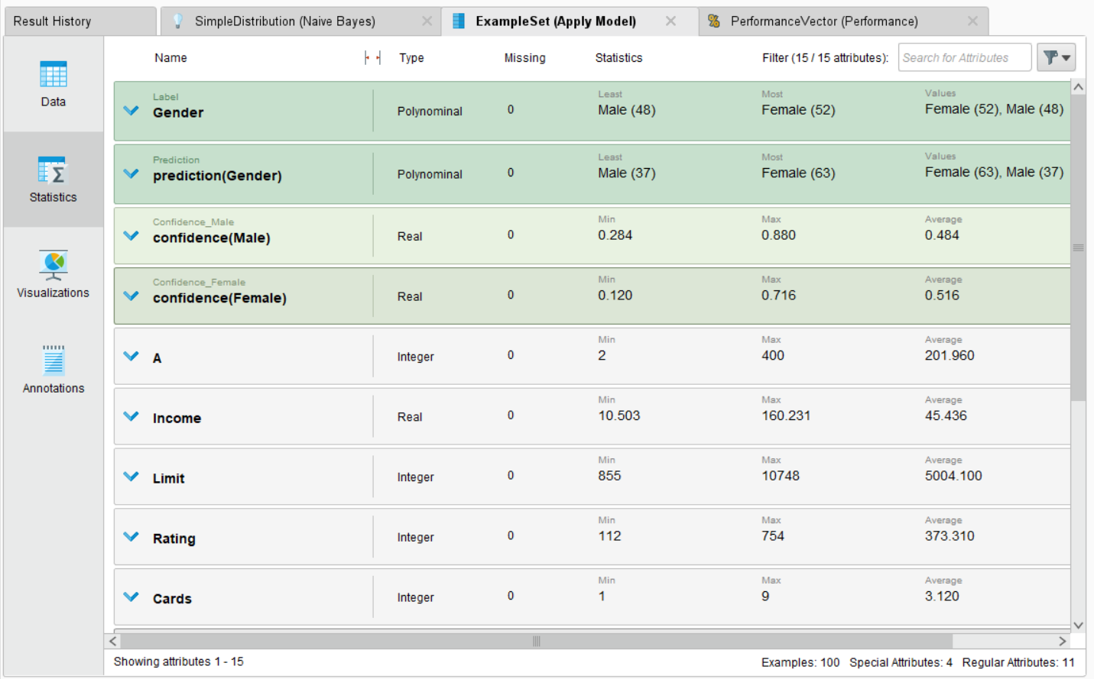

**VISUALIZATIONS:**

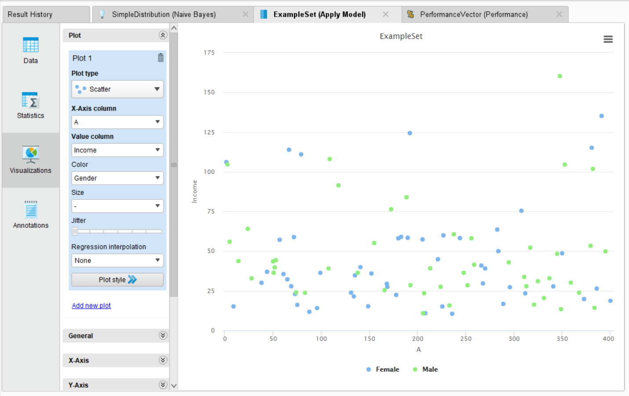

**SIMPLE DISTRIBUTION:**

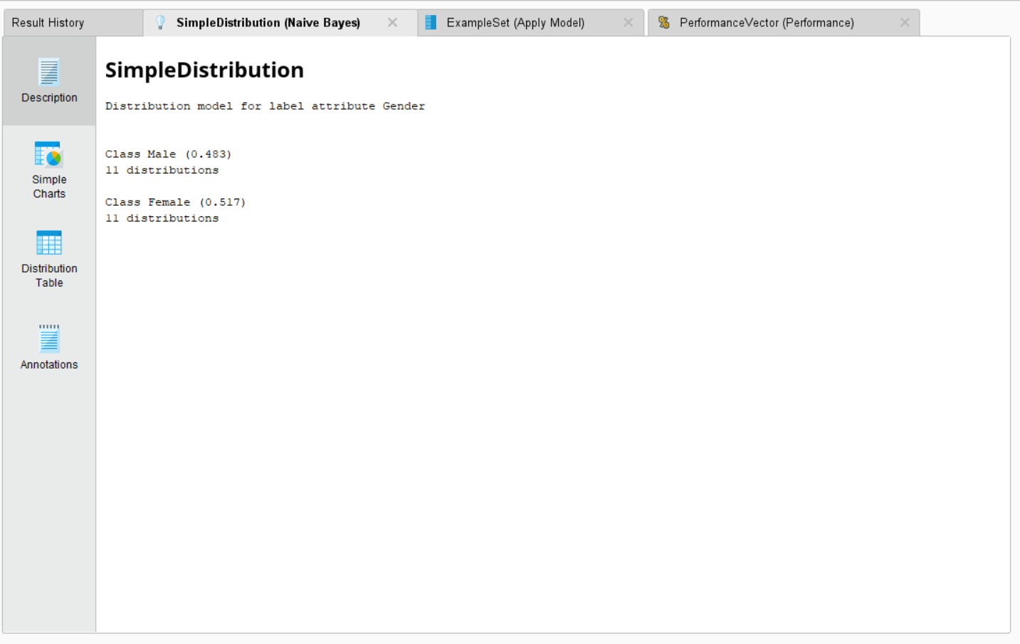

**SIMPLE CHARTS:**

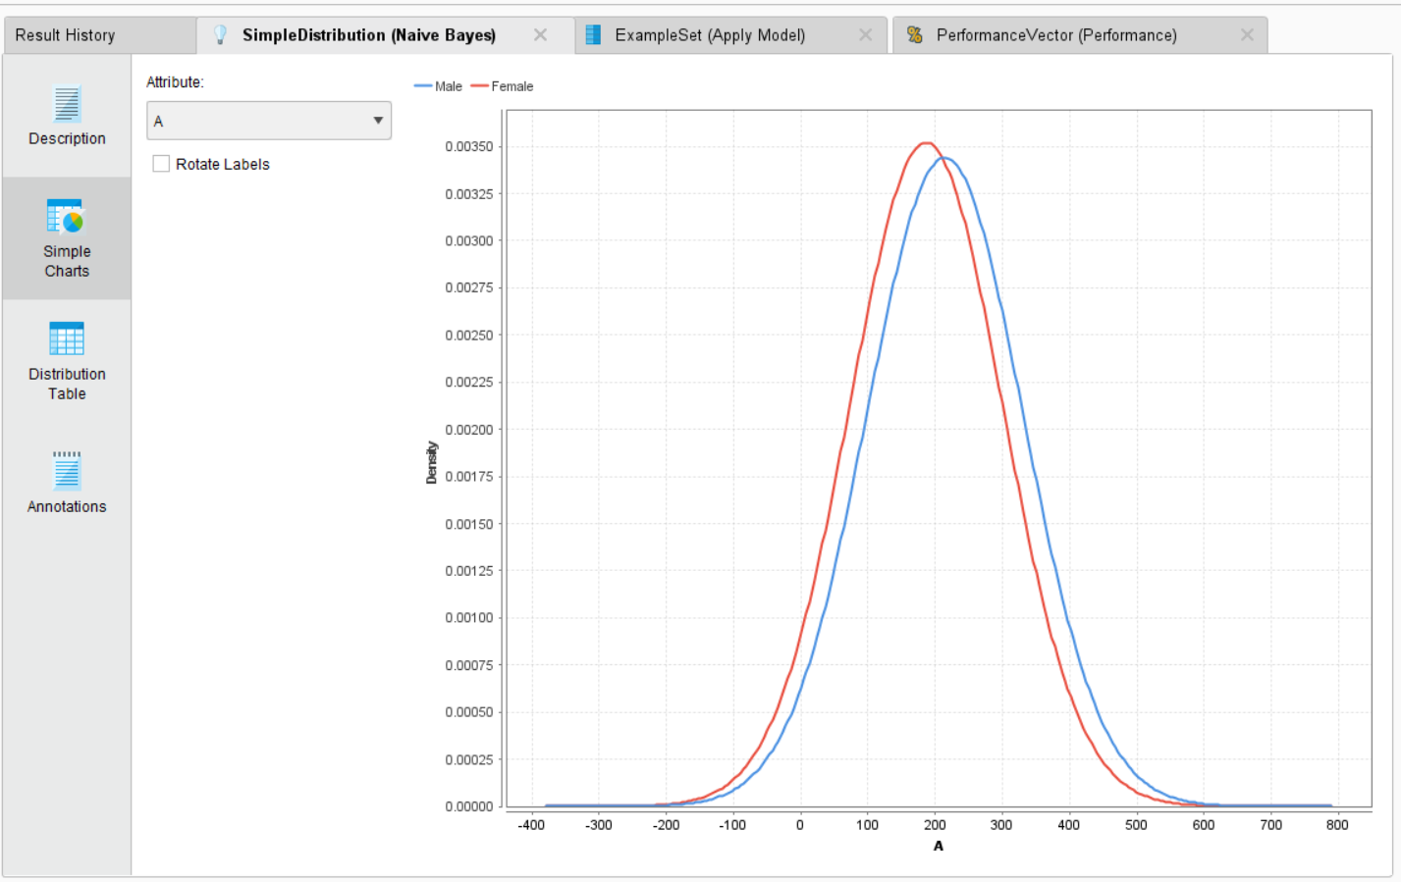

**DISTRIBUTION TABLE:**

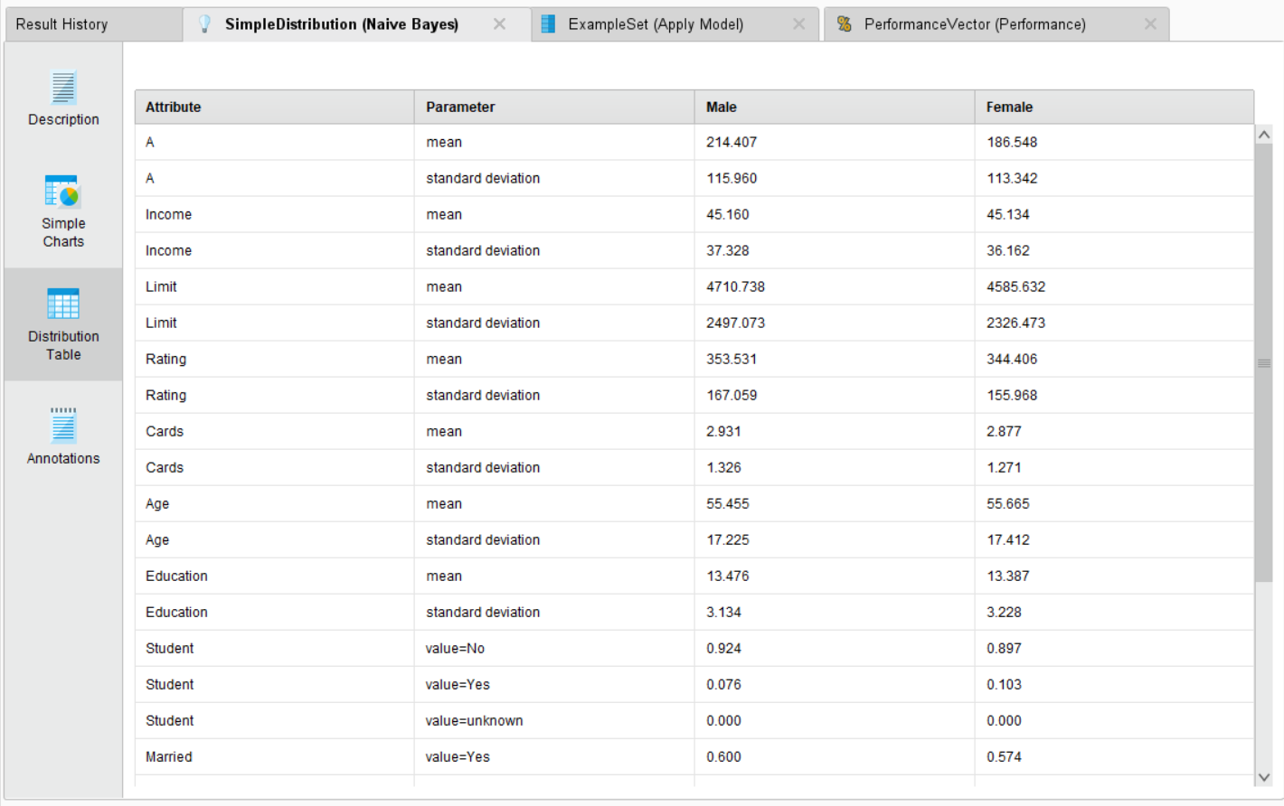

**PERFORMANCE VECTOR:**

**ACCURACY:**

**TABLE VIEW:**

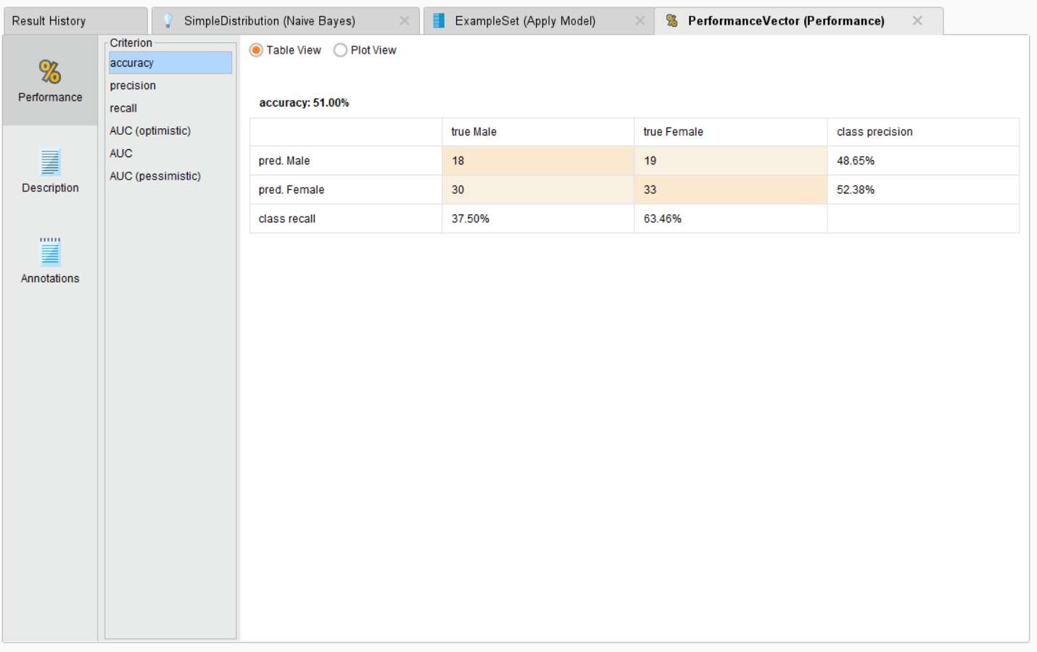

**PLOT VIEW:**

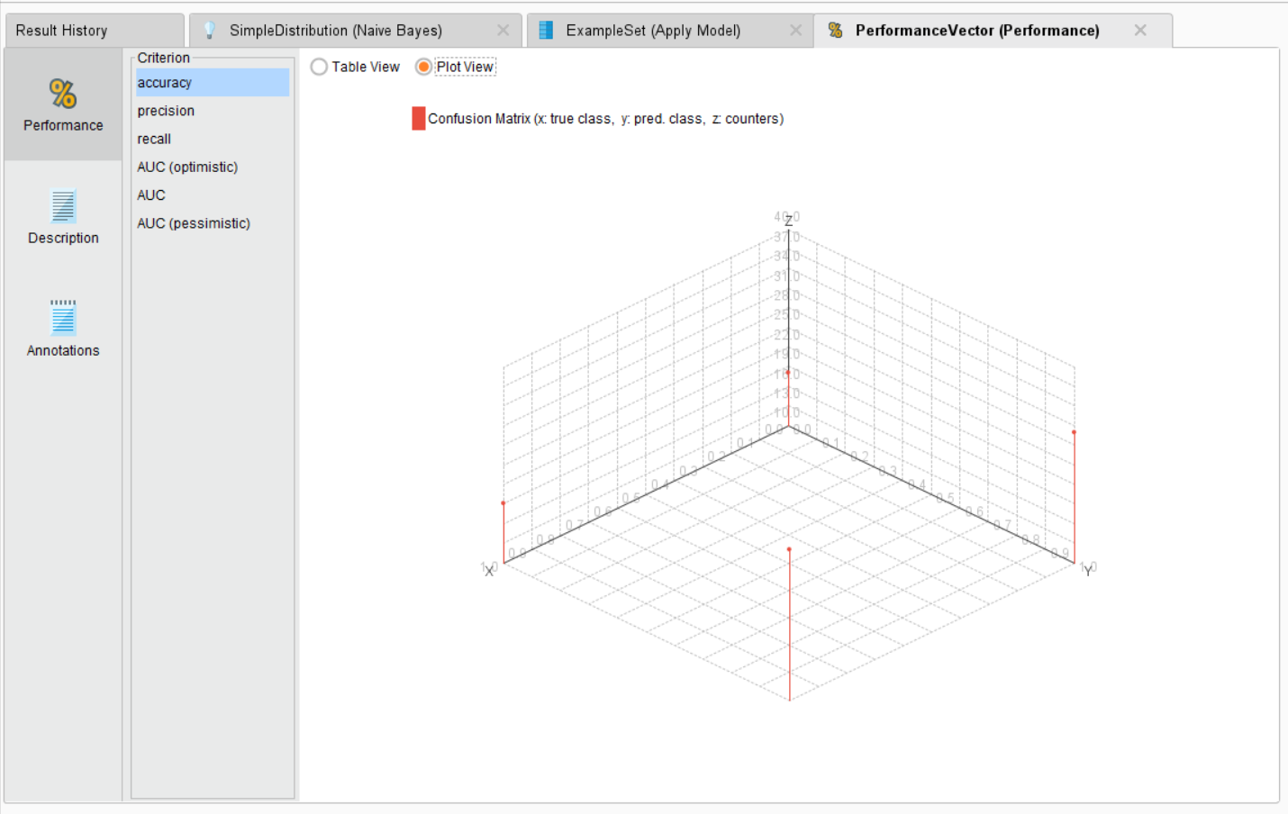

**PRECISION:**

**TABLE VIEW:**

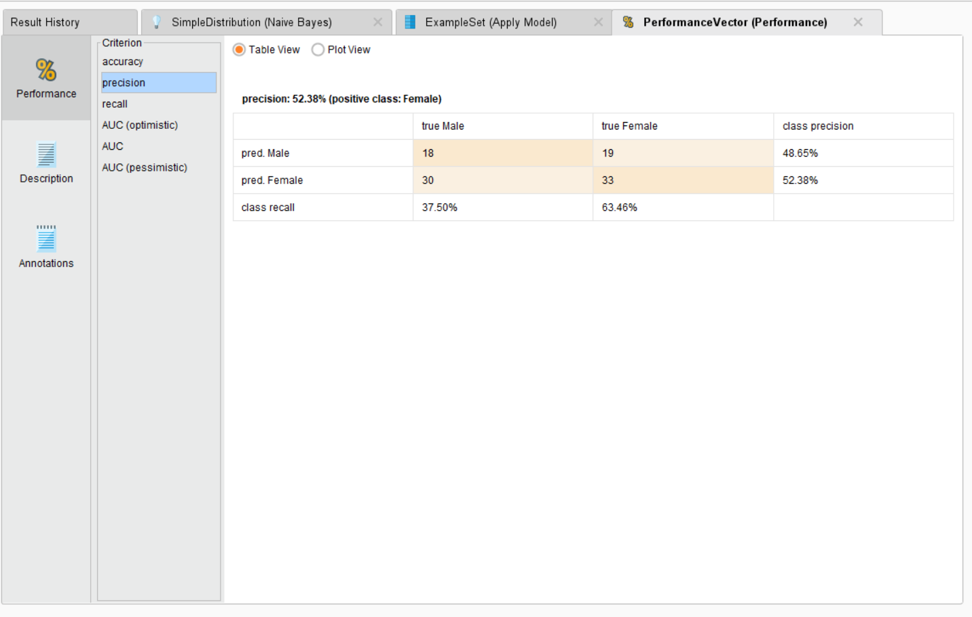

**PLOT VIEW:**

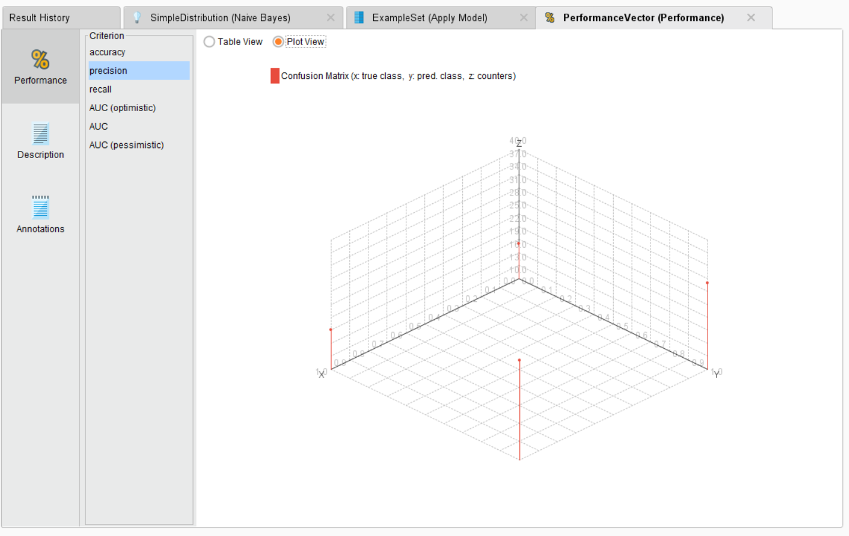

**RECALL:**

**TABLE VIEW:**

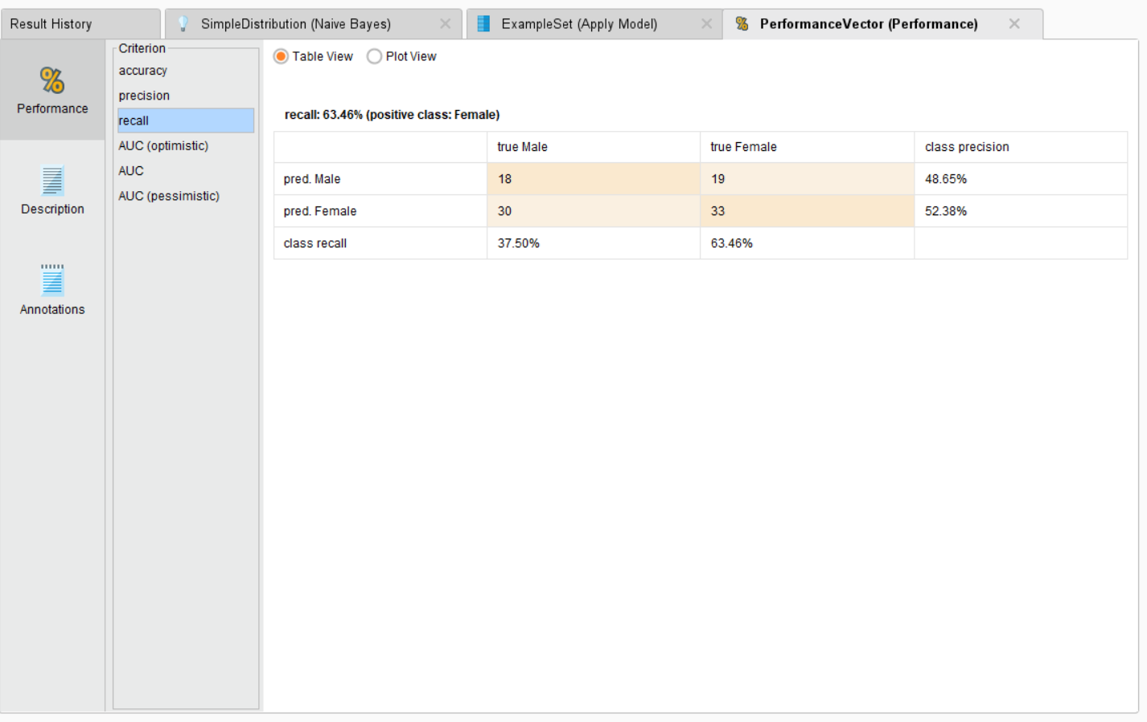

**PLOT VIEW:**

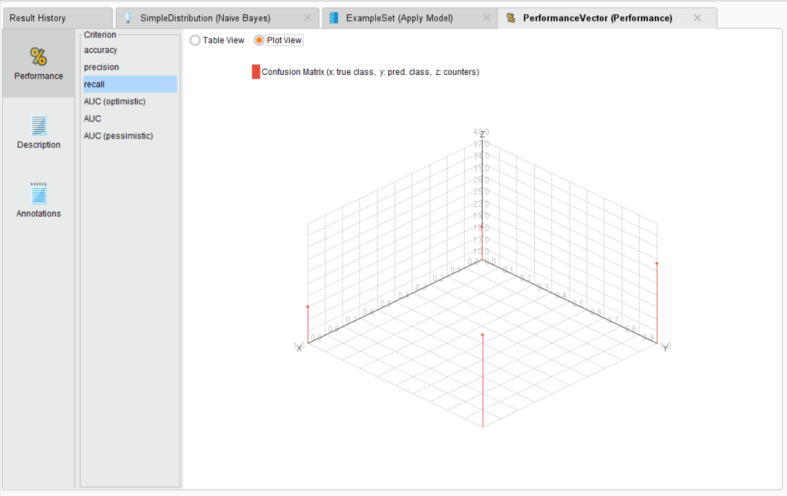

**AUC(OPTIMISTIC):**

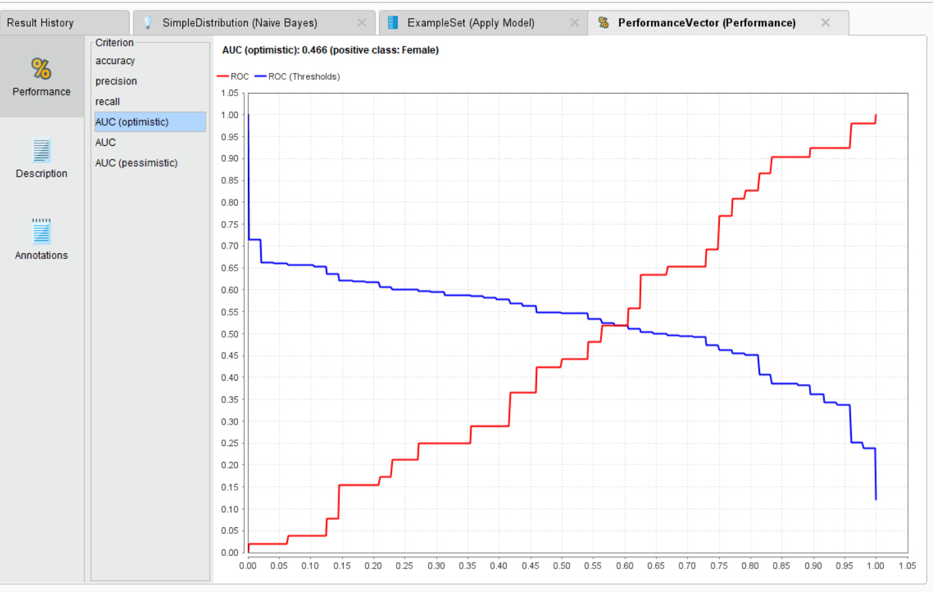

**AUC:**

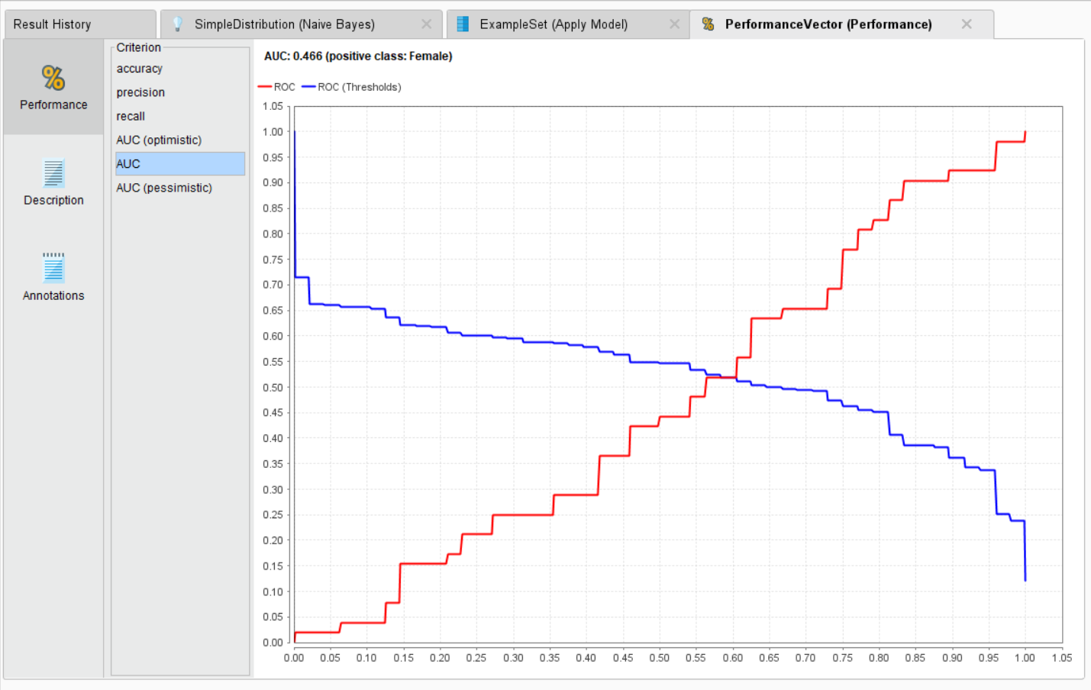

**AUC(PESSIMISTIC):**

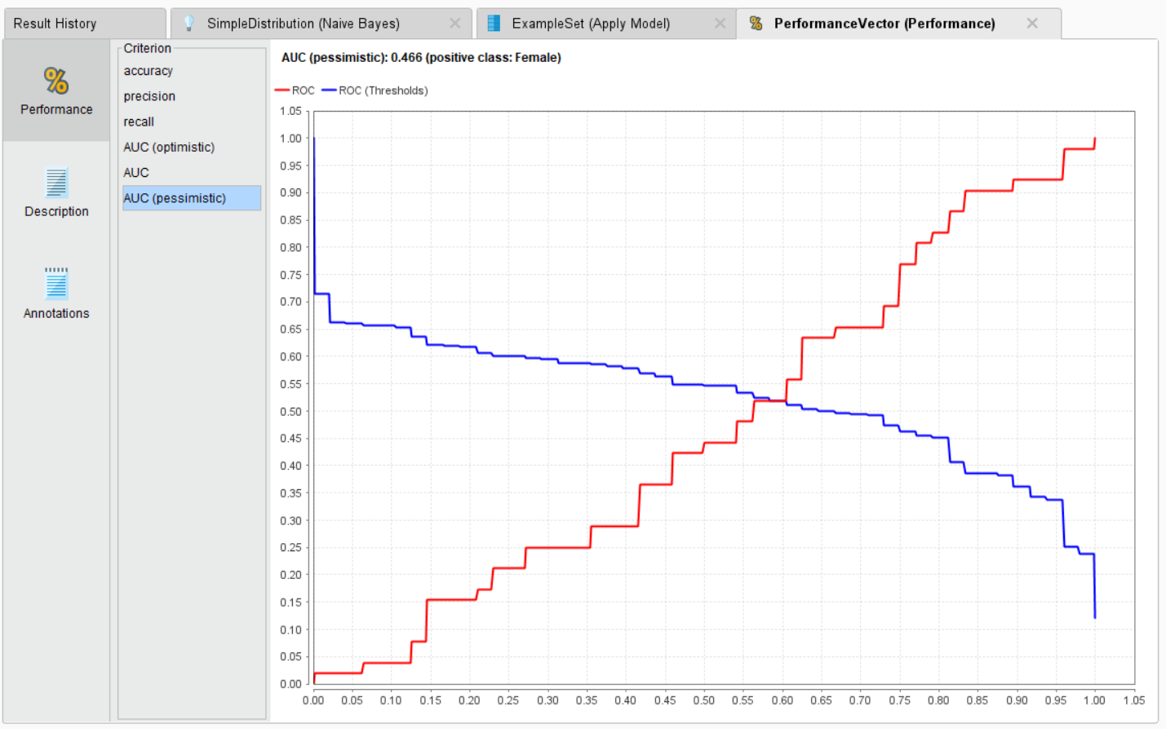

**DESCRIPTION:**

**CONFUSION MATRIX:**

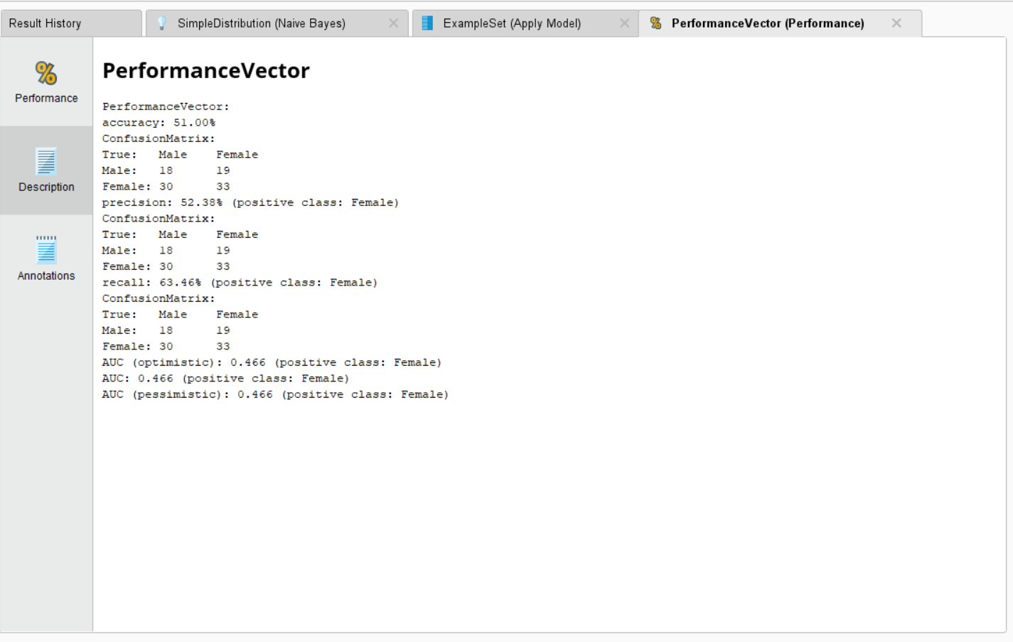

**2)KNN CLASSIFICATION:**

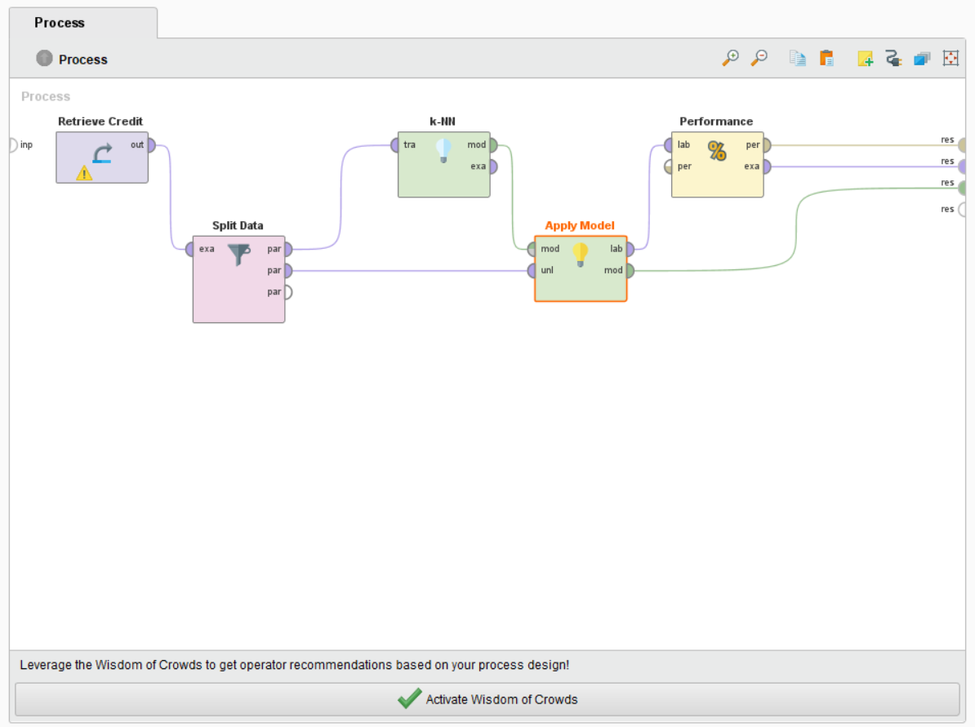

**FOR ETHNICITY CLASSIFICATION:**

**DESCRIPTION:**

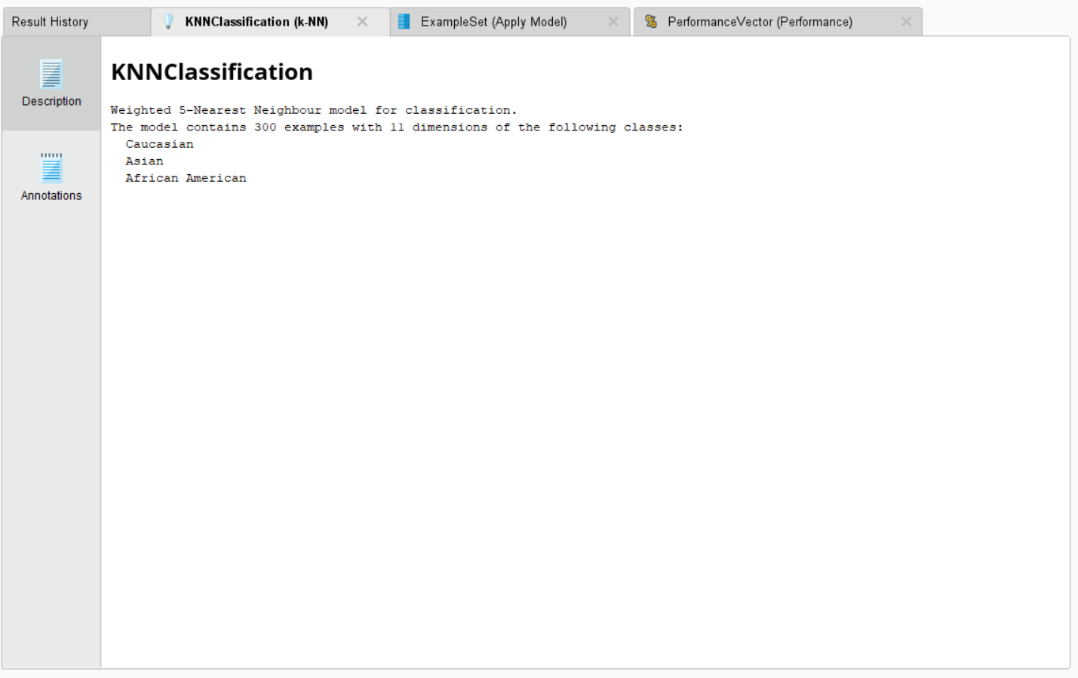

**DATA:**

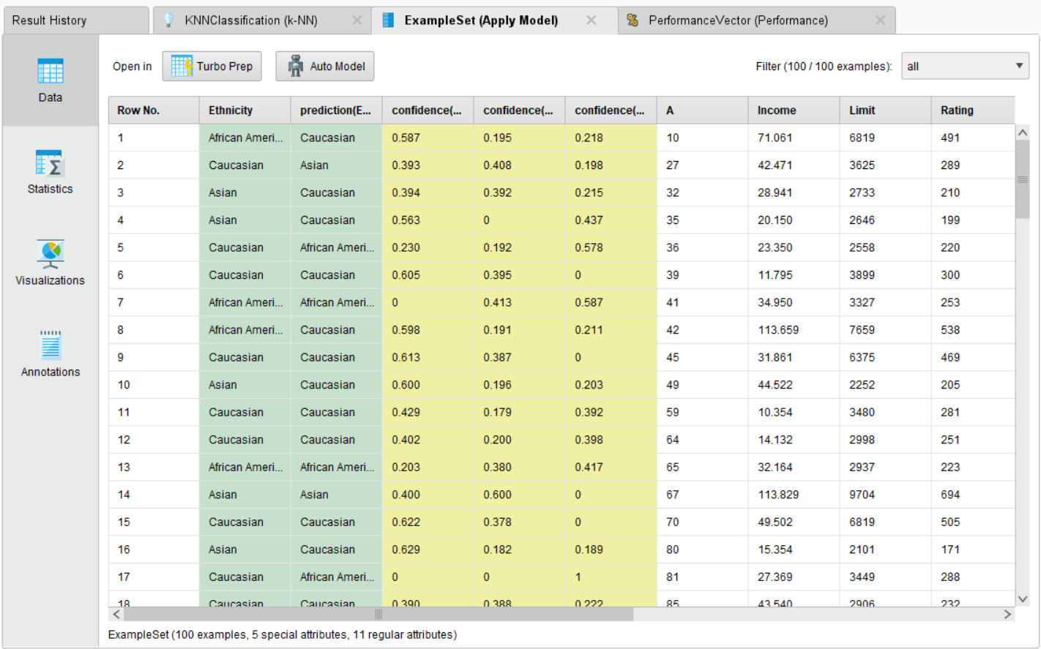

**STATISTICS:**

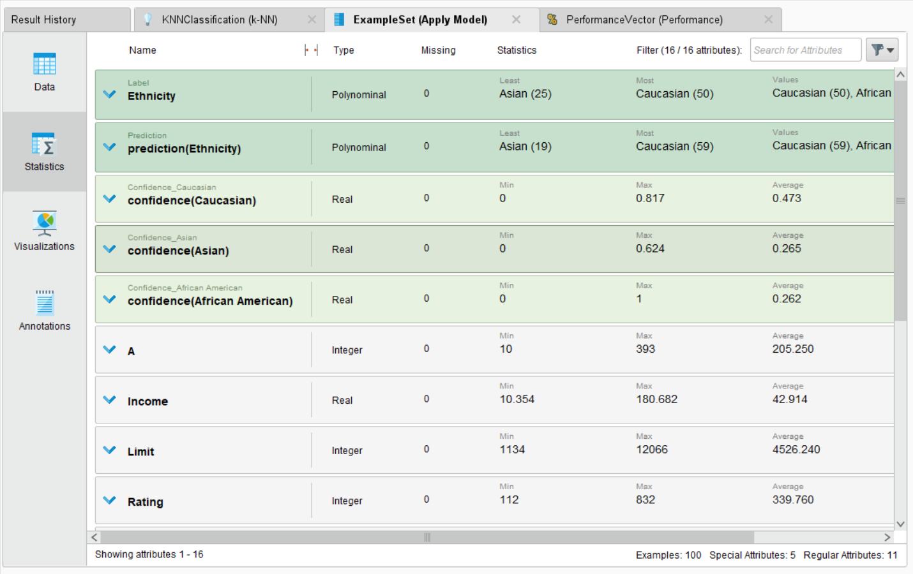

**VISUALIZATIONS:**

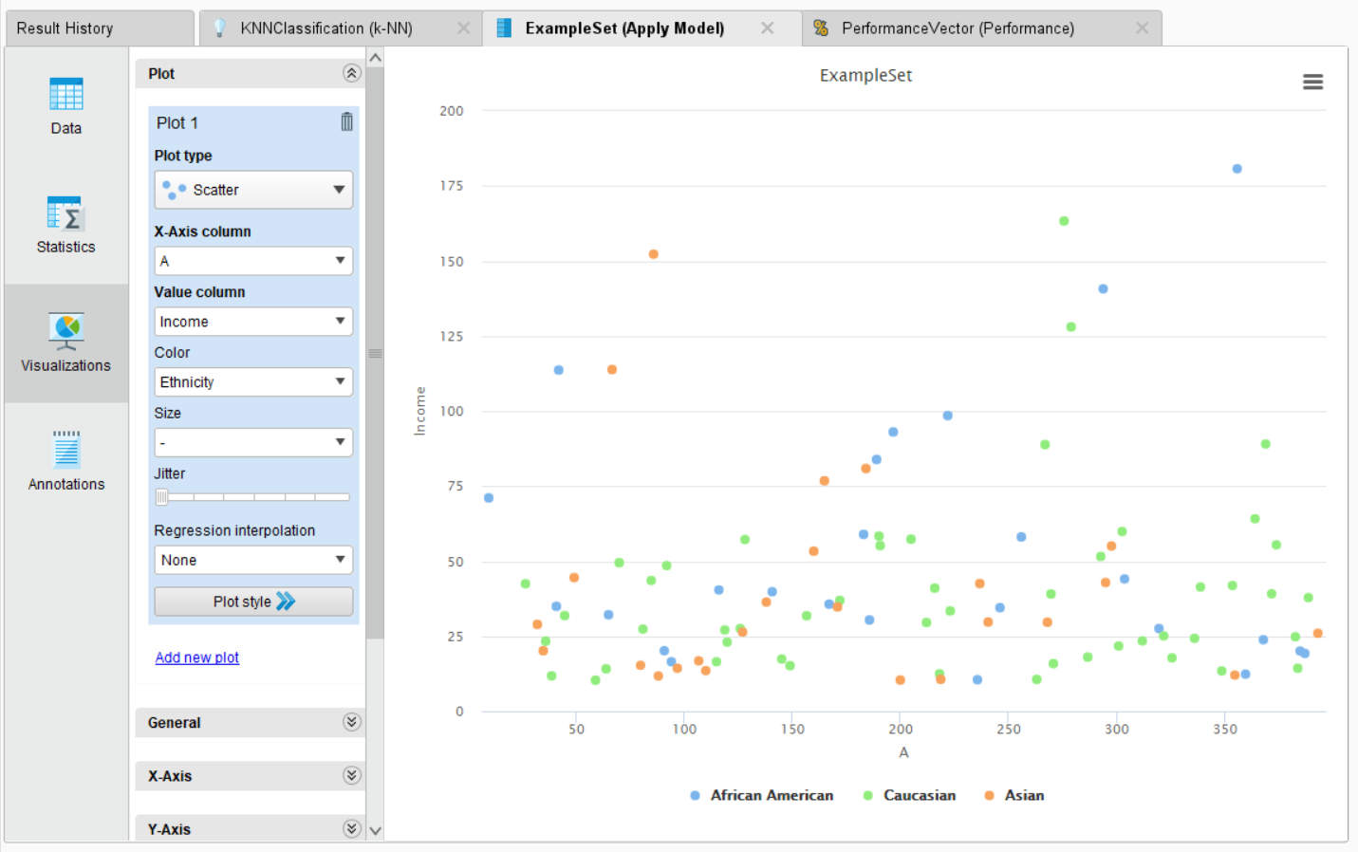

**PERFORMANCE VECTOR:**

**ACCURACY:**

**TABLE VIEW:**

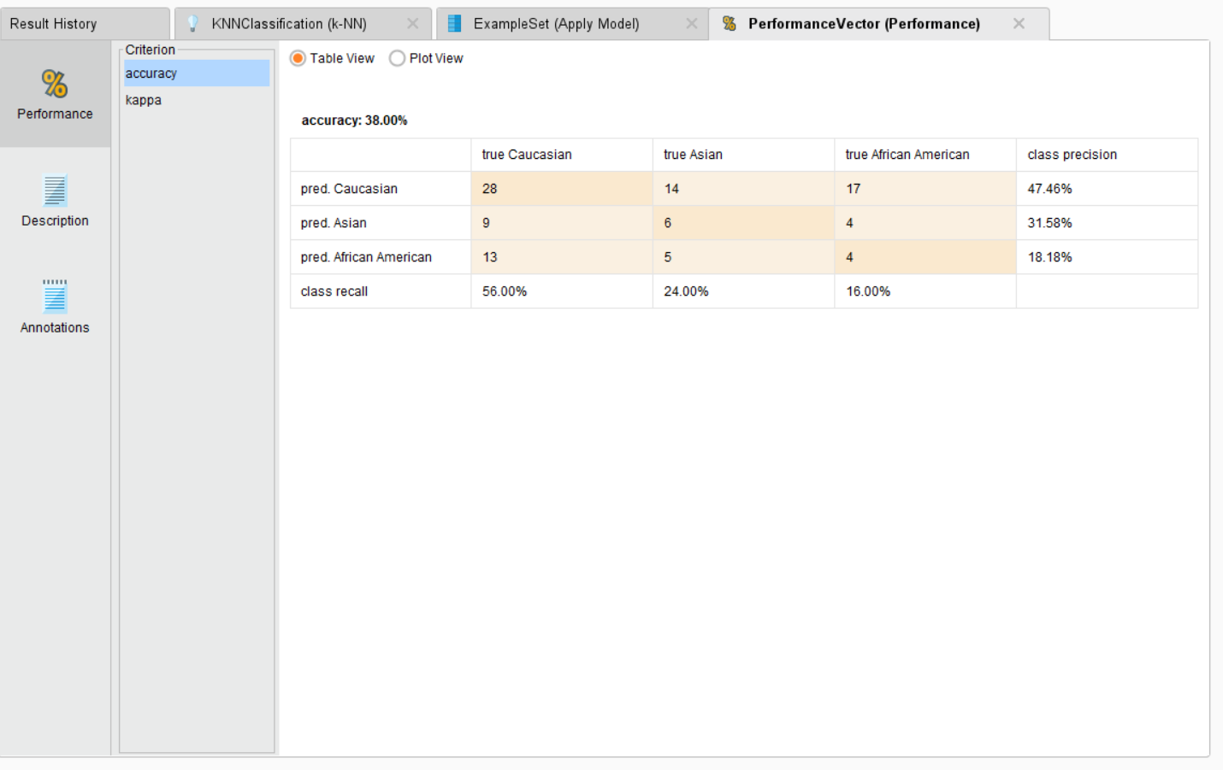

**PLOT VIEW:**

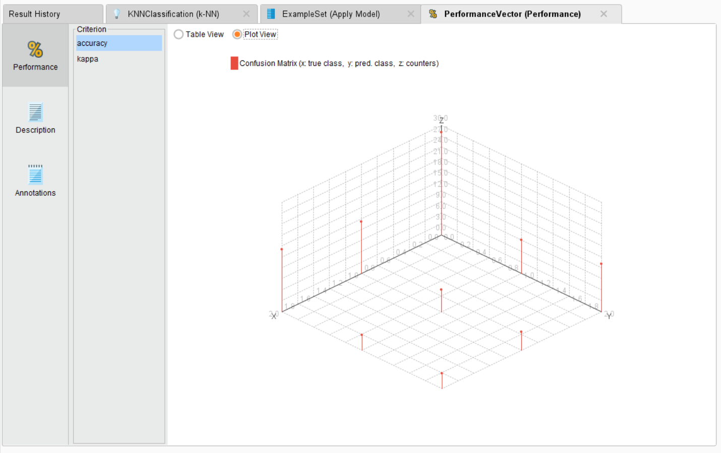

**KAPPA:**

**TABLE VIEW:**

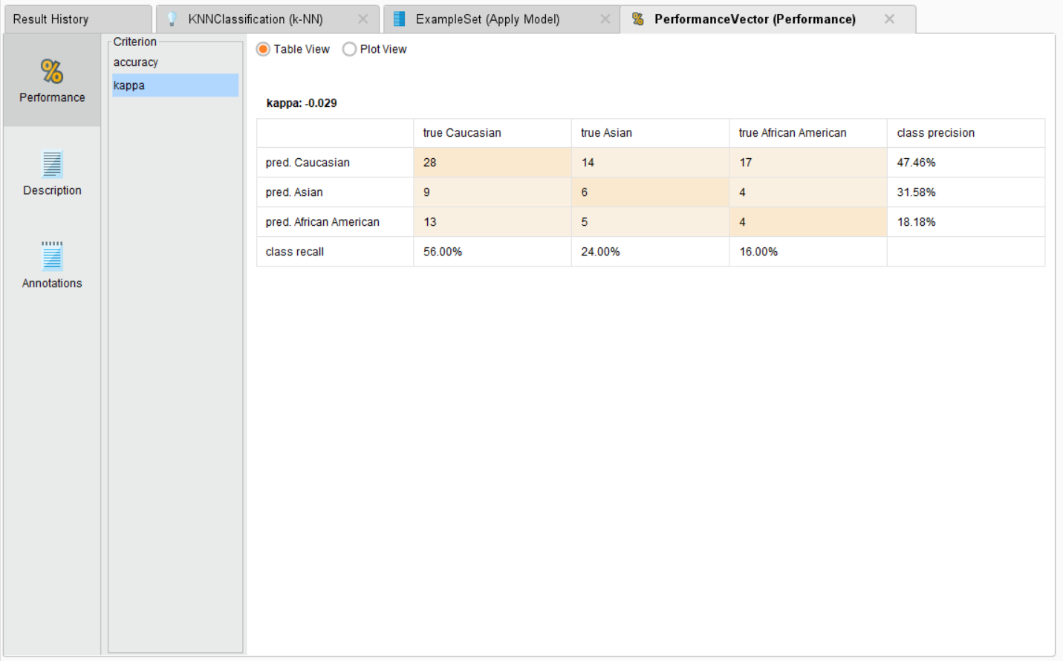

**PLOT VIEW:**

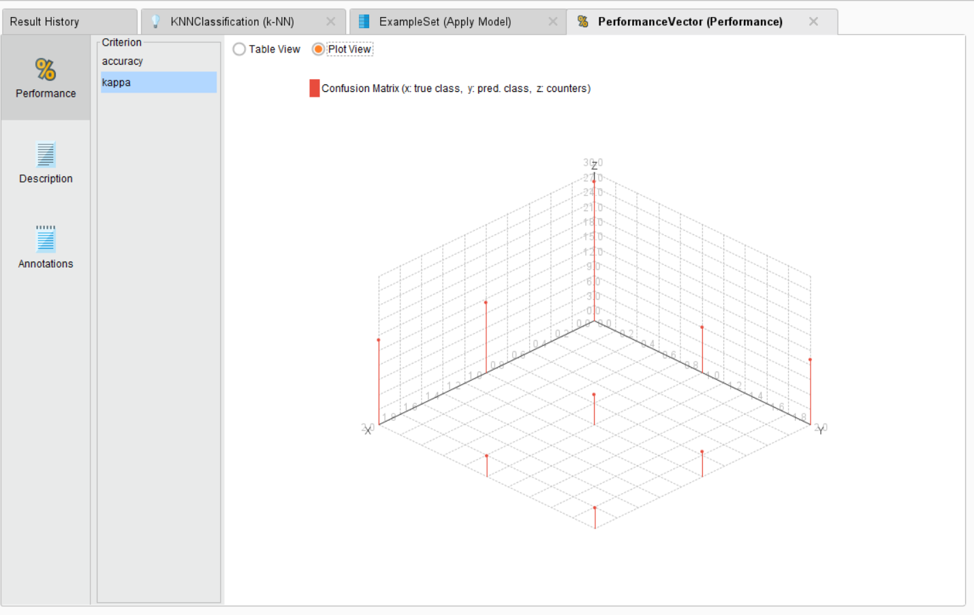

**CONFUSION MATRIX:**

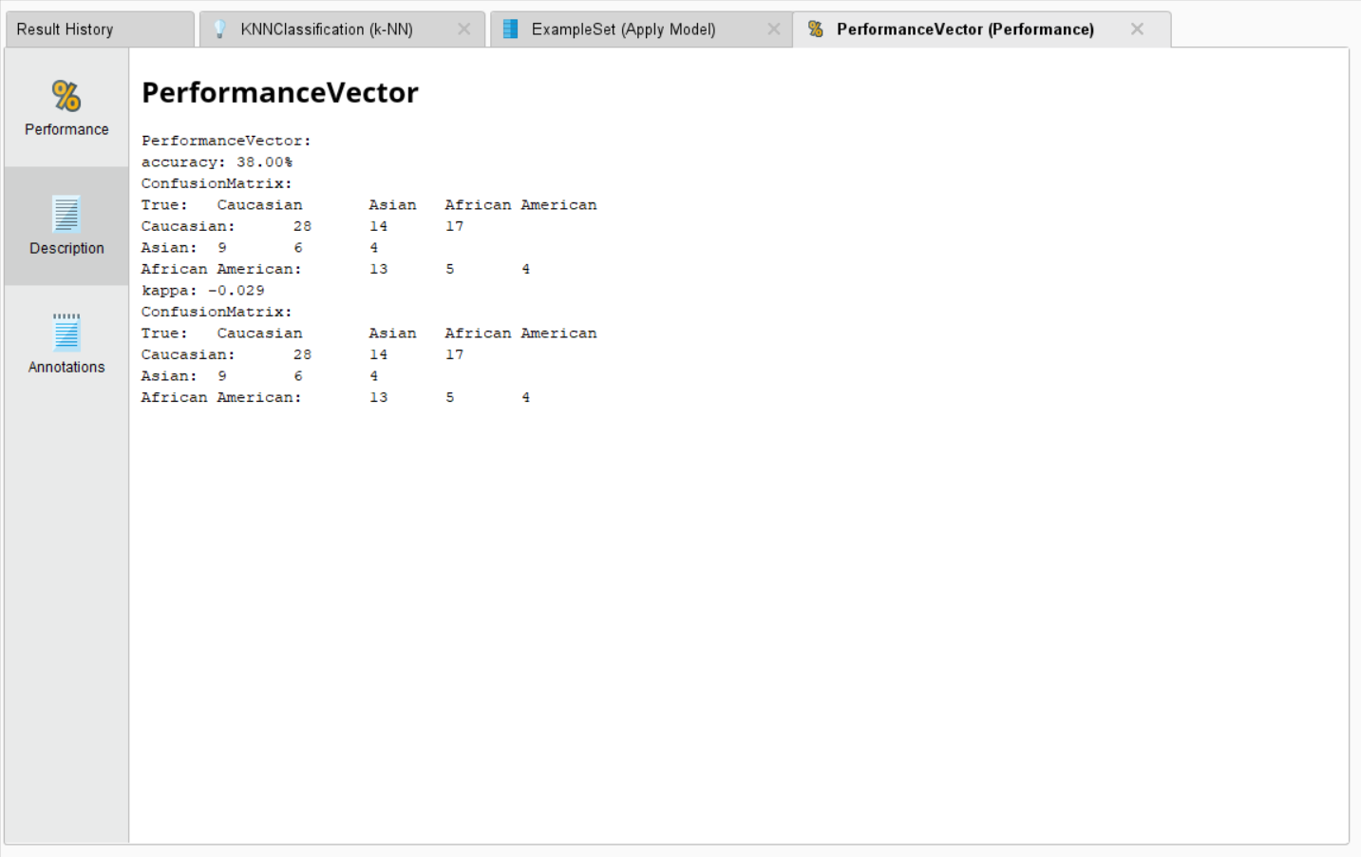

**FOR GENDER CLASSIFICATION:**

**DESCRIPTION:**

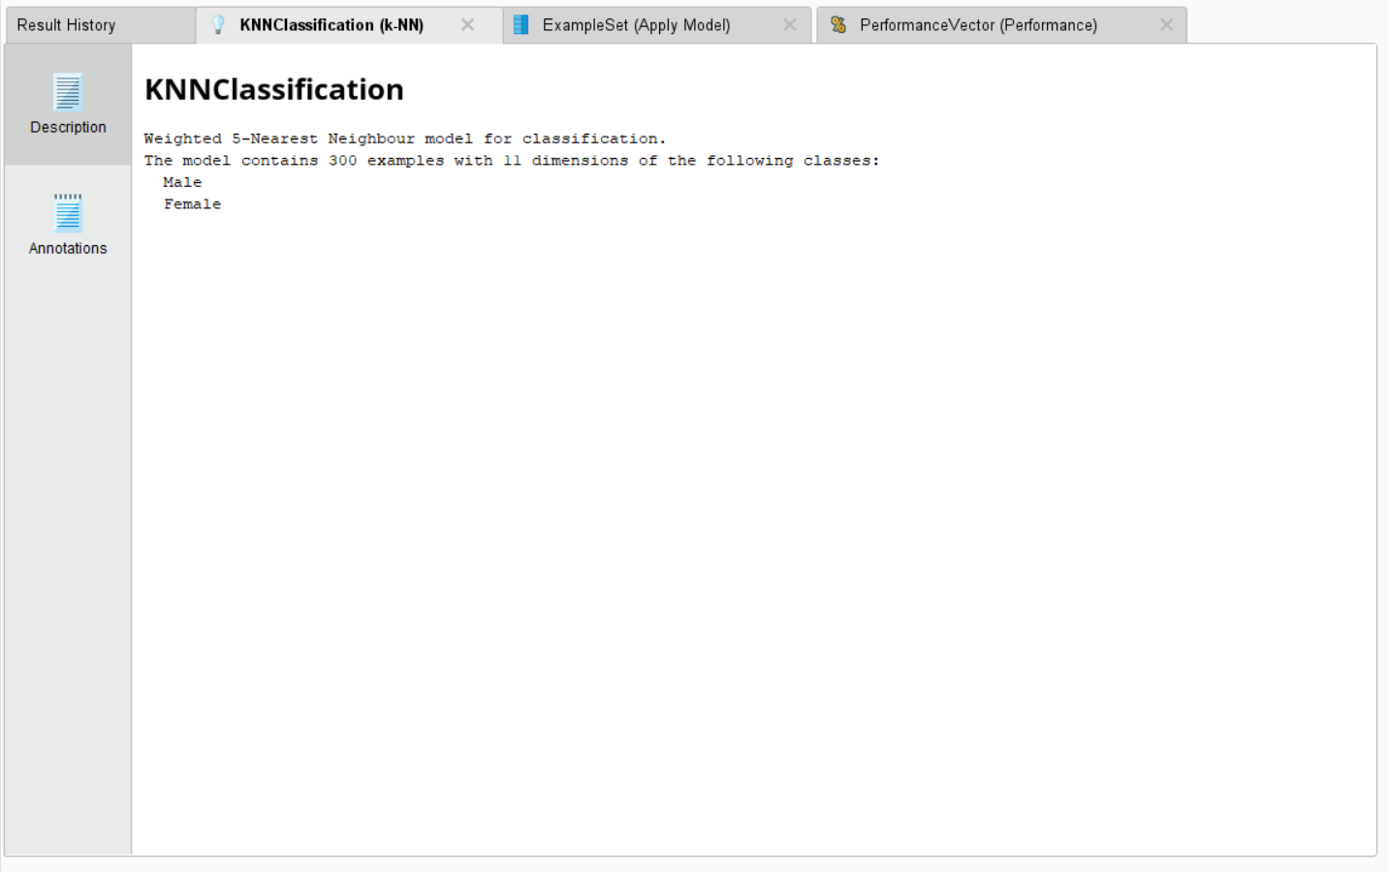

**DATA:**

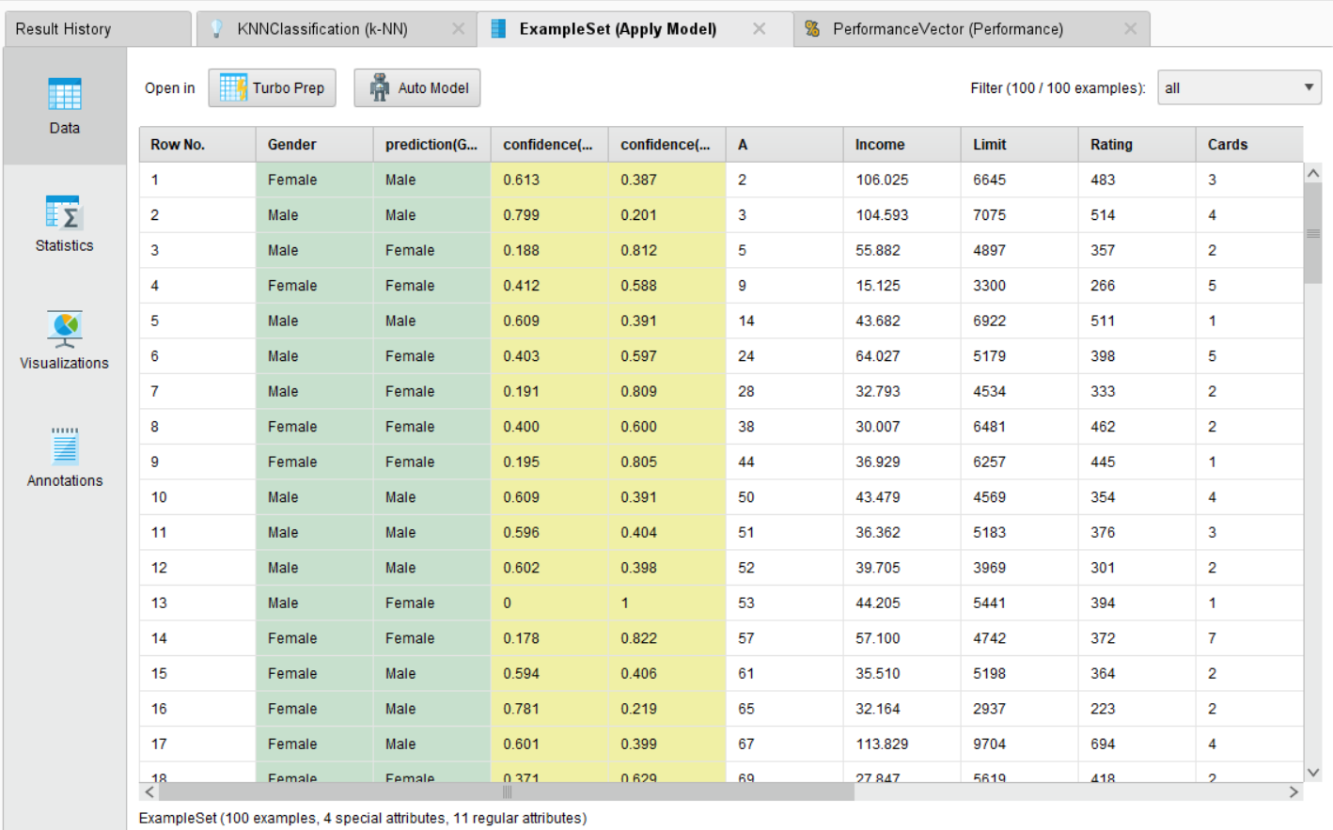

**STATISTICS:**

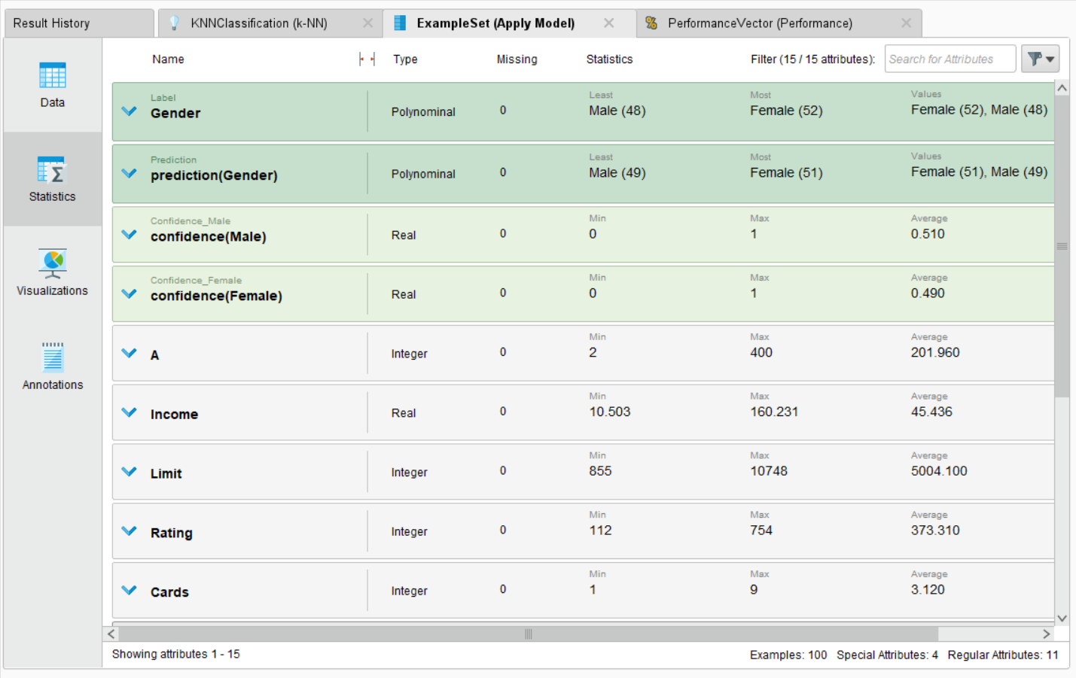

**VISUALIZATION:**

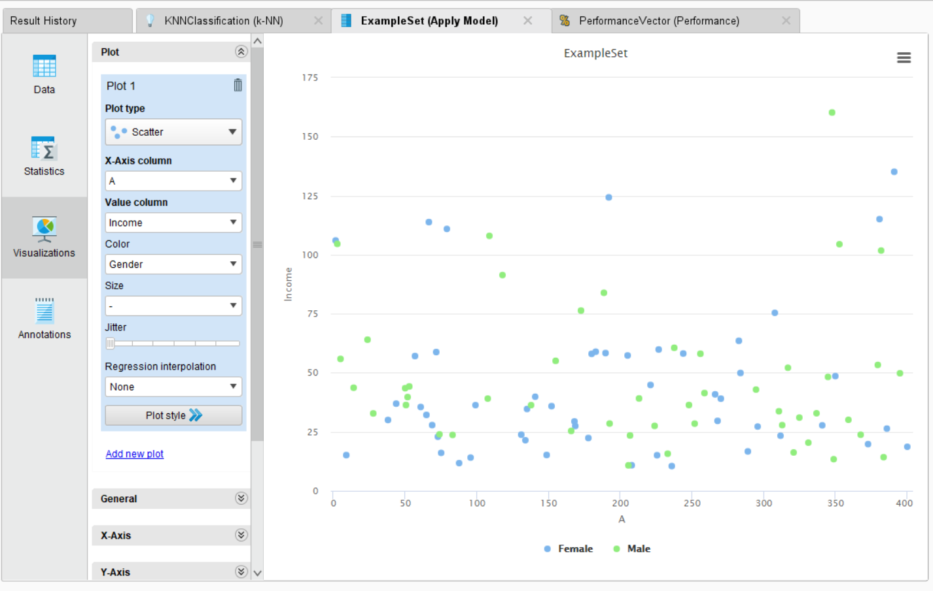

**PERFORMANCE VECTOR:**

**ACCURACY:**

**TABLE VIEW:**

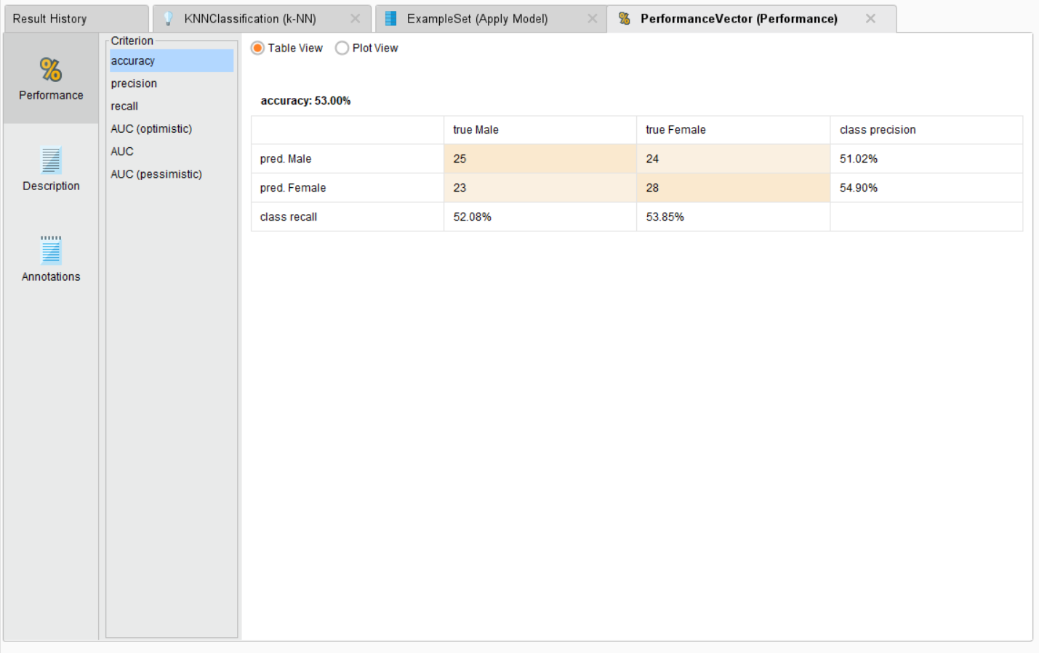

**PLOT VIEW:**

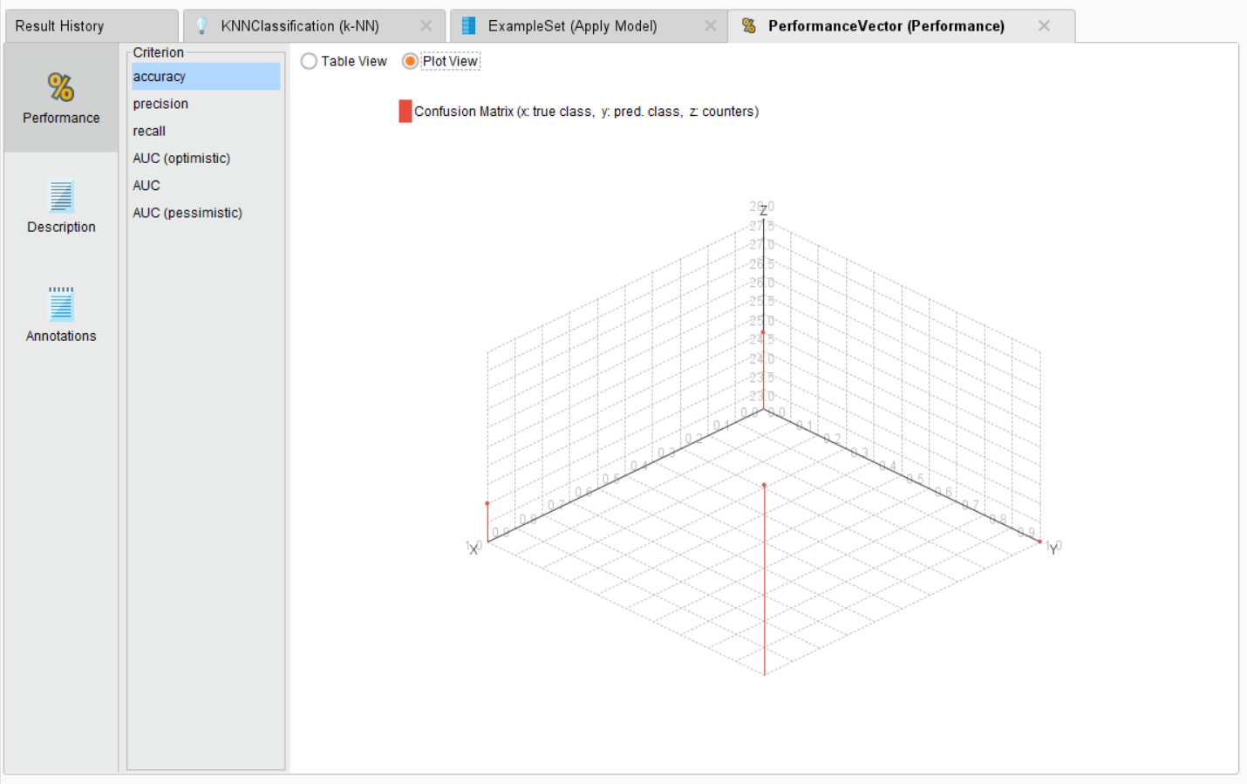

**PRECISION:**

**TABLE VIEW:**

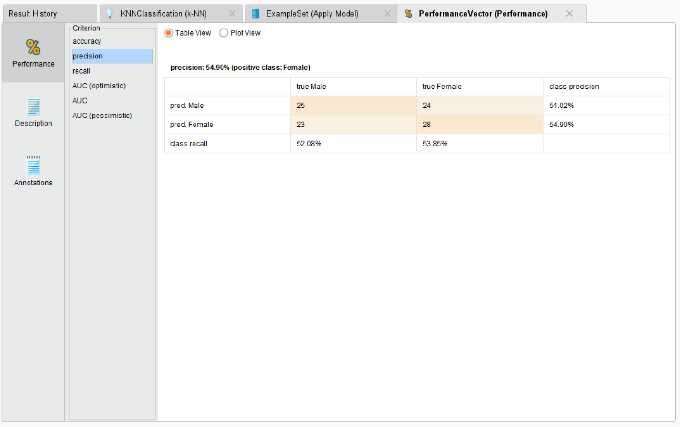

**PLOT VIEW:**

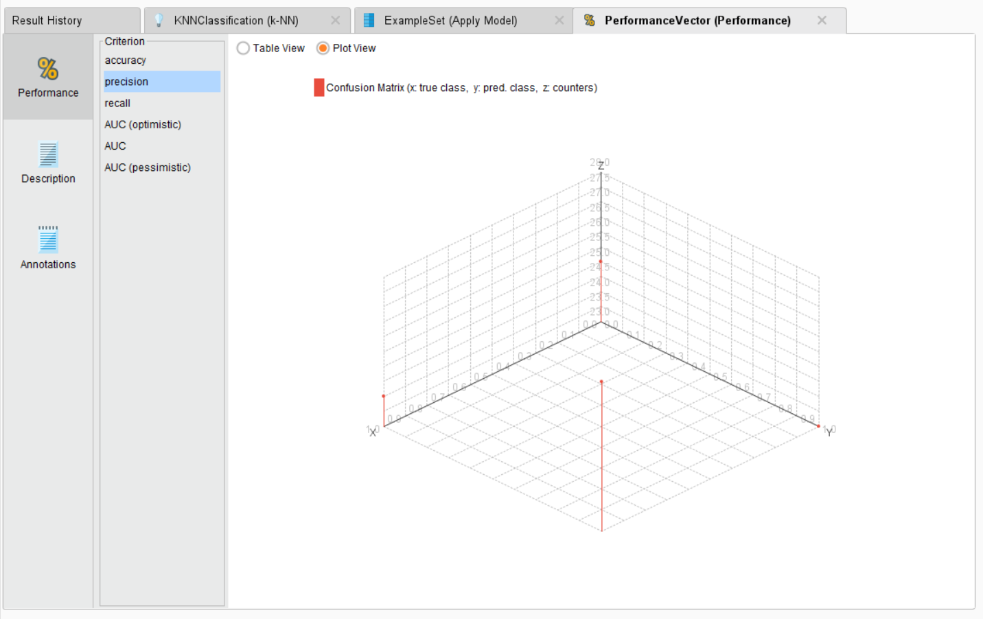

**RECALL:**

**TABLE VIEW:**

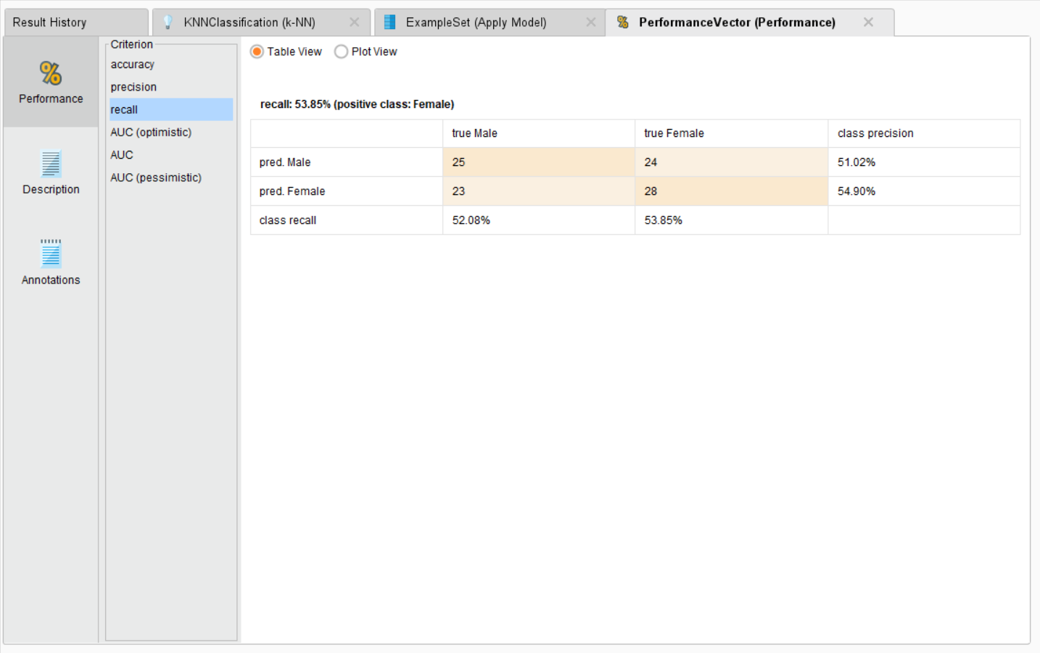

**PLOT VIEW:**

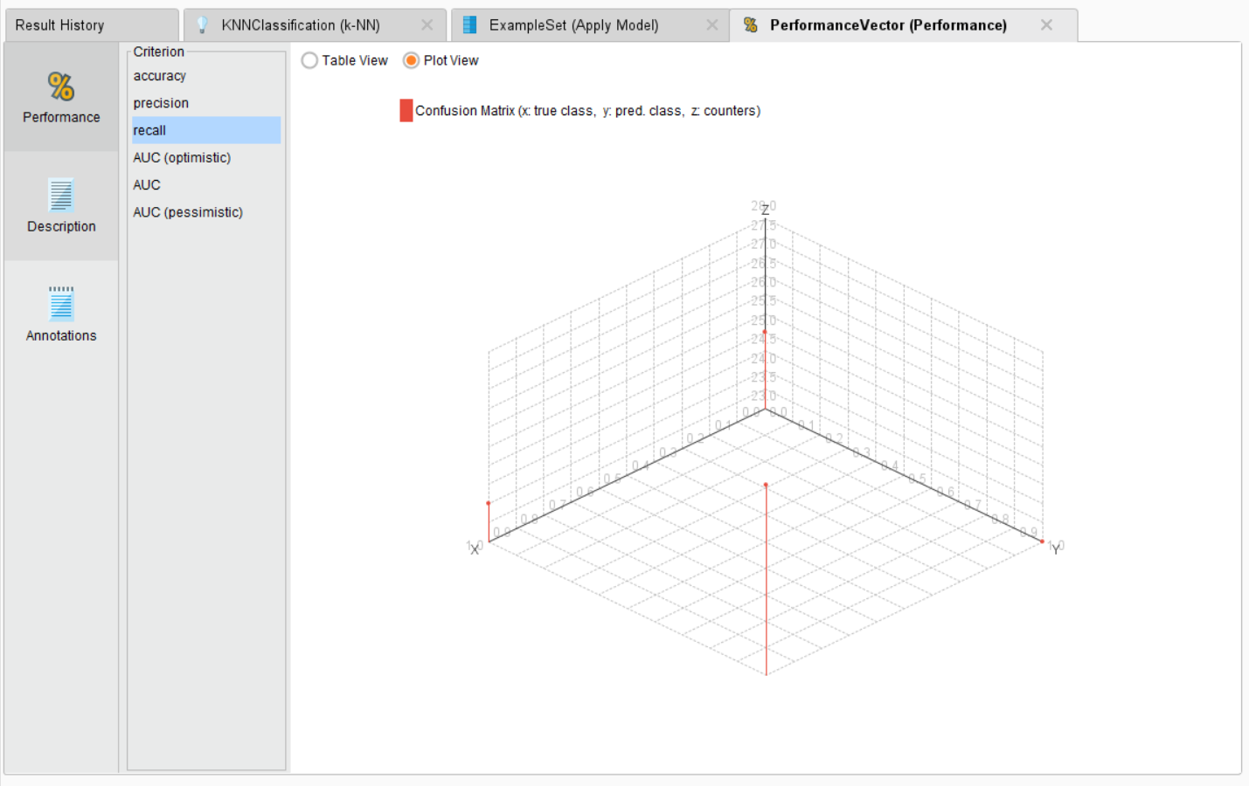

**AUC:**

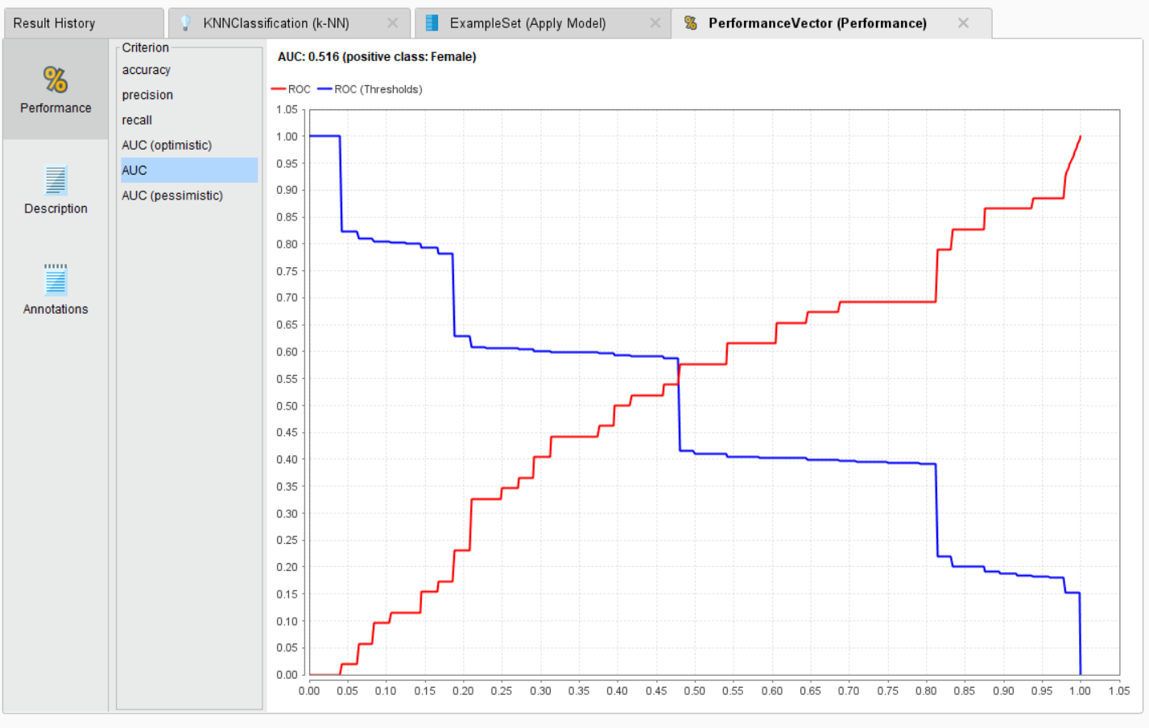

**CONFUSION MATRIX:**

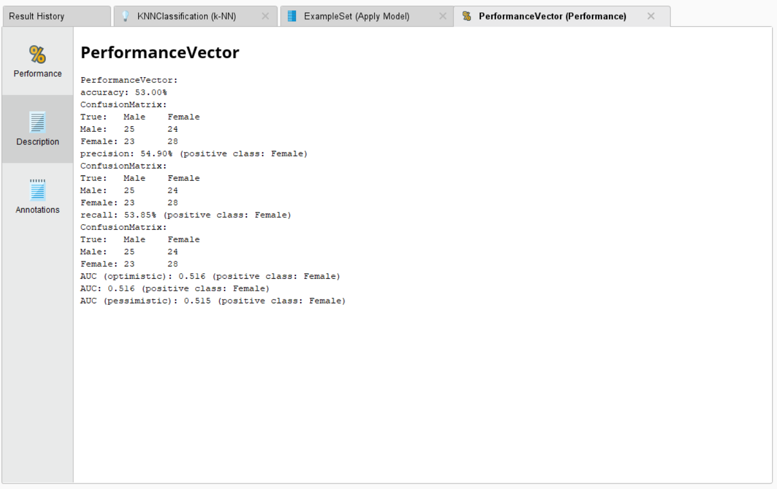

**3)DECISION TREE:**

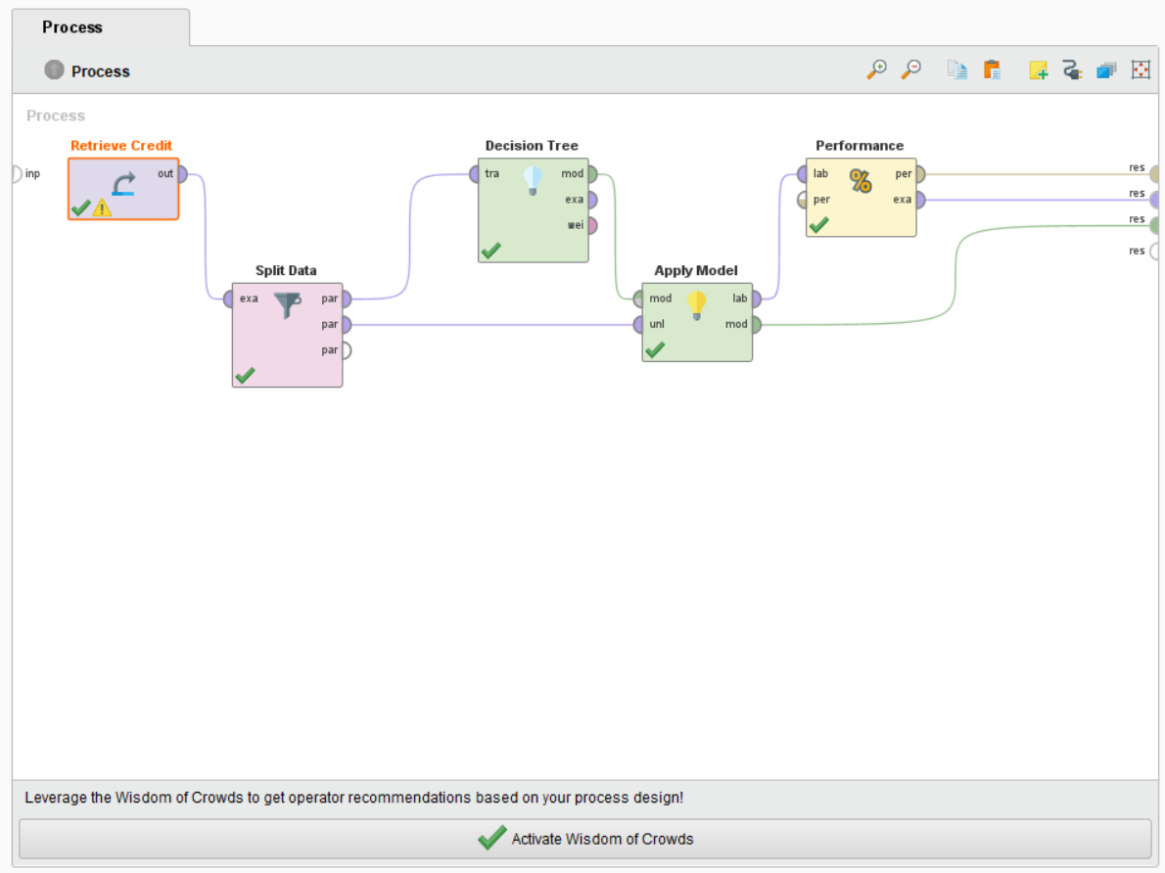

**FOR ETHNICITY CLASSIFICATION:**

**TREE:**

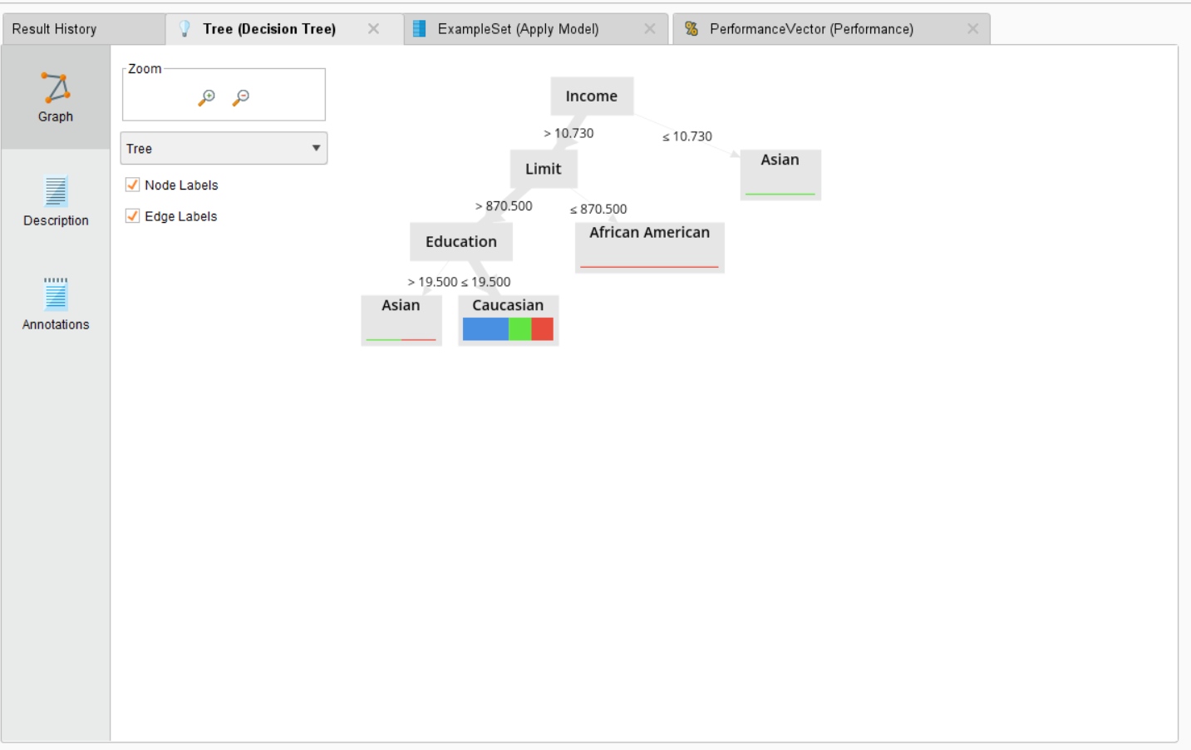

**PERFORMANCE VECTOR:**

**TABLE VIEW:**

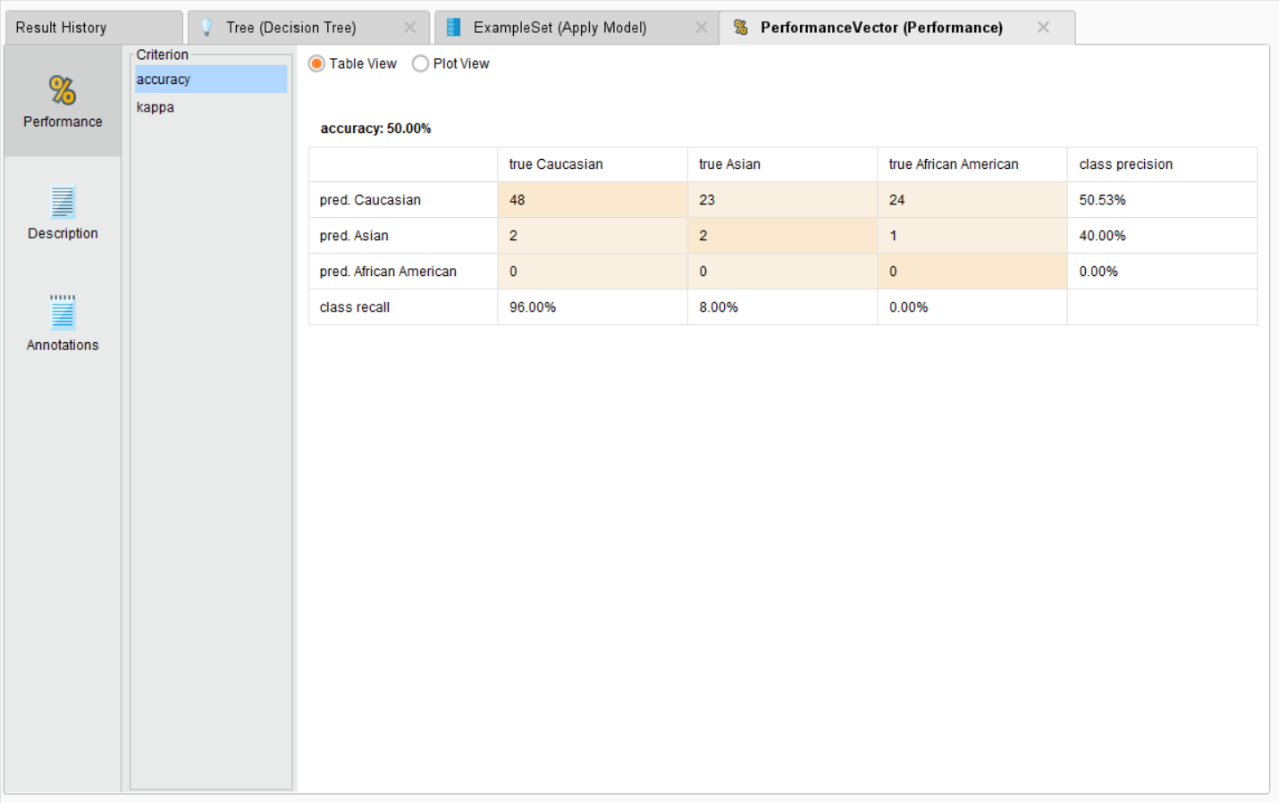

**PLOT VIEW:**

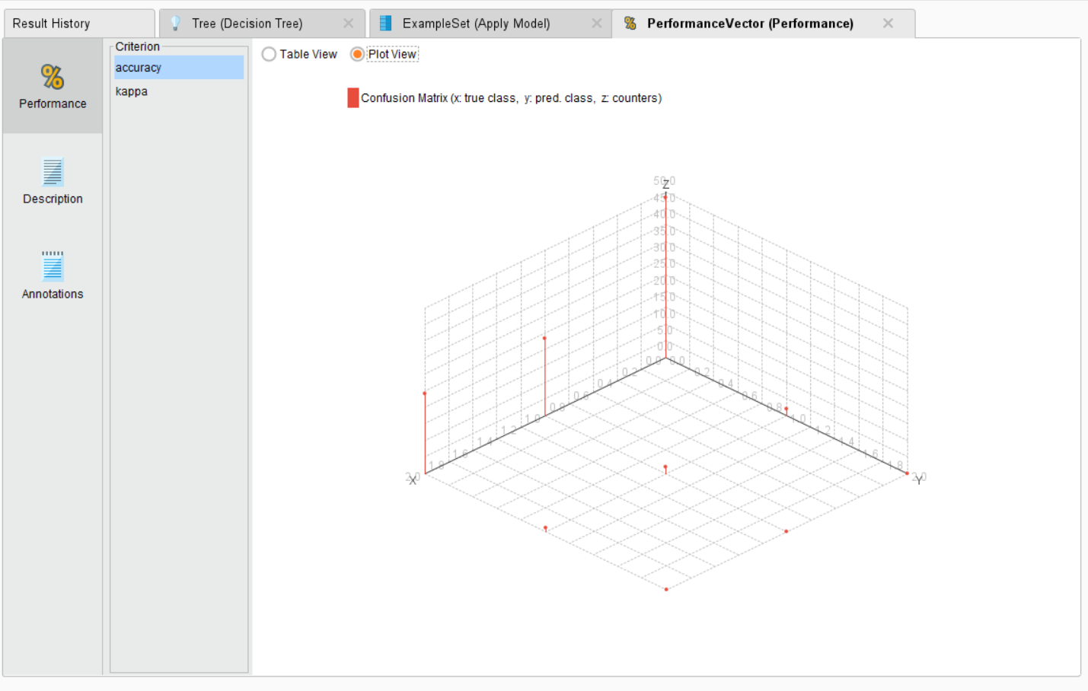

**KAPPA:**

**TABLE VIEW:**

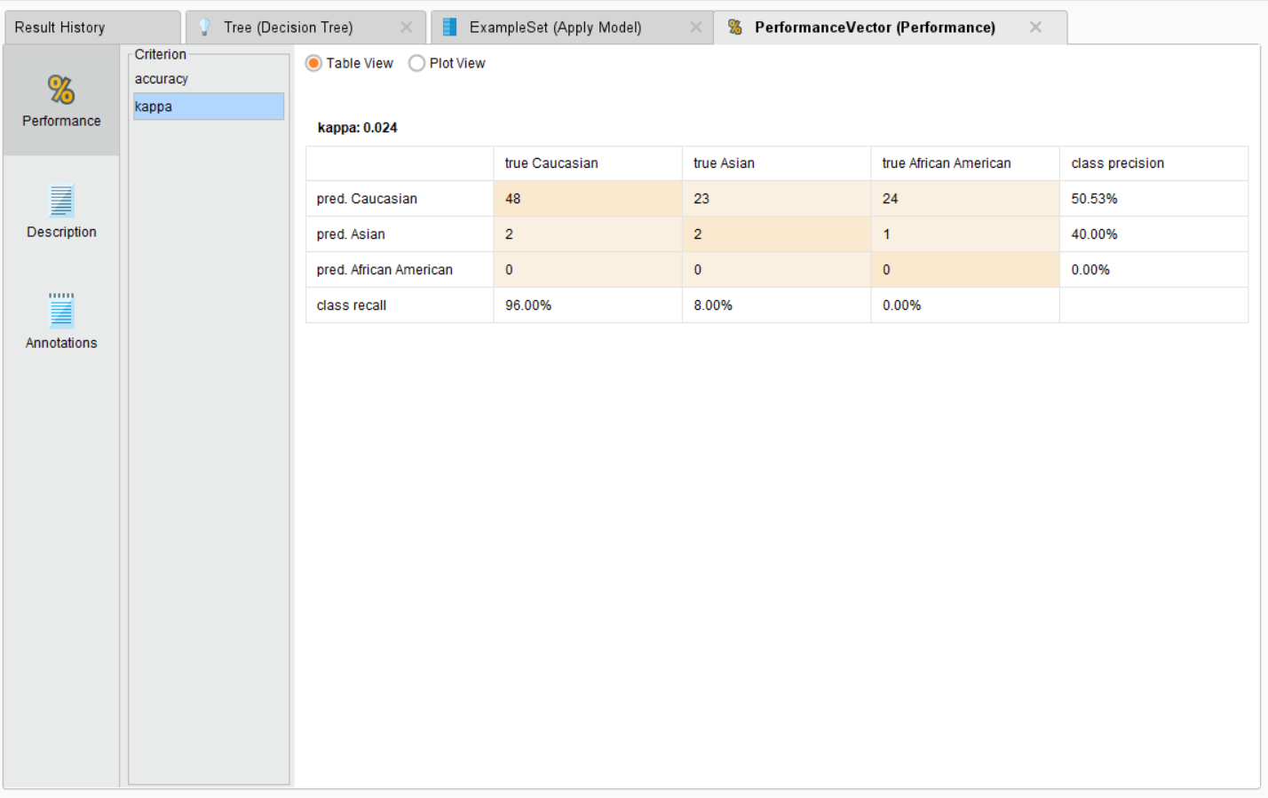

**PLOT VIEW:**

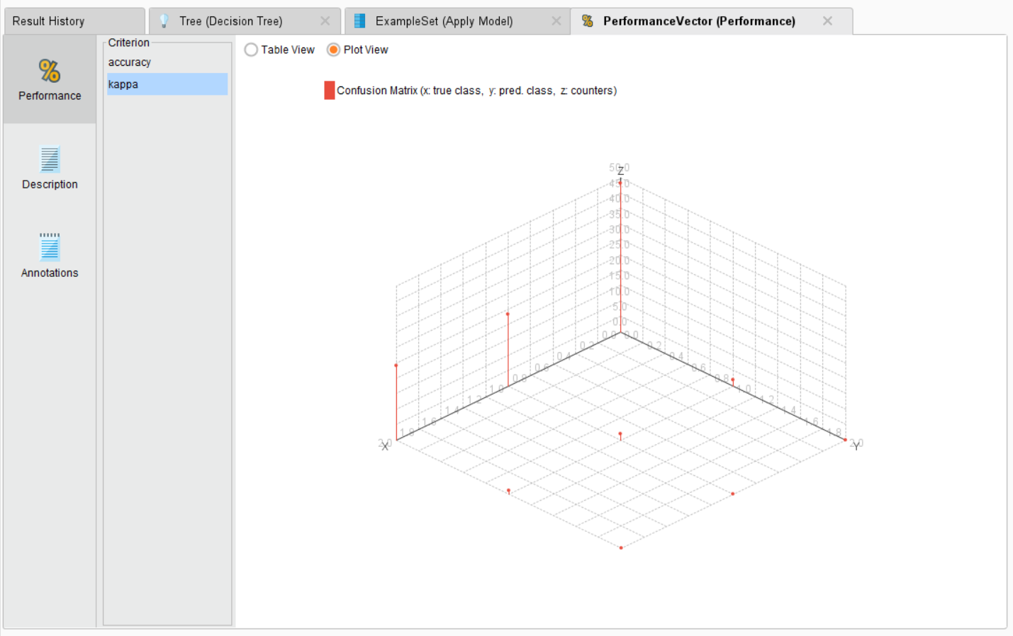

**CONFUSION MATRIX:**

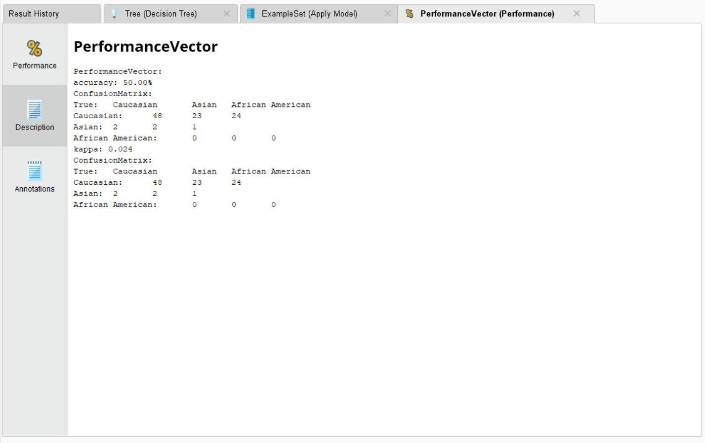

**FOR GENDER CLASSIFICATION:**

**TREE:**

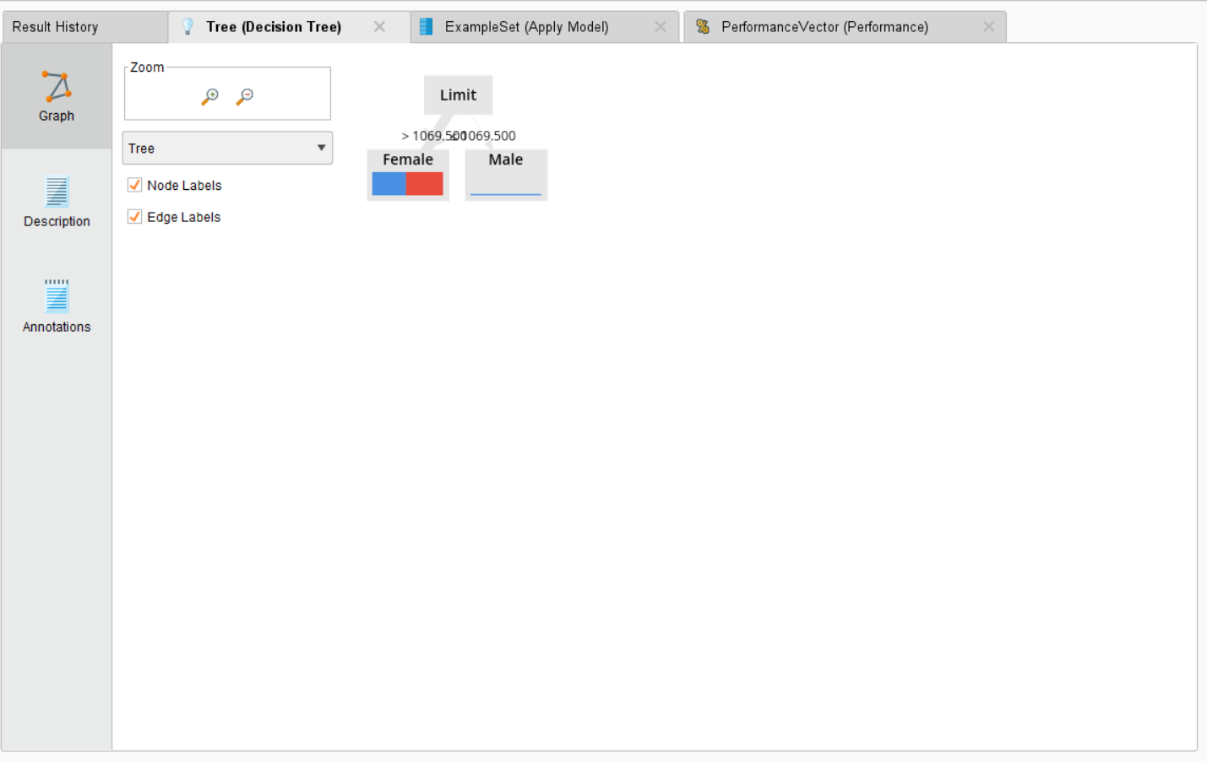

**ACCURACY:**

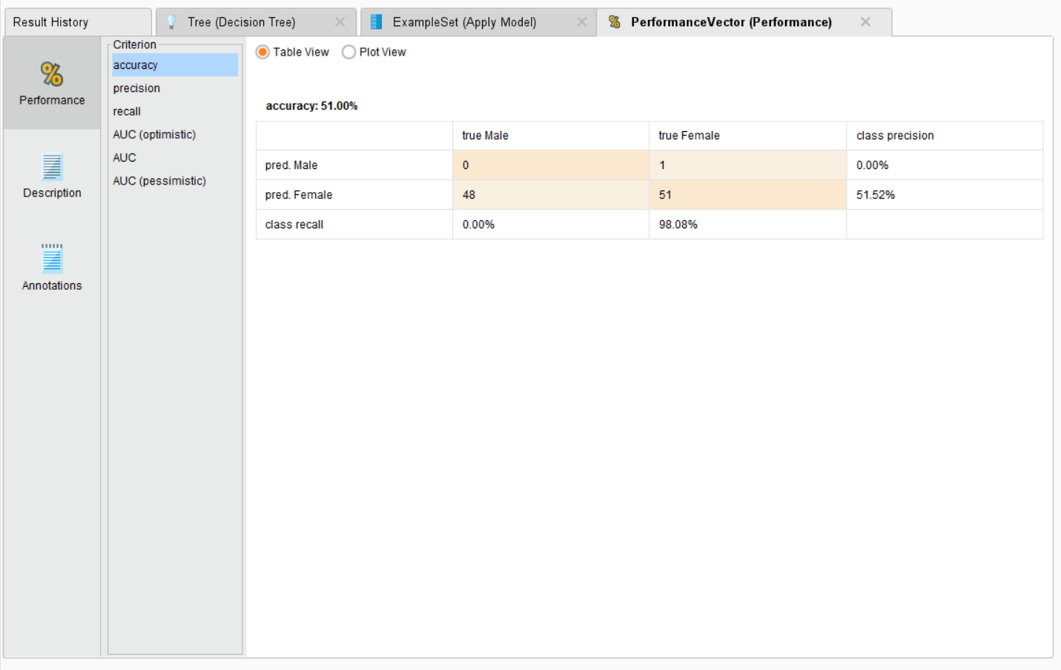

**PLOT VIEW:**

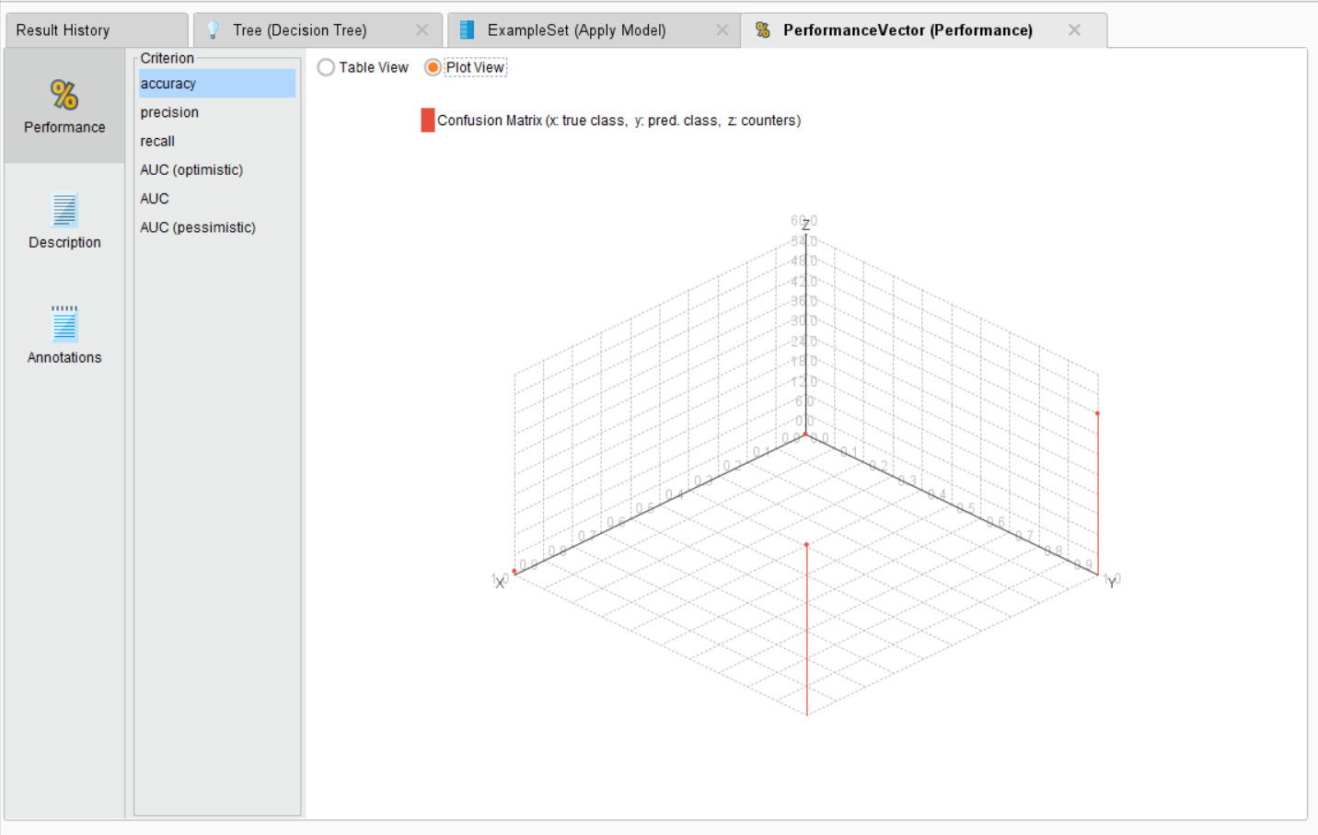

**PRECISION:**

**TABLE VIEW:**

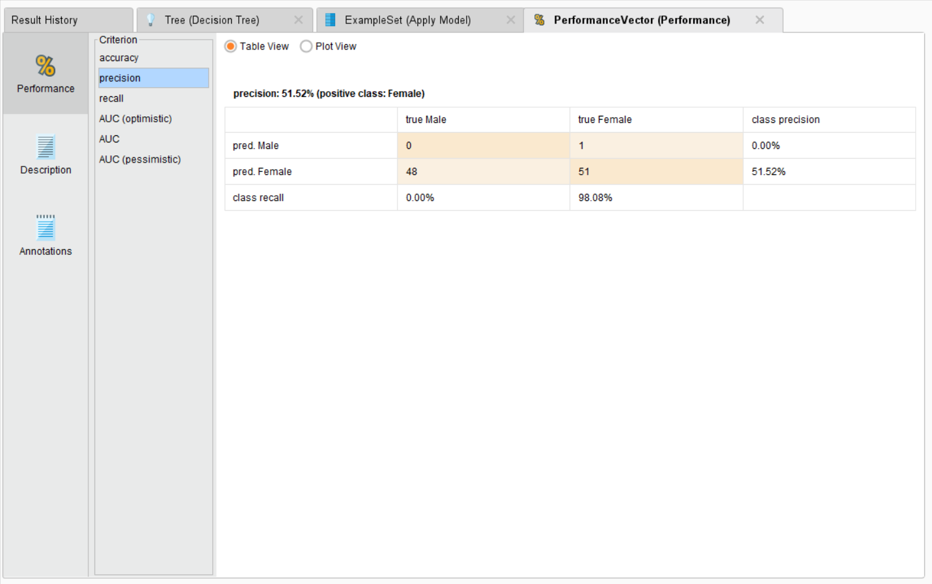

**RECALL:**

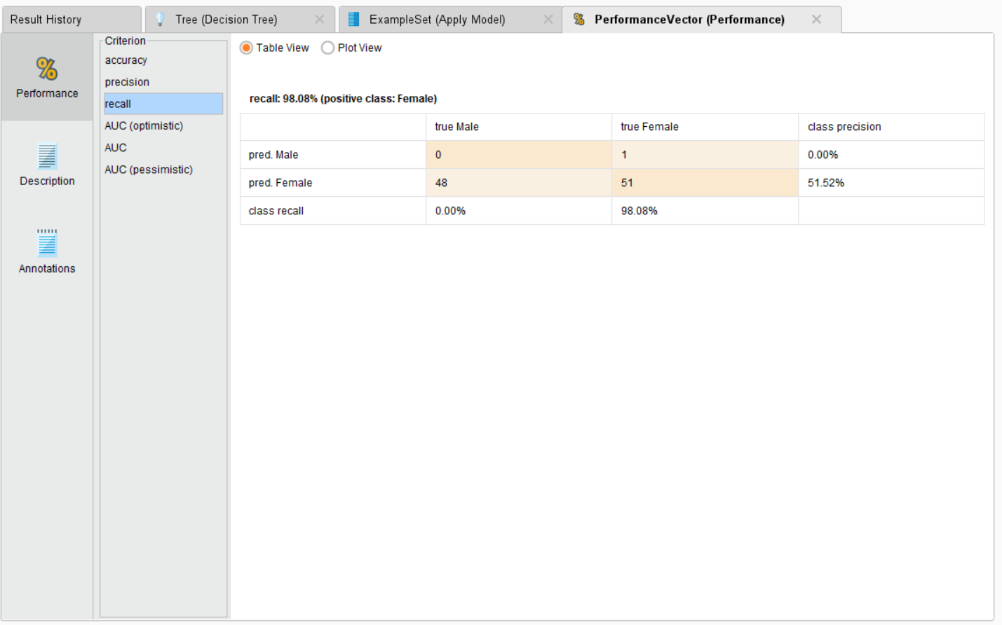

**AUC:**

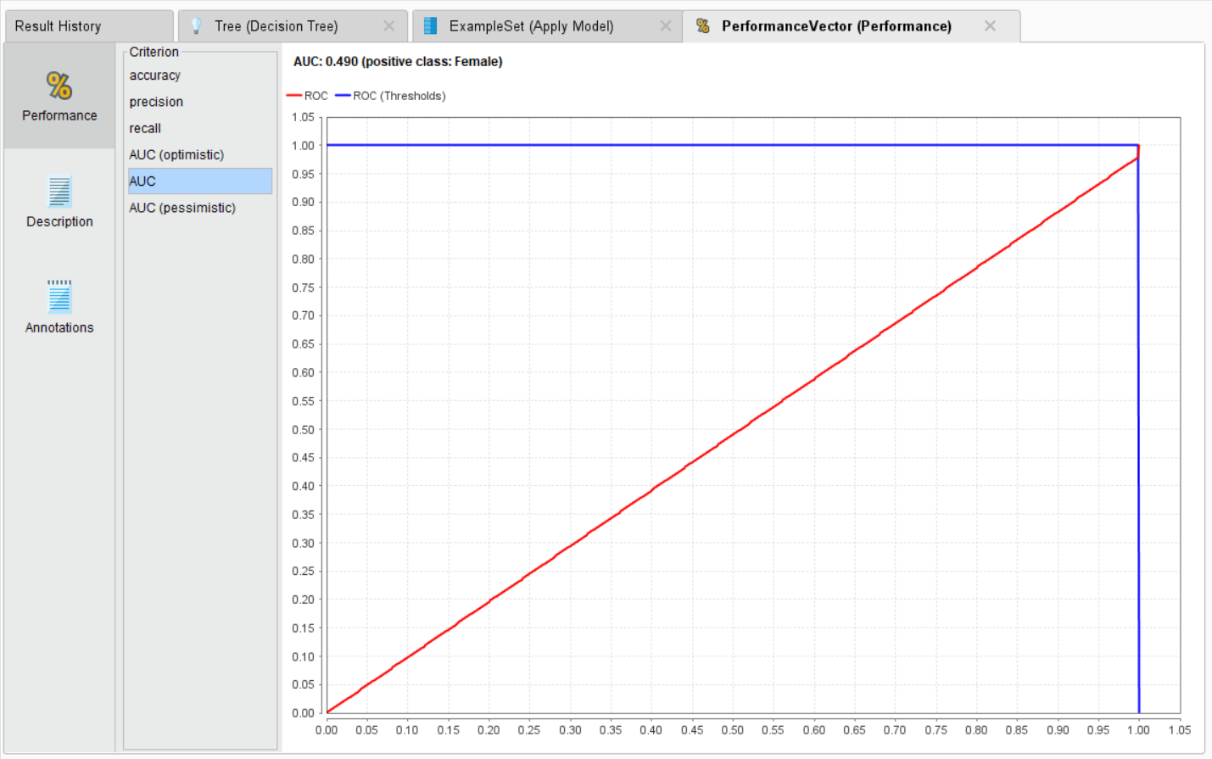

**CONFUSION MATRIX:**

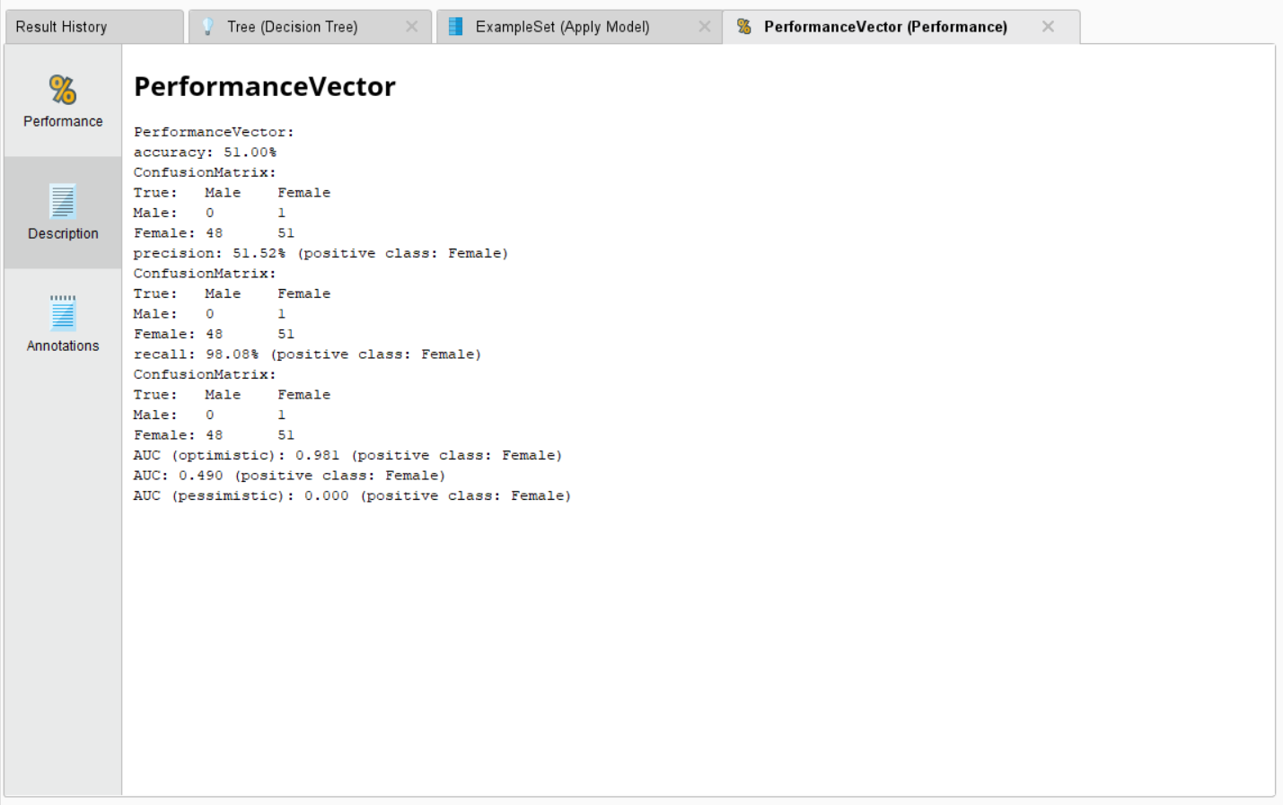

**4)RANDOM FOREST:**

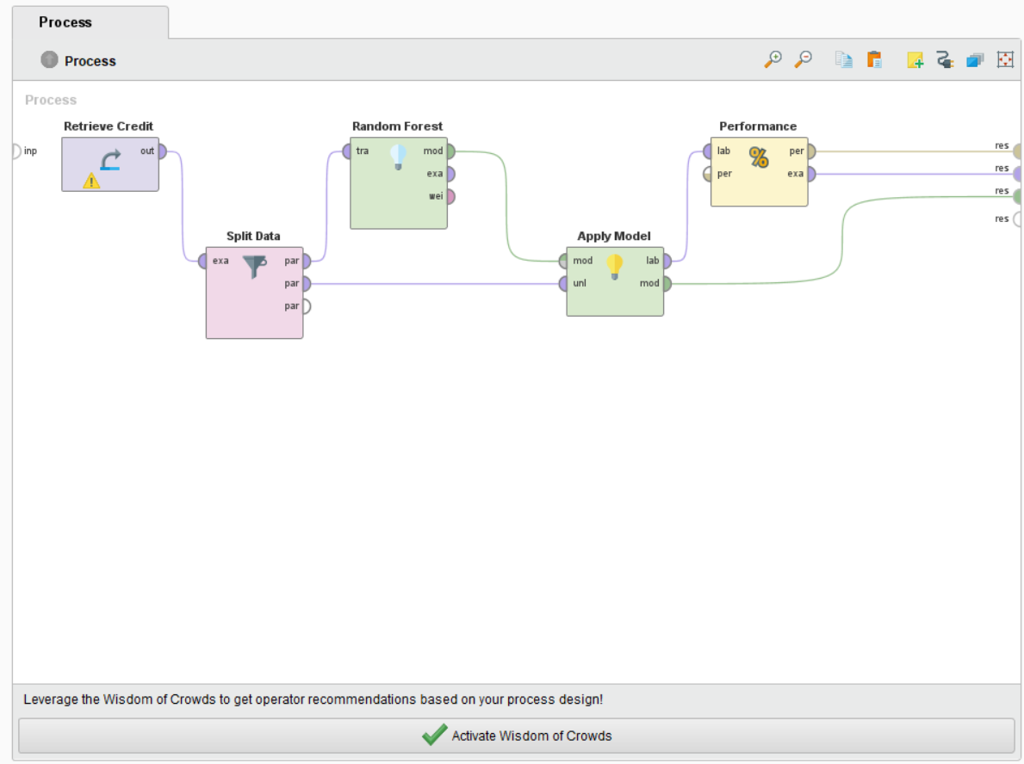

**FOR ETHNICITY CLASSIFICATION:**

**MANY TREES ARE FORMED ONE OF THEM IS:**

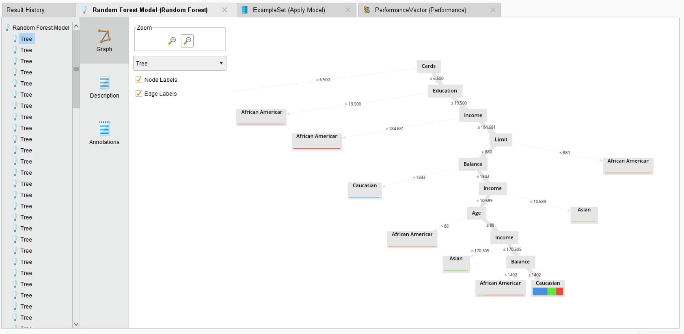

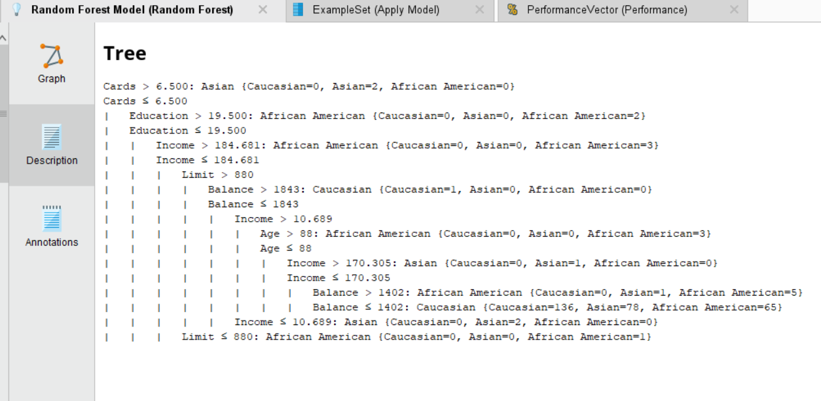

**DATA:**

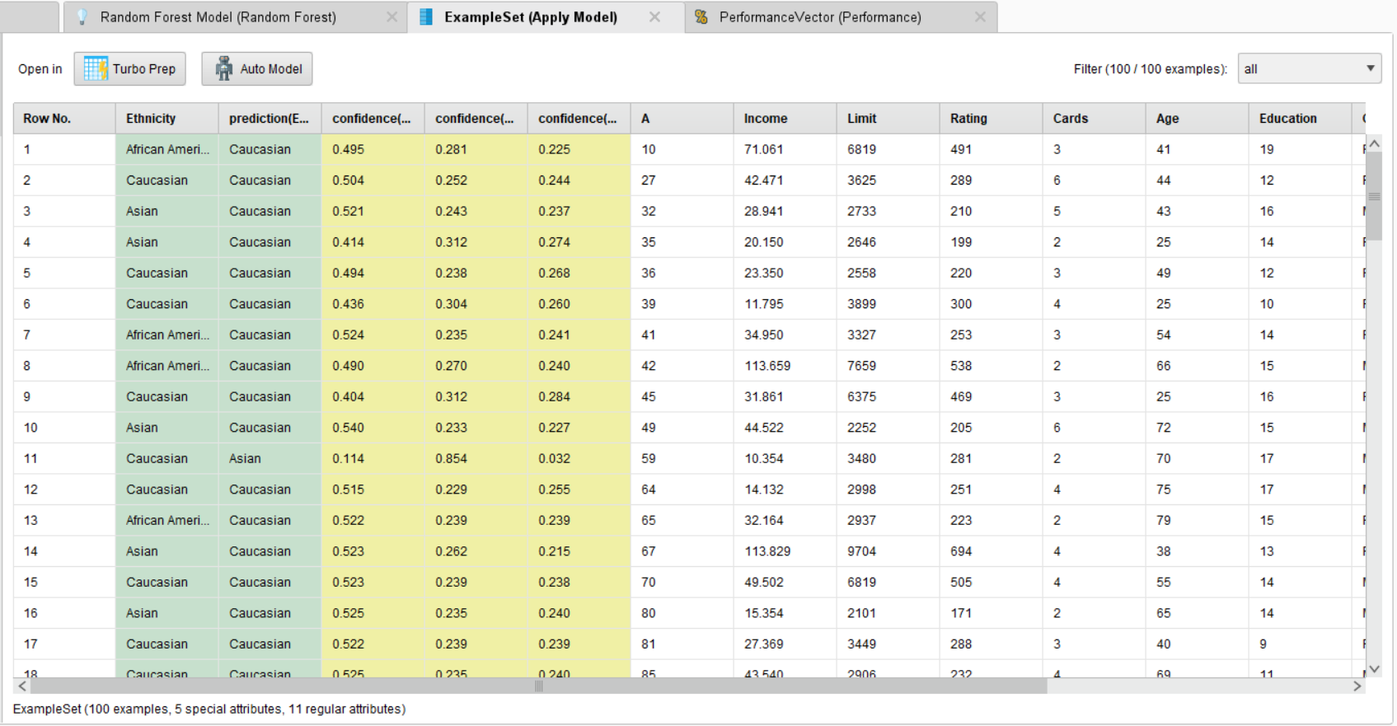

**PERFORMANCE VECTOR:**

**ACCURACY:**

**TABLE VIEW:**

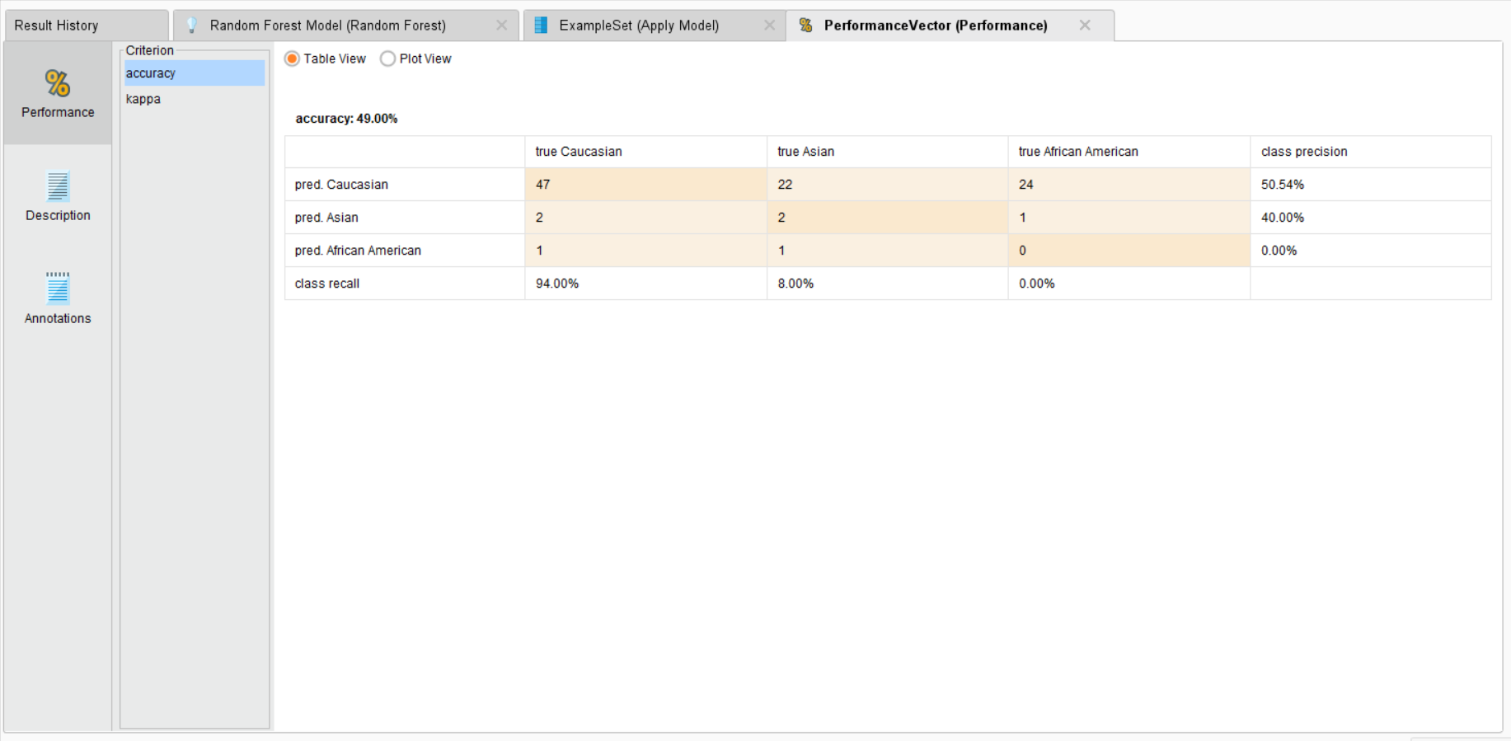

**PLOT VIEW:**

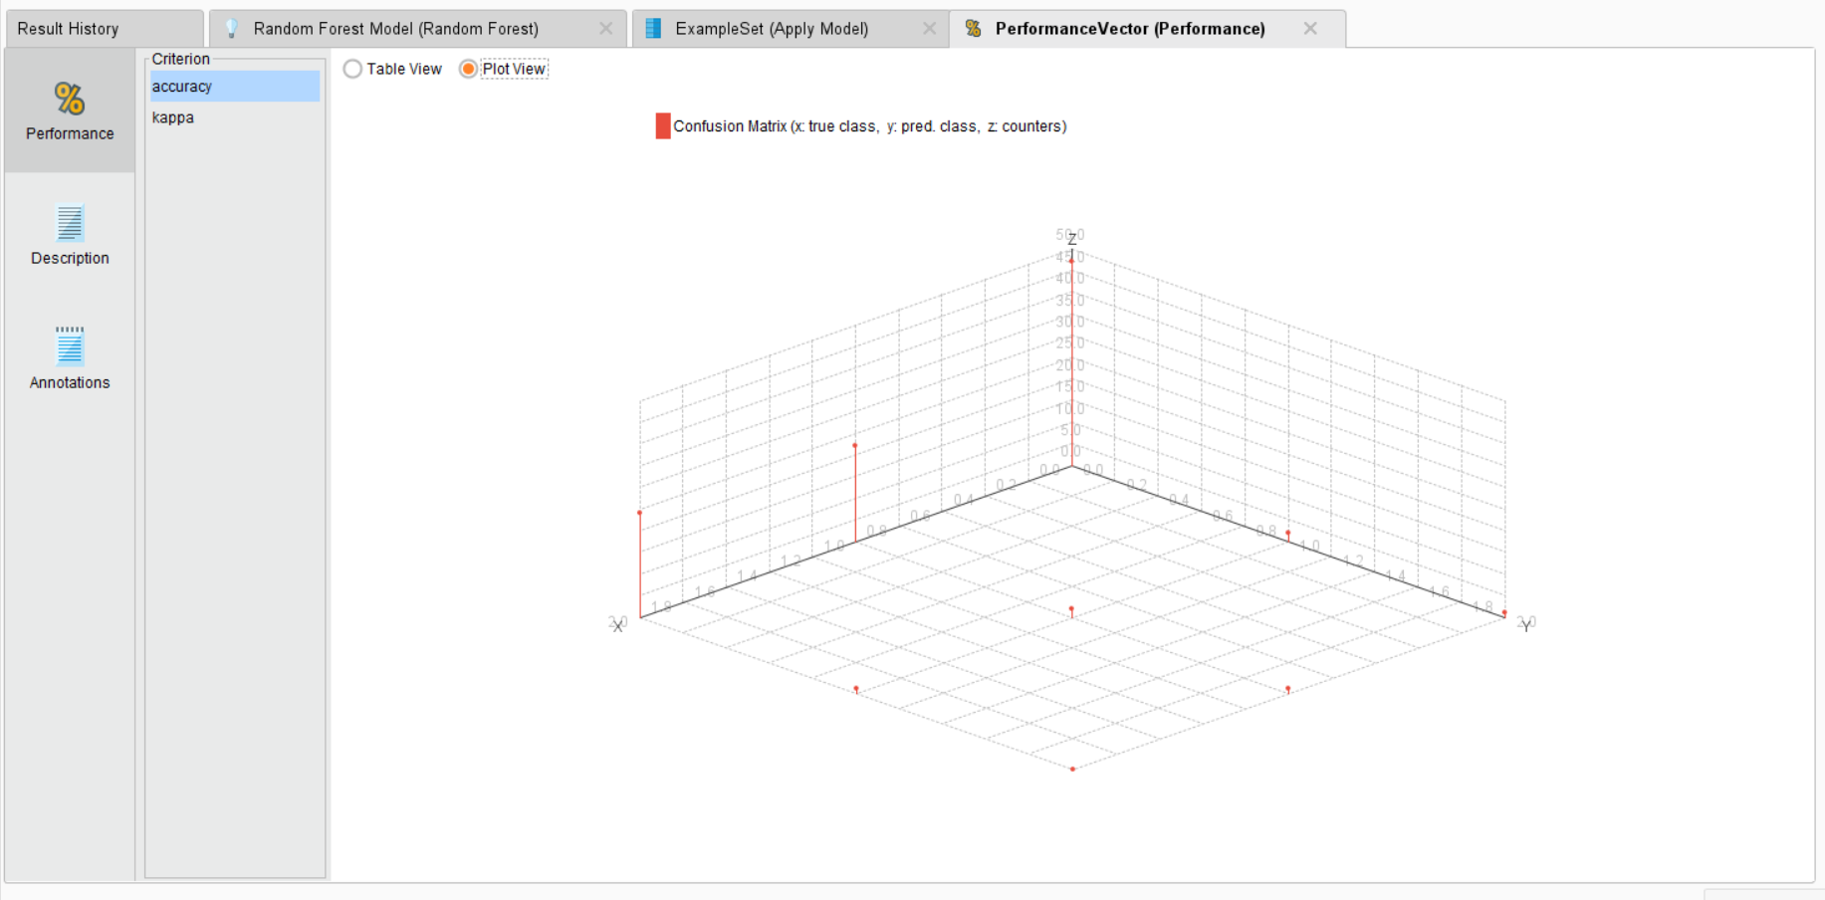

**KAPPA:**

**TABLE VIEW:**

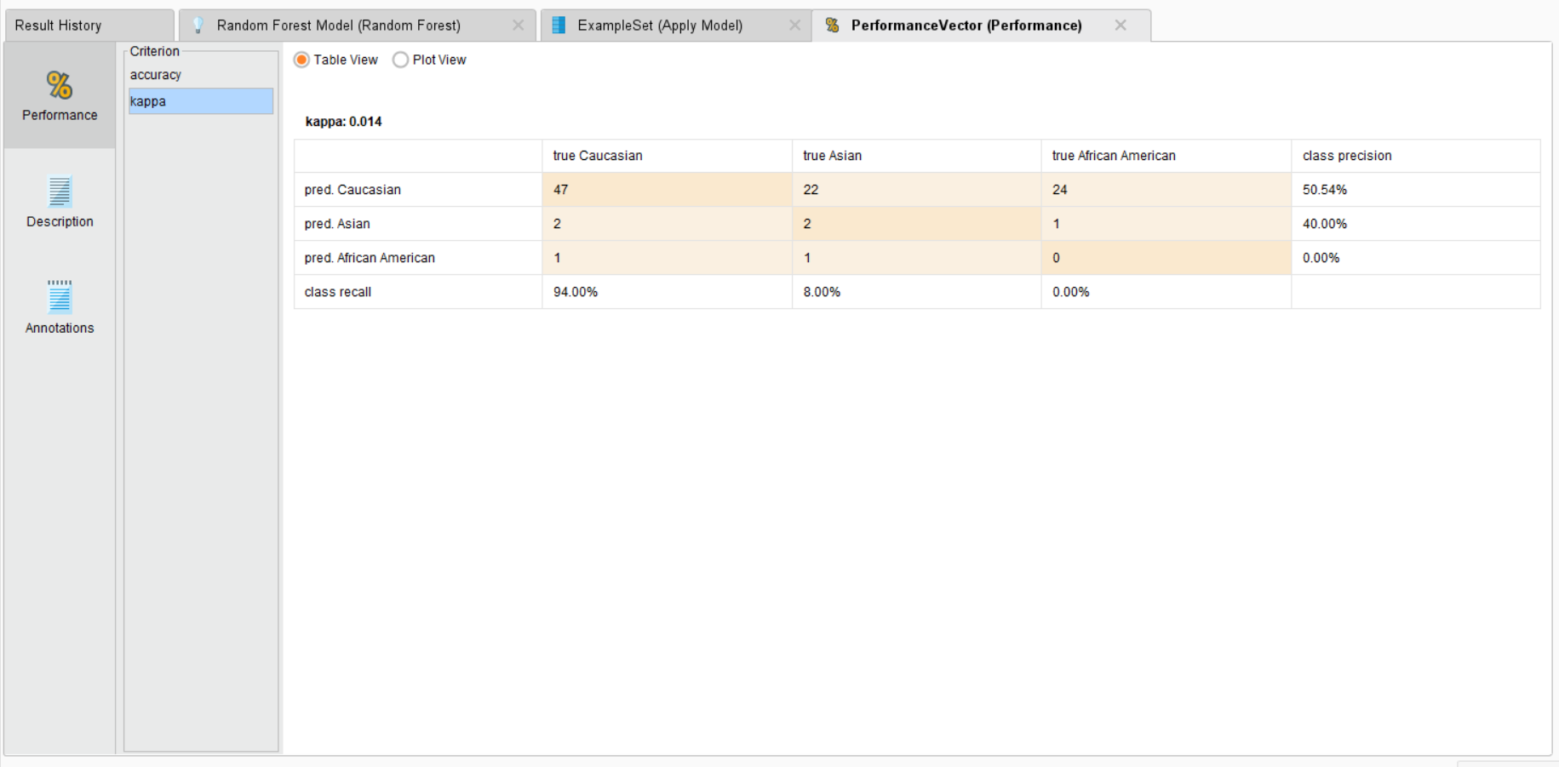

**CONFUSION MATRIX:**

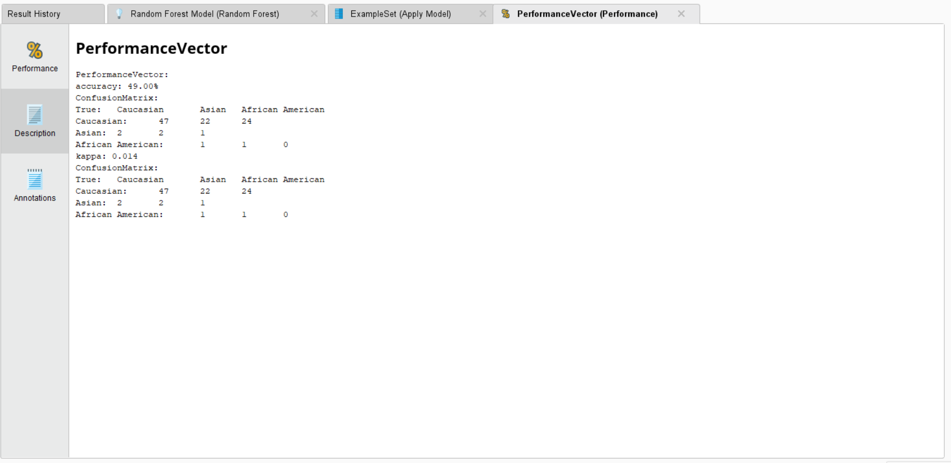

**FOR GENDER CLASSIFCATION:**

**ONE OF THE TREES FORMED:**

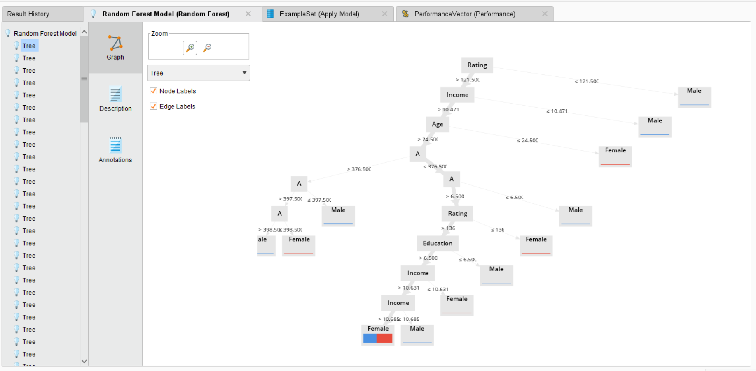

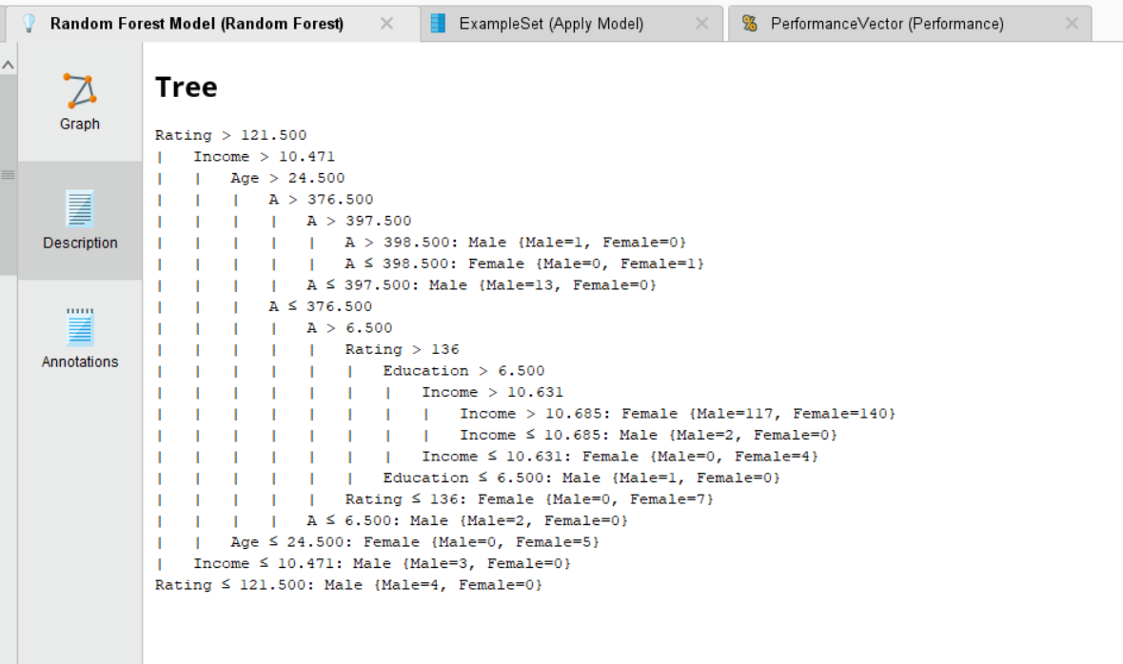

**RANDOM FOREST DATA RESULT:**

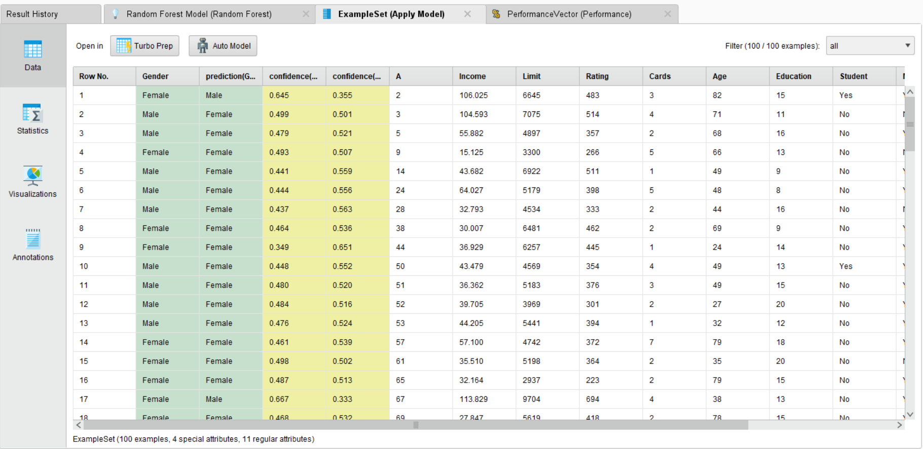

**PERFORMANCE VECTOR:**

**ACCURACY:**

**TABLE VIEW:**

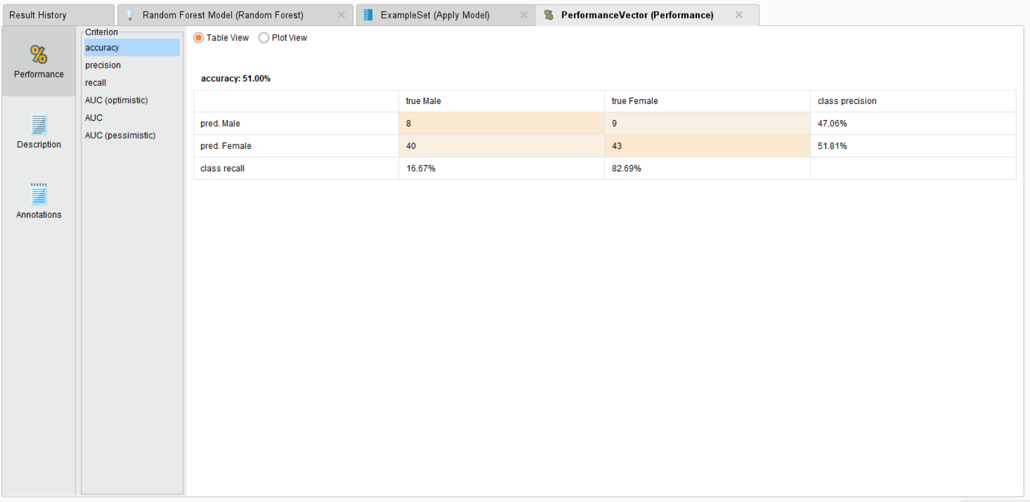

**PLOT VIEW:**

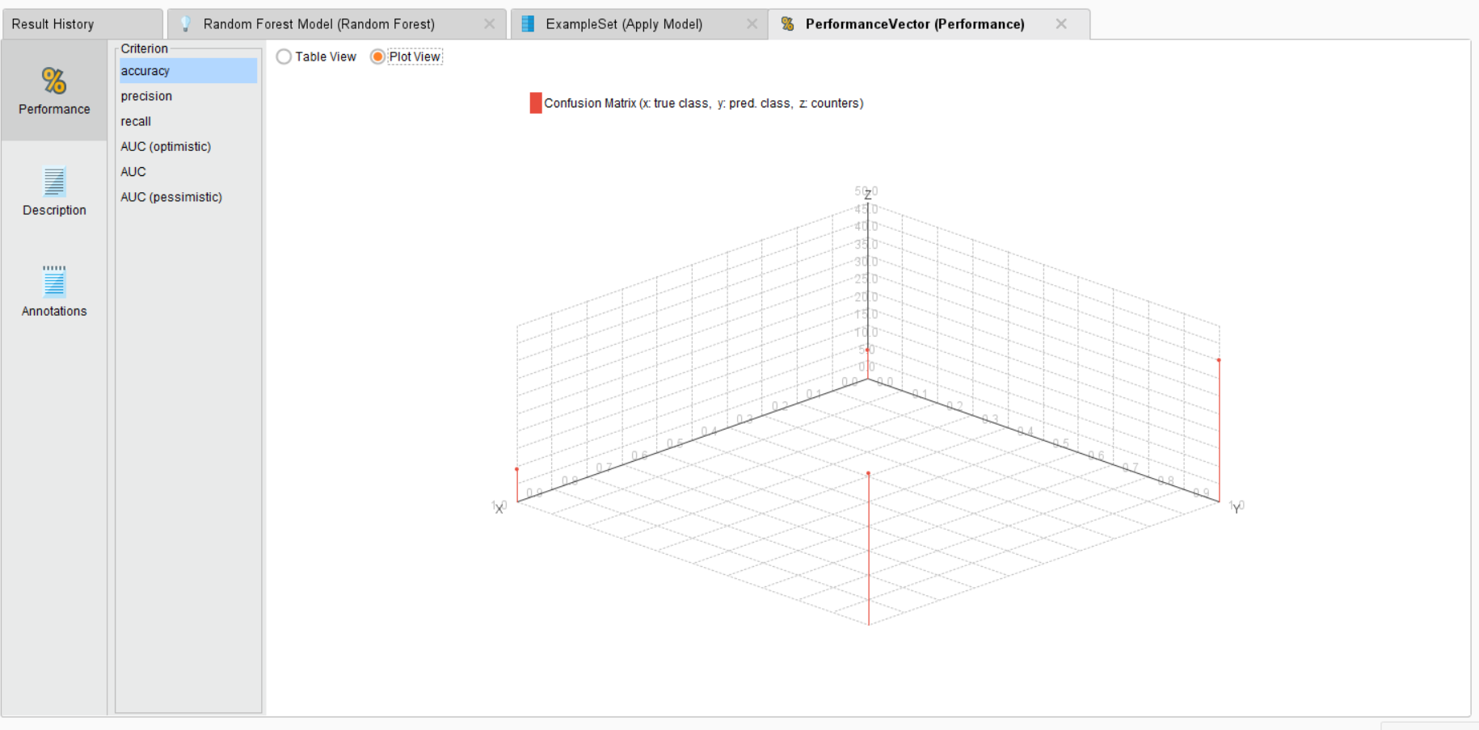

**PRECISION:**

**TABLE VIEW:**

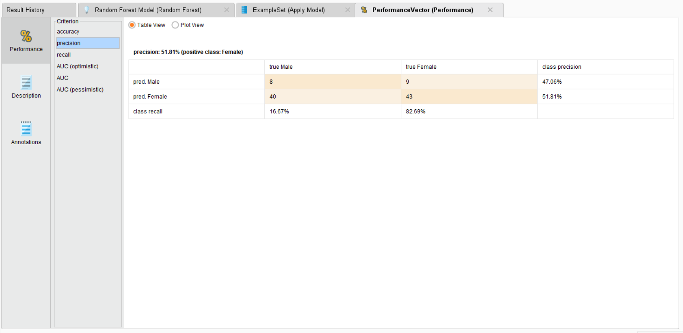

**PLOT VIEW:**

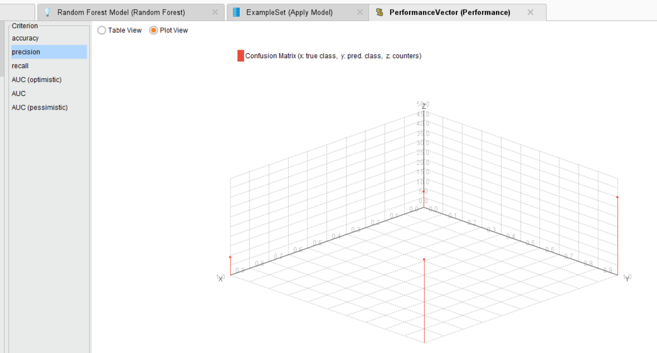

**RECALL:**

**TABLE VIEW:**

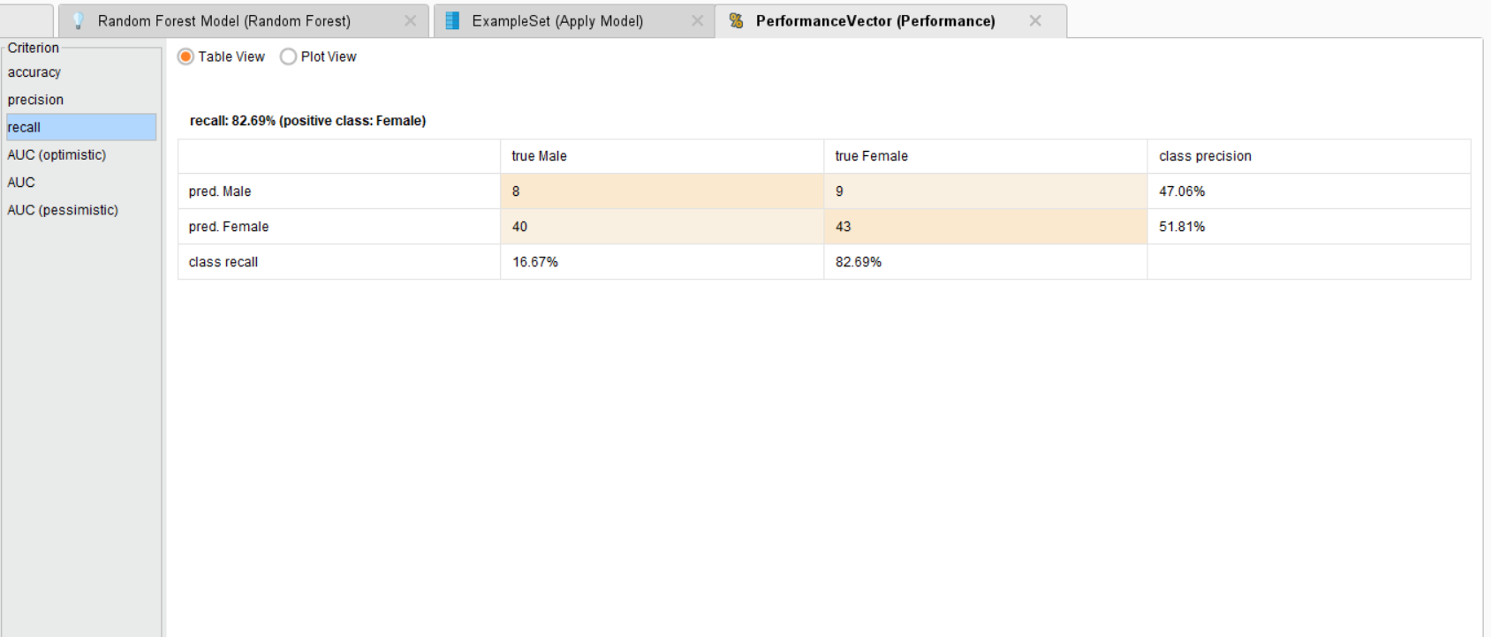

**AUC:**

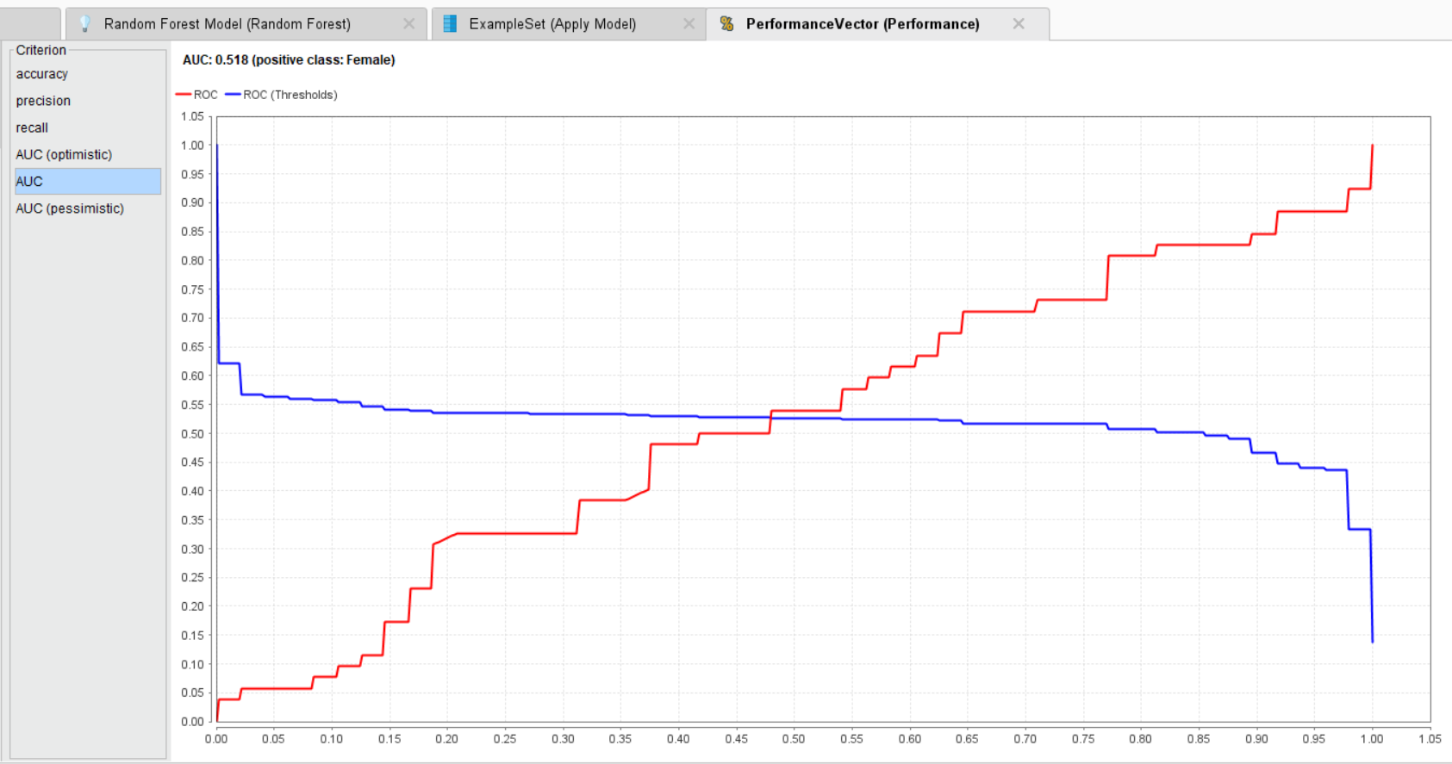

**CONFUSION MATRIX:**

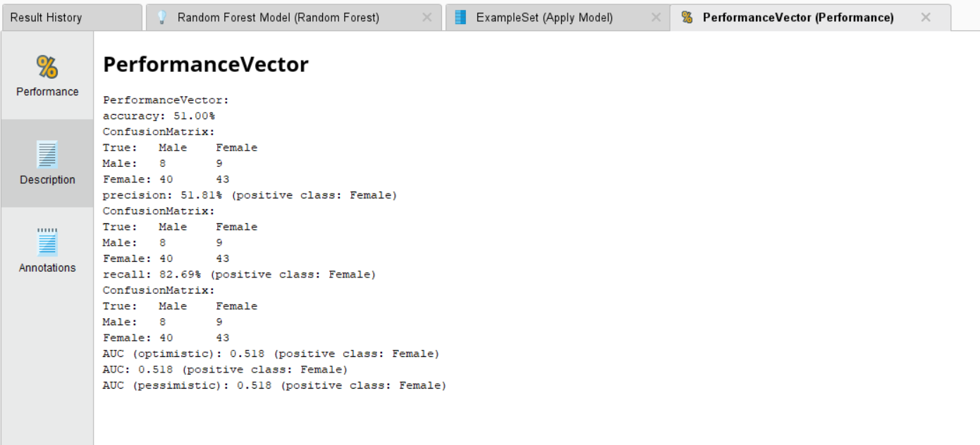

**5)LOGISTIC REGRESSION:**

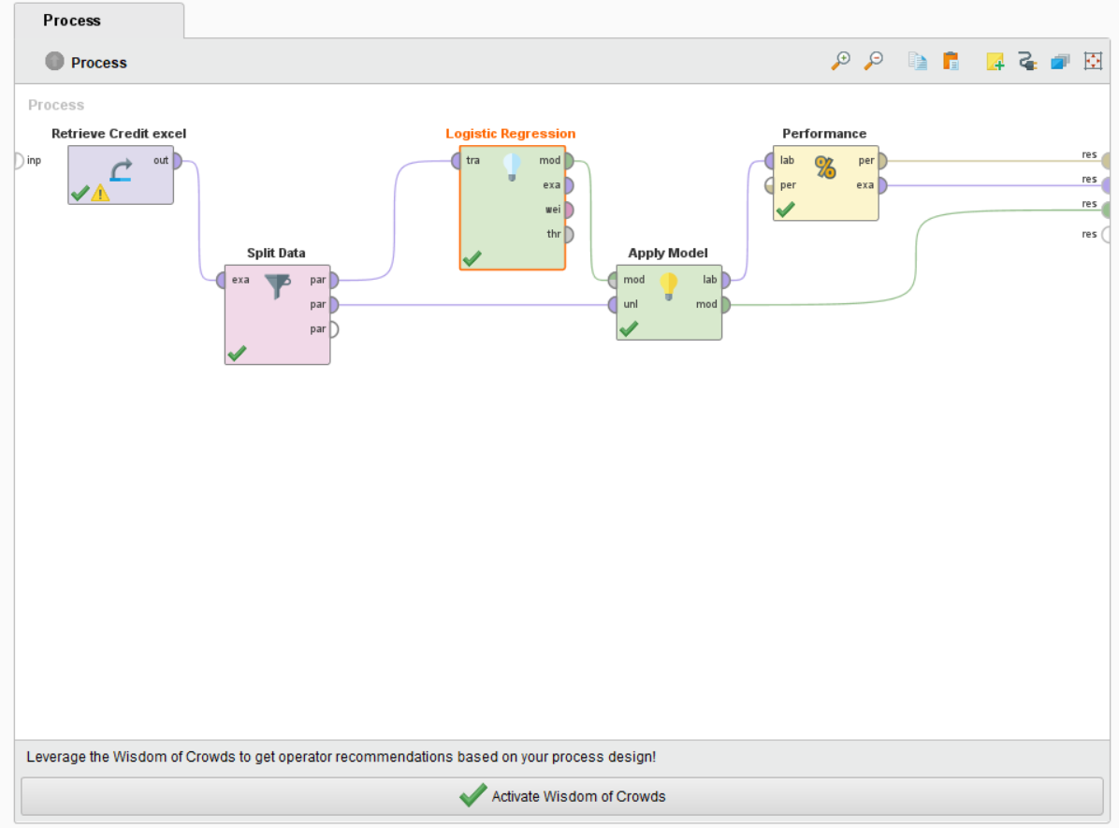

**FOR GENDER CLASSIFICATION:**

**DATA:**

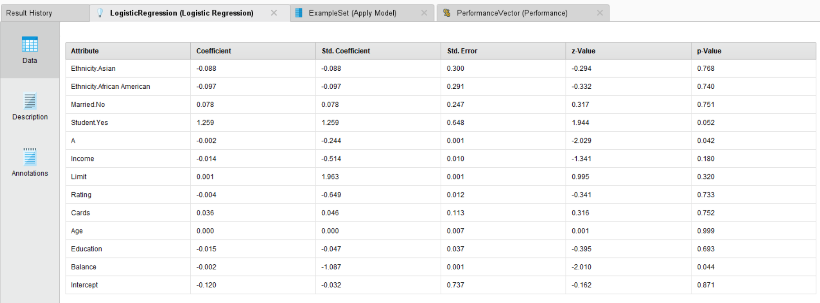

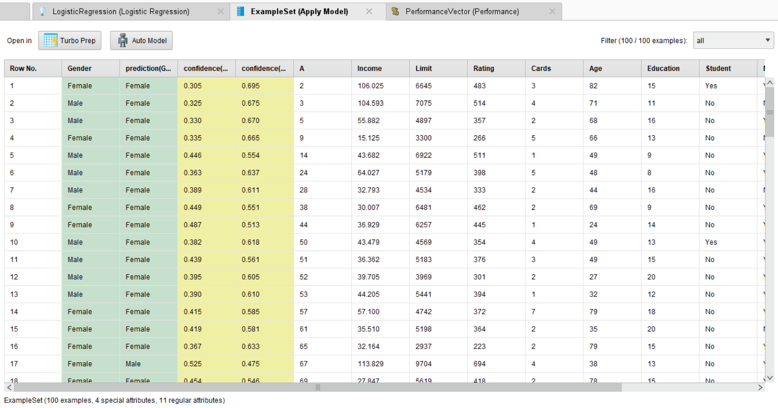

**DESCRIPTION:**

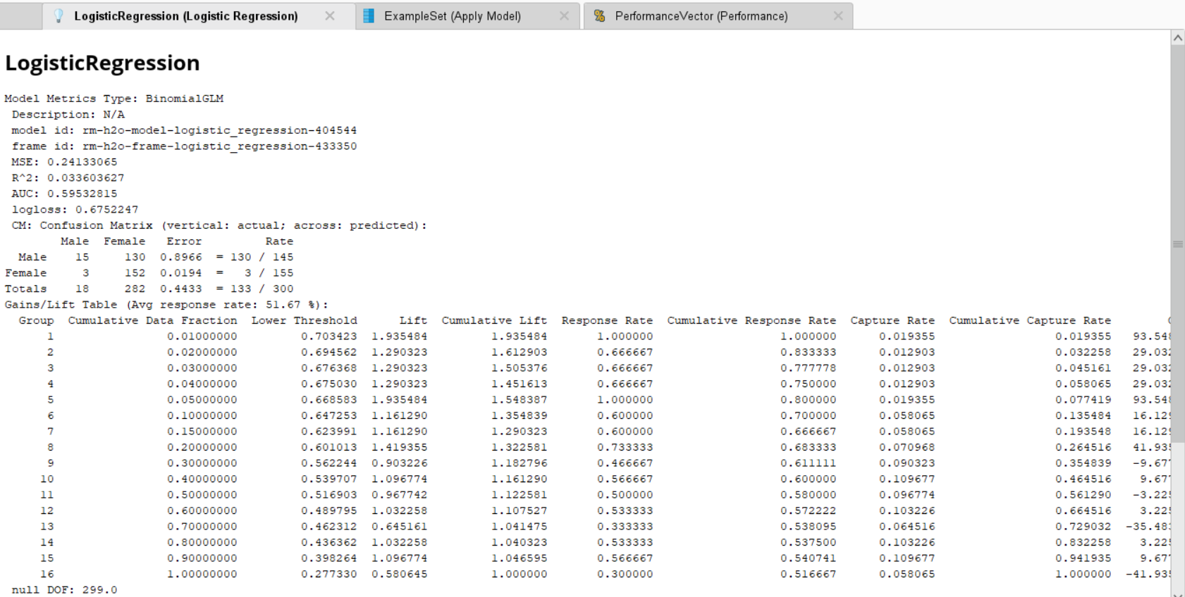

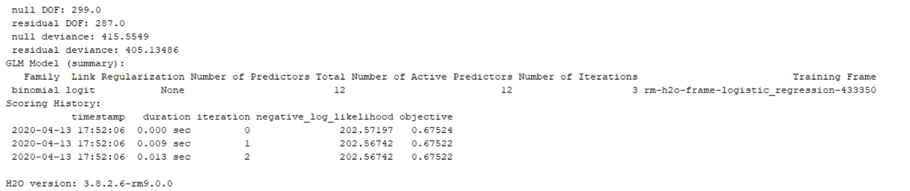

**PERFORMANCE VECTOR:**

**ACCURACY:**

**TABLE VIEW:**

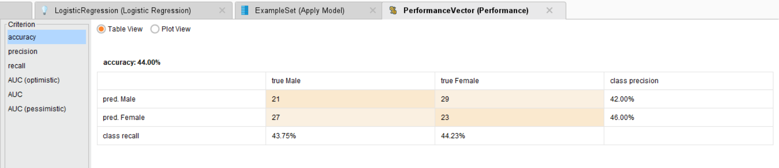

**PLOT VIEW:**

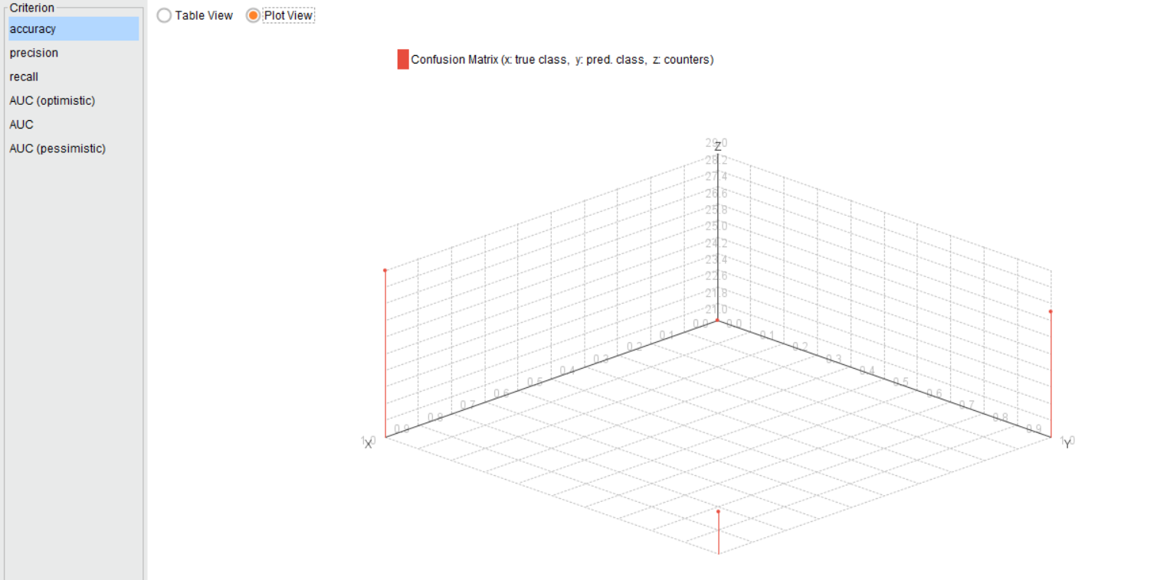

**PRECISION:**

**TABLE VIEW:**

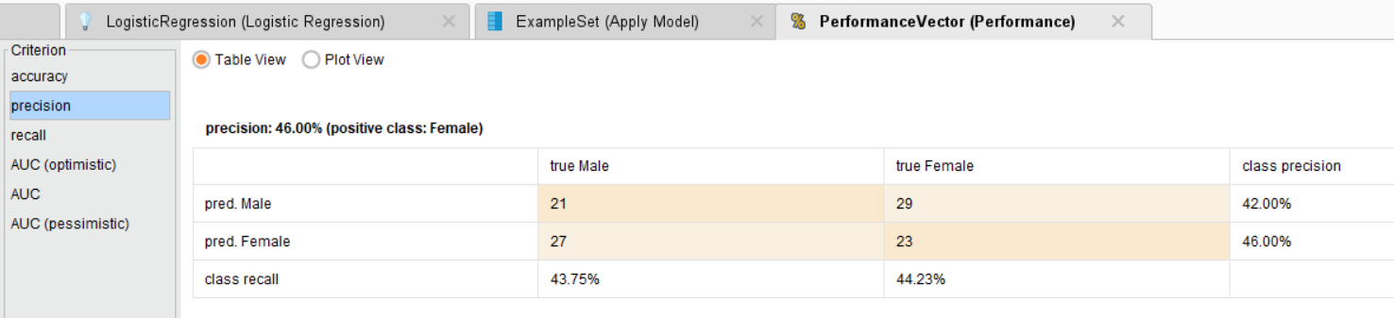

**PLOT VIEW:**

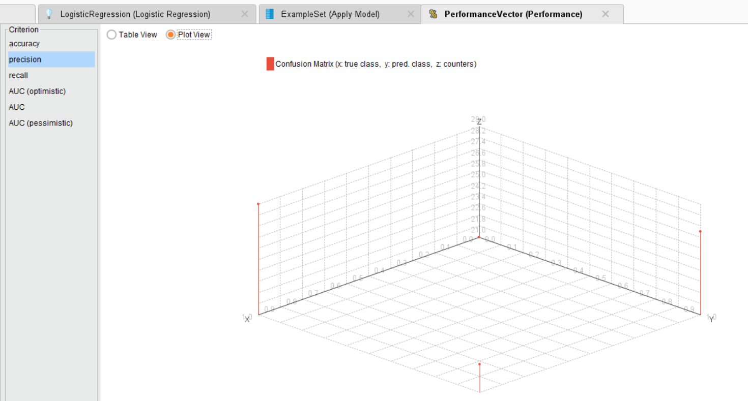

**RECALL:**

**TABLE VIEW:**

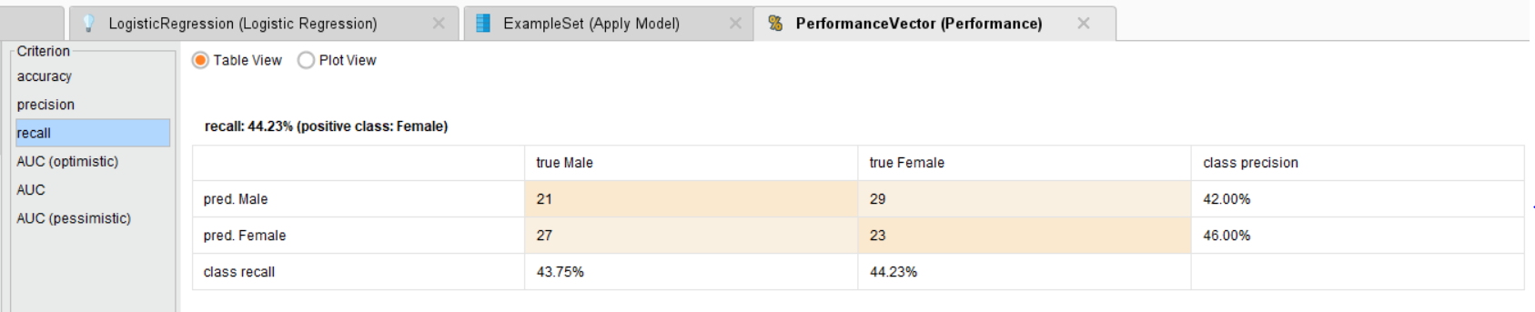

**AUC:**

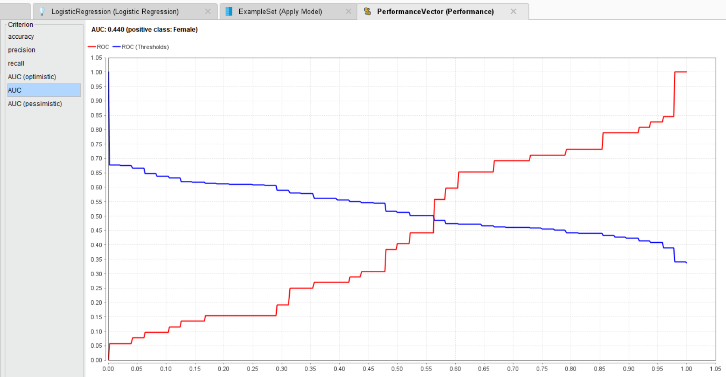

**CONFUSION MATRIX:**

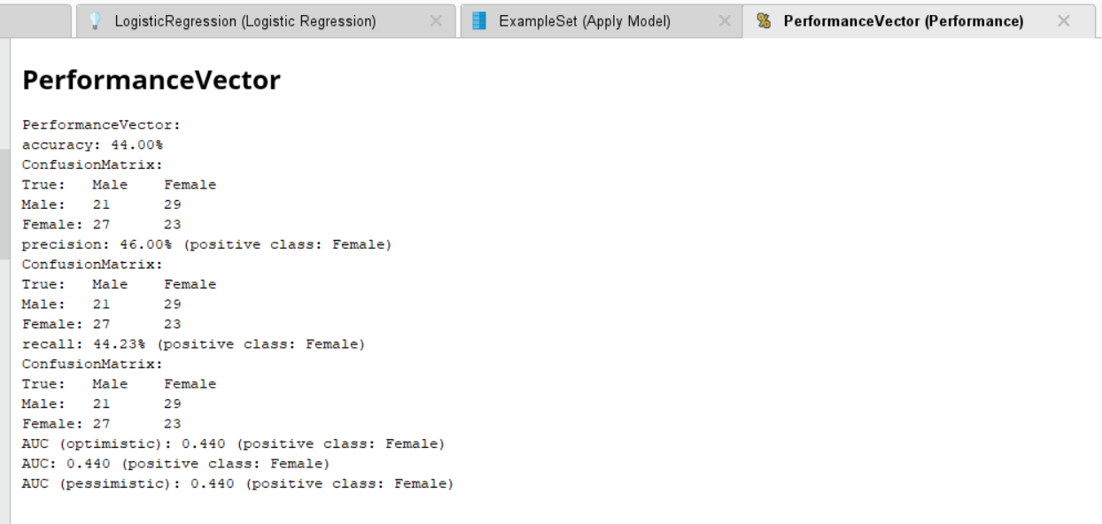

|  |  |  |
| --- | --- | --- |
| **CLASSIFICATION MODEL** | **ETHNICITY CLASSIFICATION (ACCURACY IN %)** | **GENDER CLASSIFICATION (ACCURACY IN %)** |
| **NAÏVE BAYES** | **46** | **51** |
| **KNN** | **38** | **53** |
| **DECISION TREE** | **50** | **51** |
| **RANDOM FOREST** | **49** | **51** |
| **LOGISTIC REGRESSION** | --- | **44** |

**RESULT:**

Hence, performed 5 classification models and found out knn classification to be best with accuracy of 53% for gender classification and decision tree with accuracy of 50% for ethnicity classification and successfully generated confusion matrix for all models.